**April 2019**

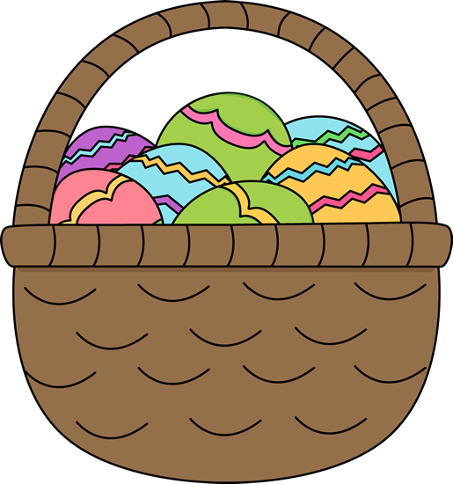

Important Dates

April 12th – No School

April 19th – No School

April 21st – Easter

April 22nd – No School

Reminder:

Towards the end of this month the teachers will start sending out welcome packets for the summer. Please fill it out and turn it in as soon as possible. Thank you!

Parents,

BBA has recently started an Amazon Wish List for all the kids at BBA including our classroom. If you would like to browse our list or donate to our classroom please let us know and we will send you the link! Thank you so much for all that you do to support BBA and the kiddos. We appreciate your generosity!

* Miss. Sarah