

# Winter 2017-2018 Season

# Week 4

# 25th November 2017

# Singles League

# 

**Christmas Charity Doubles Open**

**Saturday 2nd December 2017**

# Top of the table Matt Buesnel was up against Andrew Bellamy-Burt. Not many people taking part in the Super 6 gave Matt a Chance.

# 

# Matt though took the first game 13 – 8. The second game though went to a 12 – 12 shootout with Andrew taking that final point for a draw.

# Matt Pinel forgot his boules, borrowed some from Magic Touch two sizes smaller than his normal ones and still beat Callum Stewart 13 – 6, 13 – 11!

# Well if you’ve played Super 6 check this out!!!

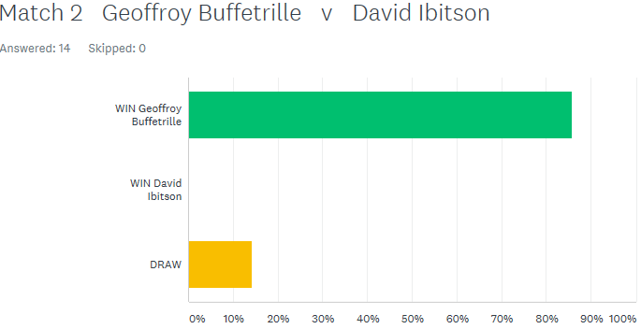

# Not one person thought David Ibitson would beat Geoffroy Buffetrille, but that he did and comfortably as well, 13 – 7, 13 – 3! Well Done David who now tops the league on points difference.

# Toby came back from 10 – 0 down in the first game to narrowly lose 13 – 10, before another 12 – 12 shootout saw Toby gain the draw, with Neil and Toby drawing their first 2 matches.

# 

Well one person called this a relegation battle between Alice & Ross (come on! It’s only week 2!). Ross took the first match 13 – 6, but he may have had his own prediction in the Super 6 Tie-Breaker in the back of his mind (Ross picked himself to win the second game 13 – 9, three other people also picked this score), but it was Alice who won 13 – 5.

Cassie Stewart was the closest on the Tie-Breaker guessing 13 – 6 to Alice.



Division 1 saw its first match played with Brian taking all three points against Colin Myers, winning the second game 13 – 12.

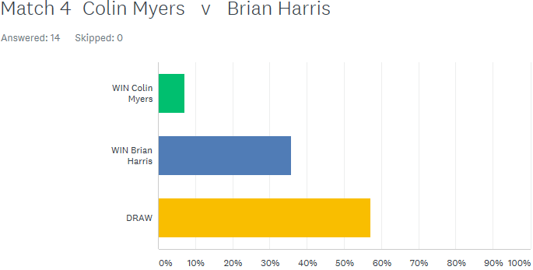

Paul Bell played his first Singles league matches for the club. Despite losing the first game against experience player David Le Gresley 13 – 10, won the second 13 – 2. Paul then just lost to Brian Harris 13 – 11, 13 – 10. Paul Bell will be one to watch this season.

Colin Myers lost his second match of the day to Cassie Stewart and David Le Gresley won his second but only just against Alex Stewart 13 – 11, 13 – 10.

Division 2

Laurent Pellation beat another new comer (although not sure Laurent is that new to the sport), Mo De Gruchy 13 – 1, 13 – 1 to top the table early on. Richard Williams beat Luke Canavan but only just with the second game going to 13 – 10.

Well after being relegated last Winter to division 2 not many people gave Brigitte a chance against Harrison, but 85% of people got the result wrong as Brigitte won 13 – 10, 13 – 8.

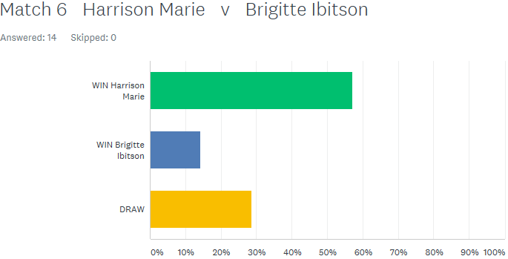

***NEXT WEEK***

**Christmas Charity Doubles Open**

**WEBSITE** [**www.liberationpetanque.co.uk**](http://www.liberationpetanque.co.uk)

**EMAIL** [**liberationpc@gmail.com**](mailto:liberationpc@gmail.com)

**Kind Regards**

**Report Editor**

**Toby Northern**

**Liberation Petanque Club**

# SPONSORED BY

# http://nebula.wsimg.com/135a1bd6338e1b589a50cdec98bd84d1?AccessKeyId=C6E923731F1A482DD910&disposition=0&alloworigin=1