Report on the UGC sponsored national seminar on Wetlands: Present Status, Ecology & Conservation held on 12th August 2015
Zoology Department of Maharshi Dayanand College organized UGC sponsored one day national seminar on Wetlands: Present Status, Ecology & Conservation on 12th August 2015, in collaboration with the Salim Ali Centre for Ornithology and Natural History (SACON) and Association of Teachers in Biological Sciences (ATBS).
The seminar was a great success with overwhelming response by 208 participants, which included 80 teachers, 20 research scholars and 108 UG and PG students from all over India.
The inaugural session started with a welcome speech by Principal Dr. T.P. Ghule, Concept note by Dr. C.S. Panse (Convener), talk by Dr. P.G. Kale (Chairman, ATBS) and Dr. Madhuri Pejaver (Dean Science faculty, University of Mumbai). Mr. Pasha Patel, ex-MLC,Govt.of Maharashtra enlightened the audience by sharing his personal experience and efforts taken to conserve water in rural Maharashtra. The inaugural function was compered by Organizing Secretary Dr. Manisha Kayande.
The chief guest for the inaugural session was Dr. Rajendra Singh (Water man of India, Ramon Magsaysay Award winner and Stockholm Water Prize winner 2015). Dr. Rajendra Singh’s intense speech left the audience spell bound. He opened everyone’s eyes and ignited zest for water conservation. He also appealed the audience to participate in the Water Peace March.
The Keynote speaker of this conference was Shri N. Vasudevan, (IFS, chief conservator for Forests, Mangrove cell, Mumbai). He shared his thoughts on the significance of conserving biodiversity in a rapidly urbanizing India. He emphasized that mangroves are necessary for the survival of the urban population and mitigate pollution and provide strong protection against floods.
The Guest speaker for the afternoon session was Dr. Sanjay Deshmukh, Hon. Vice-Chancellor University of Mumbai. He released the proceeding of the wetland seminar and delivered a talk on CRZ issues and sustainable development.
During the entire seminar total of 55 research papers were presented in oral and poster sessions. A separate poster competition was arranged for the UG and PG students, three prize winners were selected by two judges Dr. Vinay D. Deshmukh (Former Principal Scientist and OIC, CMFRI-MRC) and Dr. Anuradha Patel (HOD, Dept. of Zoology, Bhavan’s College, Andheri).
During the valedictory session the seminar activities were summarized by Dr. Goldion Quodros (Sr. Scientist, SACON). The seminar was concluded with a valedictory session by Principal Dr. T.P. Ghule. Prizes and certificates were distributed to the participants.
As an effort to inculcate research aptitude in students and to motivate them to participate in the wetlands seminar, a pre-conference workshop was organized by Department of zoology in collaboration with Maharashtra Nature Park, Dharavi on 3rd August 2015. This preconference workshop was possible due to the support extended by Mr. Avinash Kubal, Dy. Director, MNP. The huge participation by UG and PG students in the poster competition in the wetlands seminar was an outcome of the motivation they received in the pre-conference workshop.
The preconference workshop and seminar was a huge success due to the untiring efforts by 15 student volunteers, departmental support staff, and the organizing committee.

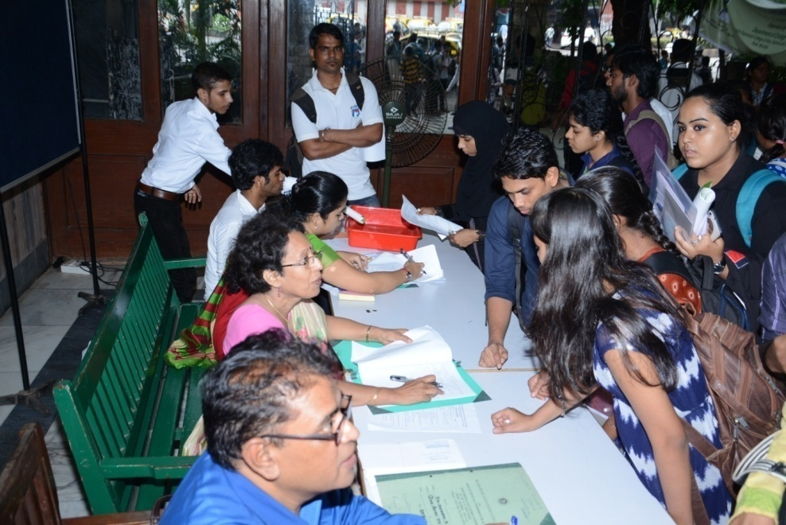
Registration of the participants

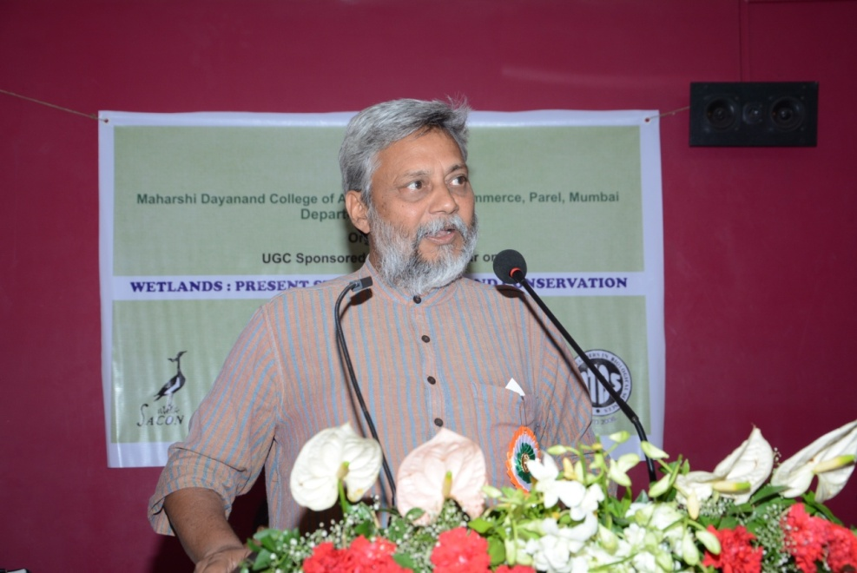
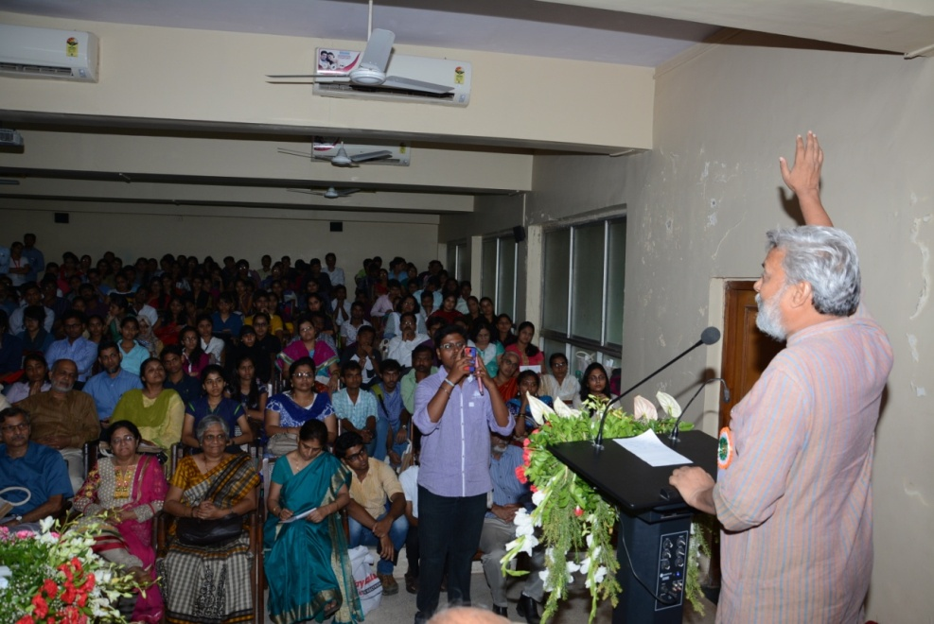
Dr. Rajendra Singh Addressing the gathering
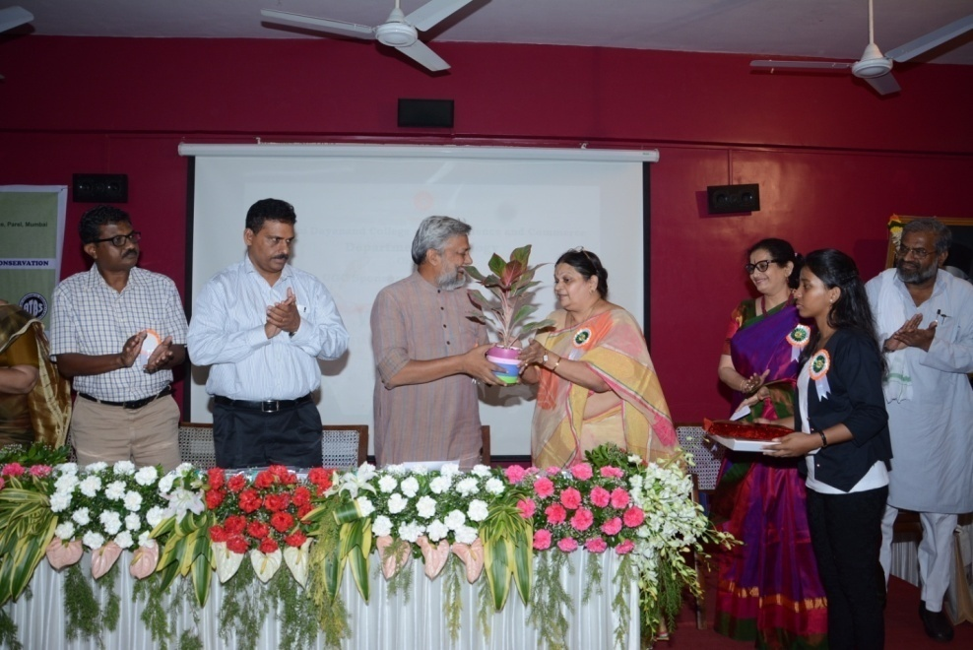
Felicitation of the guests
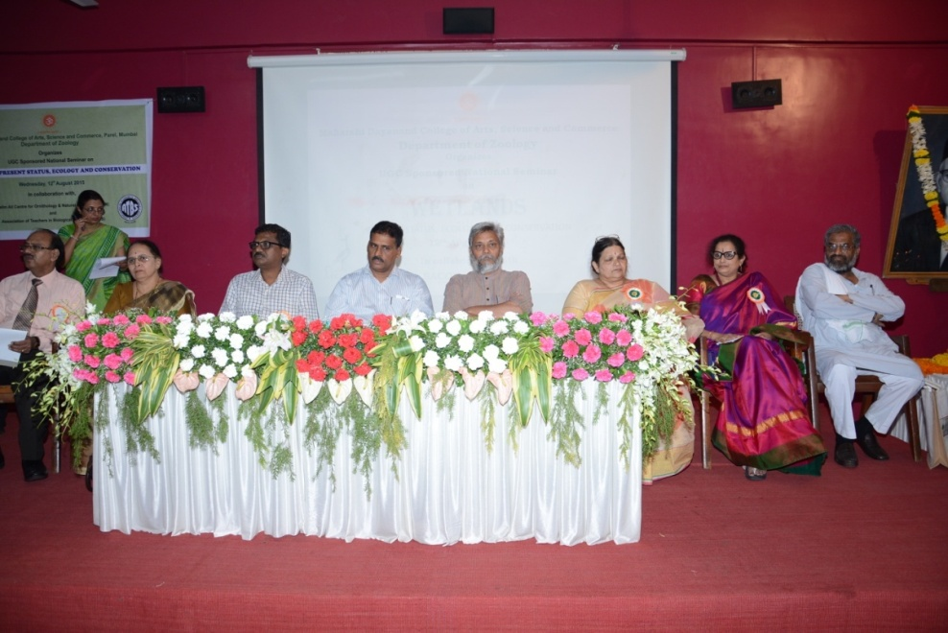
Dignitaries on the dais
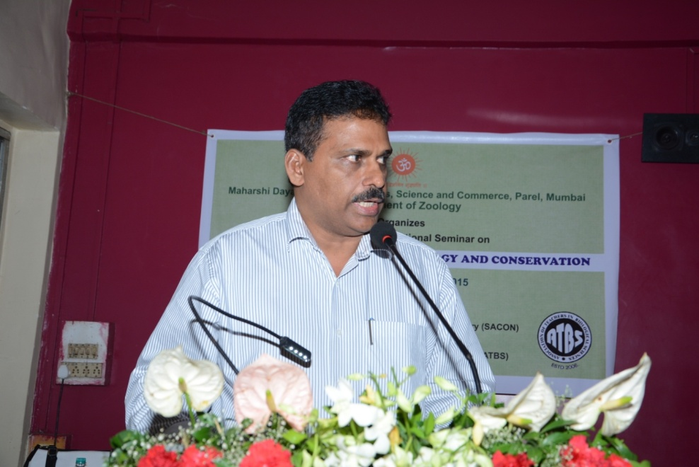
Shri. N. Vasudevan Addressing the gathering
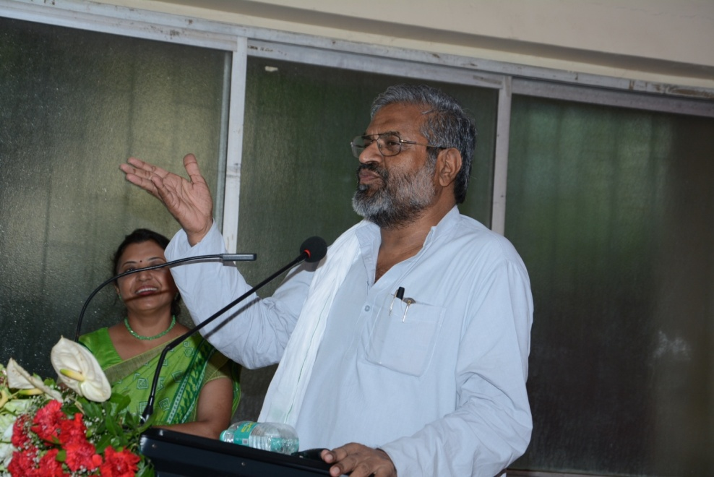
Shri. Pasha Patel addressing the gathering

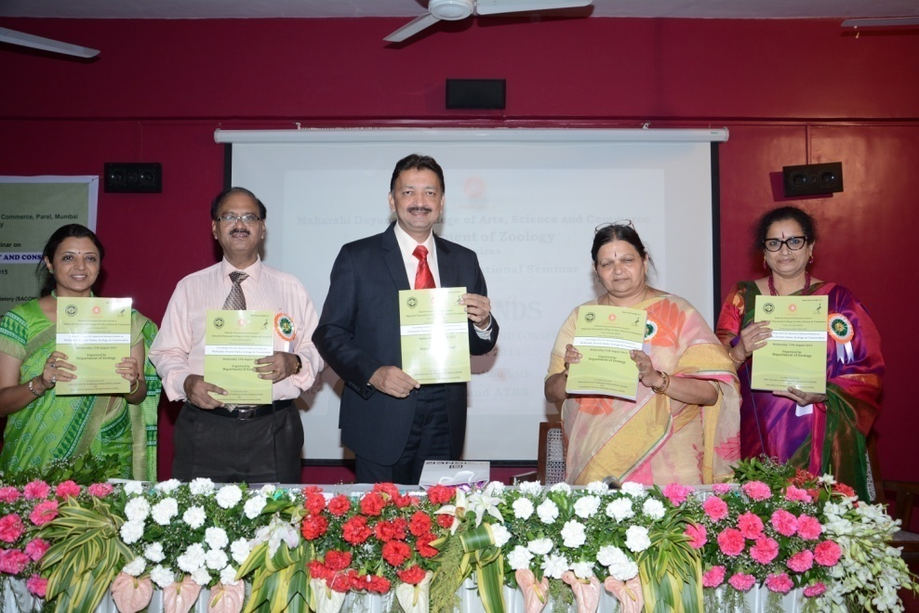
Release of the seminar proceedings by Dr. Sanjay Deshmukh, Hon. Vice-chancellor, University of Mumbai
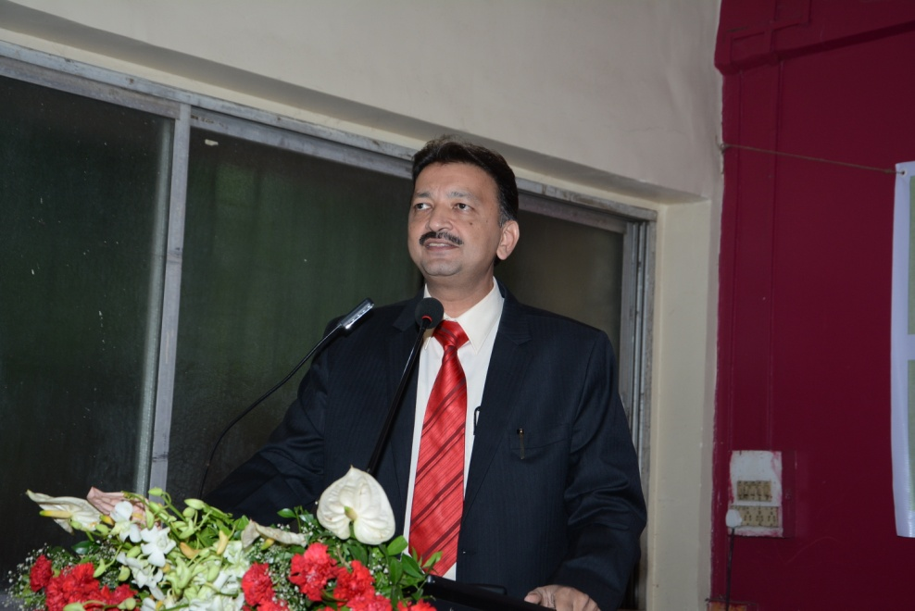
Dr. Sanjay Deshmukh, Addressing the gathering
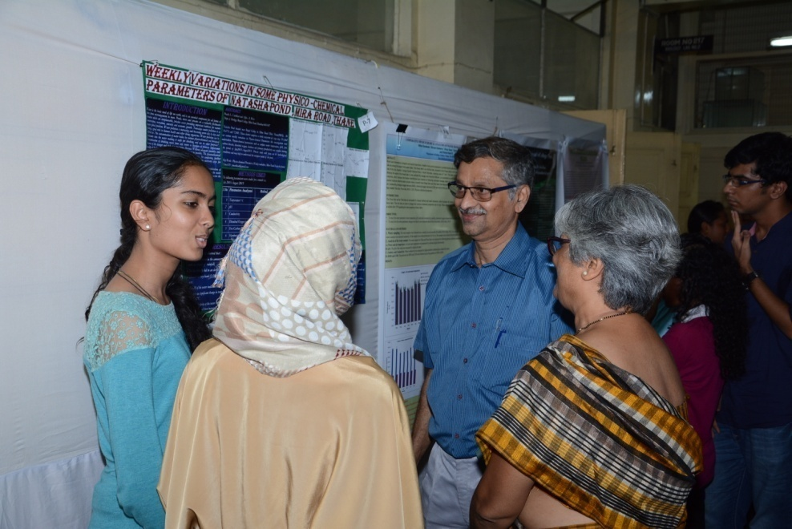
Dr. Vinay D. Deshmukh and Dr. Anuradha Patel, Judging the students poster competition
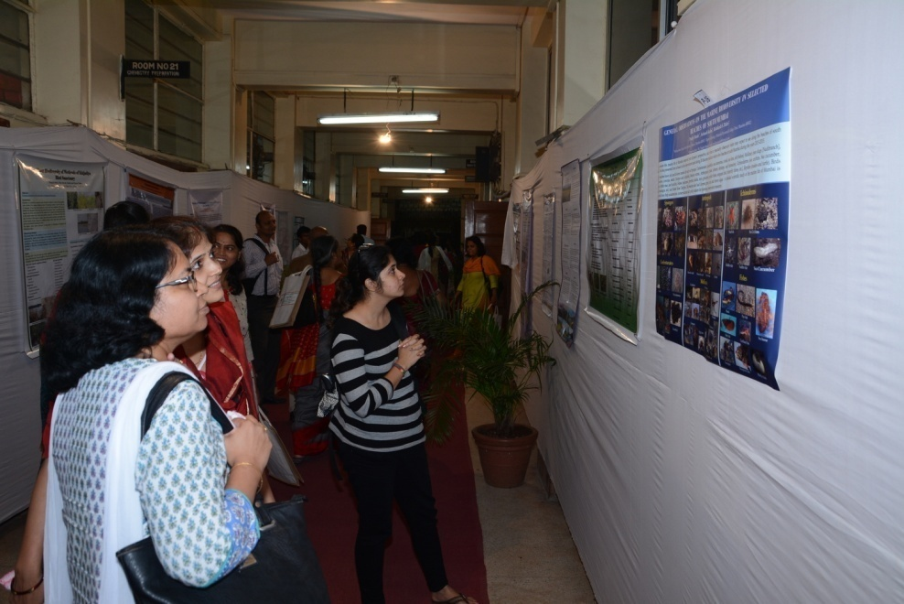
Viewing of poster presentation by teacher
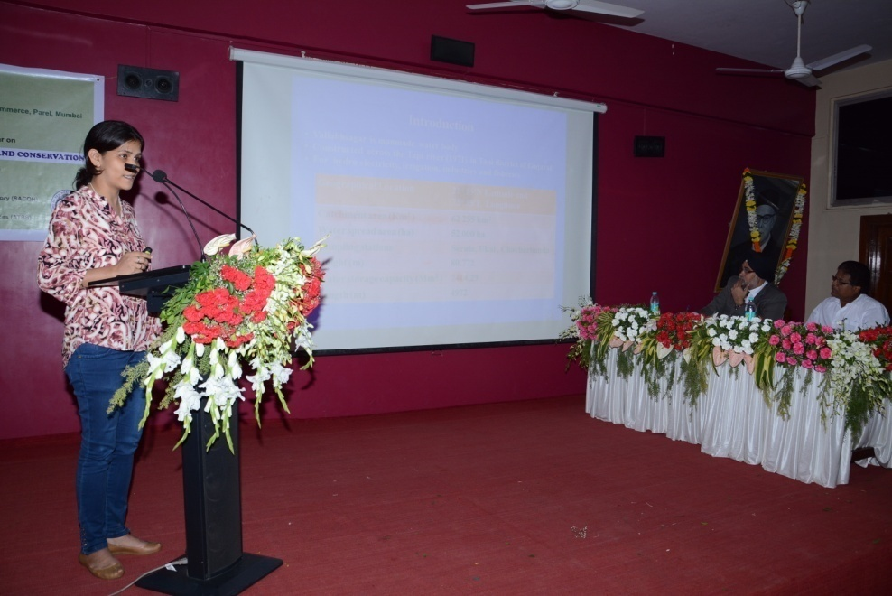
Oral poster presentation by teachers and students

Report by Dr. Manish Kayande, Organizing Secretary

