Our Weekly Activities These are the days/hours for the…
Week of March 4, 2018
Sunday, March 4, 9:30am Sunday school, Fellowship hall; 11am Morning Worship, preaching Rev. James Stansbury. Monday, March 5, 9am TOPS #217, Fellowship hall. Tuesday, March 6, 9:30am Fitness – Strength, Fellowship hall; 5pm Girl Scouts #400, Fellowship hall. Wednesday, March 7, 8:30am Walk about the neighborhood, begins @ Fellowship hall; 9:30am Fitness – Stretch, Fellowship hall; 3pm Choir Practice in the Choir room. Thursday, March 8, 2pm Presbyterian Women, Parlor. Friday, March 9, 9:30am Fitness – Flex. Senior #2, Fellowship hall.
Week of March 11, 2017
Sunday, March 11, 9:30am, Sunday school, Fellowship hall; 11am Morning Worship, preaching Rev. James Stansbury. Monday, March 12, 9am TOPS #217, Fellowship hall. Tuesday, March 13, 9:30am Fitness – ‘Easy Does It’, Fellowship hall. Wednesday, March 14, 8:30am Walk about the neighborhood begins @ Fellowship hall; 9:30am Fitness – Stretch, Fellowship hall; 3pm Choir Practice in the Choir room. Thursday, March 15, 7pm Bay County Stamp Club, Fellowship hall Friday, March 16, Fitness program makes-way for Evening program; 4:30am ‘Grand Junction Band’ set-up; 5:30pm St. Patrick’s Dinner & Music – Hall of Fellowship featuring Great music, wonderful Home-cooked main dishes, fabulous desserts, door prizes, plus more.

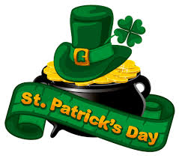
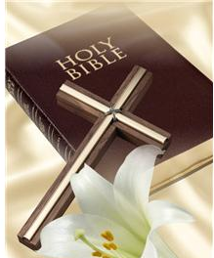
Announcements & Items of Interest . . . March 4, 2018 Rev. James Stansbury returns to us for the next five weeks, counting Easter/’Lord’s Supper’. Great having him back. Thanks to Bruce Davis for filling in for Pastor Connor last week. We are now in the Closing Days of the - St. Patrick’s Day Dinner & Music from the: “GRAND JUNCTION BAND” . . . Saturday March 17 is rapidly approaching. Several people are actively working on getting things in order. The Dinner is an Irish themed Covered Dish affair – with Corn beef and Cabbage, Sheppard Pie, etc. Some have said they will bring their favorite desserts. Another item is the band, The Grand Junction Band has agreed to be with us again. That’s Saturday, March 17 at 5:30pm – Hall of Fellowship. For our Visitors . . . there are tan cards in pockets in the back of the pews. Please provide us the information requested & place the card in offering plate. Blue cards are for those wishing to pass on general information to the church. Thank you!
St. Andrews Presbyterian Church ‘serving the Christian community of St. Andrew since1886’ 3007 West 14th St. @ Beck Av, Panama City, FL 32401, 850/785-8358 www.saintandrewspc.com standrewspresch@Knology.net

