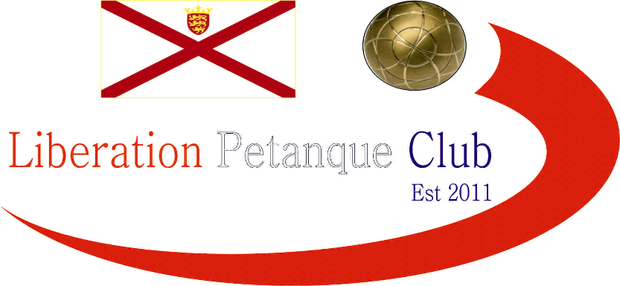

# Winter 2017-2018 Season

# Week 16

# 24th February 2018

# Singles League

# 

# We have a new Winter Singles Premier League Champion. That man is Matt Buesnel who fought back against Geoffroy to win the second game 13-12 for a valuable draw.

# This combined with Toby beating Alice and Andrew Bellamy-Burt drawing against both Keith Pinel and Neil Selby handed Matt his first ever Premier League title. Well Done Matt.

# Andrew’s two draw’s leave him and Neil still in danger of relegation, especially with Callum Stewart beating Geoffroy in a catch-up match, giving him a great chance of survival.

# Toby’s win against Alice moved him up to 5th with Ross knowing he needs to beat both Callum and Neil at least to stay up.

# Division 1 saw a shock as Brian Harris lost his first match of the season but despite this Brian is 99.9% sure to be champion as only John McGaw can catch him now but he needs to win all three matches remaining and hope Brian loses his final match of the season against Cassie.

# Cassie beat John McGaw comfortably but needs a result against Brian to guarantee a top three finish.

# Alex Stewart also beat Paul Bell as both players finished the season early. These two results moved Alex into third place but he has a nervous wait to see if he gets a medal.

# Paul Le Moines chances of promotion took a blow losing to Paul Bell who has had a great first ever singles season playing in Division 1 as well. Well Done Paul.

# Division 2 saw Laurent Pellaton win again, now five in a row for Laurent who needs to beat Brigitte to guarantee the title on the final week of the season. Brigitte could only draw with Matt Hutchings but beat Luke Canavan in a catch up match to guarantee a top three finish and a medal, it just depends now which one it will be.

# Just two weeks to go to the end of the season Sunday 11 March 2018.

# Don’t Forget firing competition Saturday 10th March 2018.

***NEXT WEEK***

**FINAL SINGLES LEAGUE FIXTURE**

**WEBSITE** [**www.liberationpetanque.co.uk**](http://www.liberationpetanque.co.uk)

**EMAIL** [**liberationpc@gmail.com**](mailto:liberationpc@gmail.com)

**Kind Regards**

**Report Editor**

**Toby Northern**

**Liberation Petanque Club**

# SPONSORED BY

# http://nebula.wsimg.com/135a1bd6338e1b589a50cdec98bd84d1?AccessKeyId=C6E923731F1A482DD910&disposition=0&alloworigin=1