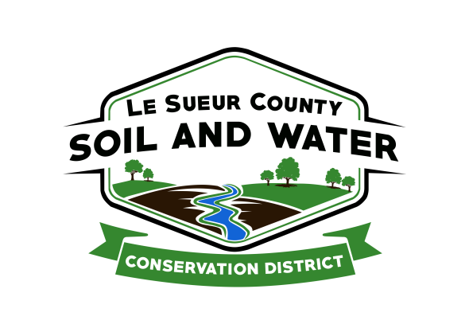

Le Sueur County Soil & Water Conservation District

Le Sueur County SWCD Tel. (507) 419-0365
181 W Minnesota St Website: www.lesueurswcd.org
Le Center, MN 56057

Minutes from October 11, 2022 regular meeting of the Le Sueur County SWCD Board of Supervisors. Le Sueur Co. SWCD building, Le Center, MN.

Meeting was called to order by Chairman Struck at 9:00 am.

Members present: Chairman, Jim Struck
Secretary, Earle Traxler
Treasurer, Cletus Gregor
PR&I, Glendon Braun

Members absent: Vice-Chairman, Greg Entinger

Others present: District Manager, Mike Schultz
District Conservationist, Steve Breaker
Resource Technician, Karl Schmidtke
Program Specialist, Sue Prchal
Le Sueur County Commissioner, Steve Rohlfing

The Pledge of Allegiance was recited.

Secretary’s report was read and approved.

Treasurer’s report was read. Motion by Braun, second by Traxler to approve as read and to pay bills.
Affirmative: All
Opposed: None
Motion carried

A new ATV, Suzuki KingQuad 750 AXi, was purchased from Cities Edge Motorsports in Shakopee for $10,798.00.
The board recommended listing the district’s 18’ trailer on Graves online auction site being is hasn’t sold yet.

Motion by Traxler, second by Braun to sign the representation letter stating Peterson Company represented the district in the 2021 year end audit.
Affirmative: All
Opposed: None
Motion carried
Motion by Braun, second by Gregor to approve payment of CD#61 MDM Storage and Treatment project, contract #MDM-20-01, in the amount of $209,041.00 to Le Sueur County Drainage Authority.
Affirmative: All
Opposed: None
Motion carried

All grant recipients will now be signing a Tennessen warning that states grant information being received is public information.

Mike and Jim gave updates on the Cannon River 1W1P JPB meeting they attended. Priority projects in the county, 2023 allocation budget, lake surveys and water sampling were discussed.

Mike updated the board on the Lower MN River East 1W1P. The 1W1P board is in the process of writing a grant and addressing priorities.

Upcoming meetings and trainings:

Lower MN 1W1P – October 20
BWSR Academy – October 25-27
Le Sueur Co. SWCD monthly meeting – November 9 (due to election on November 8)
Area 6 – November 15
Leadership Training – November 15-16
State Convention – December 13-14
Cannon 1W1P Cover Crop Meeting – December 19

Motion by Gregor, second by Traxler to give Mike Schultz sign off approval on grant agreements.
Affirmative: All
Opposed: None
Motion carried

Steve gave the NRCS report. He discussed construction projects that Colin is working on, new potential sites for projects, CRP re-enrollments and CRP rates slightly increasing.

Com. Rohlfing discussed the Lake Washington regional park project of blacktopping, curb and gutter completed and better access to trails, beach and day camping. The 2023 county levy has decreased slightly. The highway department’s budget has increased due to fuel and material costs, the sheriff’s office will be leasing vehicles due to vehicle shortages and the employees in Community Health will be moving into the transformed jail by the end of January.

The board read and voted on the 2022 resolutions.

Glendon Braun submitted a resignation from the board effective end of board meeting today, October 11, 2022.

There being no further business, meeting adjourned at 11:00 am.

________________________ ________________________________________________
Date District Secretary

