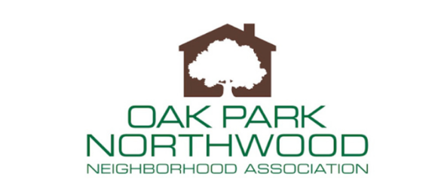
BOARD MEETING July 19, 2022
6:30 p.m.

- Welcome New Guests
- Approve June 22 Meeting Minutes
- Treasurer’s Report
- Business and Family membership Dues Drive
  - Board sign up members or give contacts for board outreach
- July 4th Parade Recap
- NeighborFest
- Bentley’s Bar
- Airport Update Presentation
  - August or September Board meeting
- Meet the Candidates
  - Races: County Judge, Commissioner Precinct 3, State Representative 121
  - Early October/late September
- Adjourn

