RIVER FALLS CLASSIC #3
JUNE 17-18, 2017
11AA DIVISION

 | American League | Win | Loss | Tie | Total Points
A1 | River Falls
A2 | Prescott

 | National League | Win | Loss | Tie | Total Points
N1 | Delano
N2 | Stillwater
N3 | Eastview

Pool Play

Saturday | Field | Team | Score | Team | Score
9:00 | JV Softball | River Falls |  | Prescott
11:00 | JV Softball | River Falls |  | Prescott

Saturday | Field | Team | Score | Team | Score
9:00 | Varsity Softball | Eastview |  | Stillwater
11:00 | Varsity Softball | Delano |  | Eastview
1:00 | Varsity Softball | Stillwater |  | Delano

First Place in American and First & Second in National receive byes
Second Place in American and Third Place in National play in for bracket play

Saturday | Game | Field | Team | Score | Team | Score
3:30 | Plan In Game | Varsity Softball | American 2nd place |  | National 3rd place

Bracket Play

Sunday | Game | Field | Team | Score | Team | Score
10:00 | Semi Game 1 | Varsity Softball | American 1st Place |  | National 2nd place
12:15 | Championship | Varsity Softball | Semi Game 1 Winner |  | Semi Game 2 Winner

Sunday | Game | Field | Team | Score | Team | Score
10:00 | Semi Game 2 | JV Softball | National 1st Place |  | Play-In Winner
12:15 | 3rd Place | JV Softball | Semi  Game 1 Loser |  | Semi Game 2 Loser

2017 MBT Qualifier Rules Apply

Pool Play Time Limits (no limit for bracket play):
9U-12U: Time limit: 6 innings/1 hr 45 mins No new inning shall begin after 1 hr 45 mins 4 innings minimum required
13U-15U: Time limit: 7 innings/2 hours No new inning shall begin after 2 hours 5 innings minimum required

POOL PLAY TIE BREAKER METHODS:
1. Won-Loss-Tie Record
2. Head to head
3. Least number of runs allowed against tied teams
4. Run differential against tied teams (maximum plus or minus 10 run)
5. Least number of runs allowed in total pool play
6. Run differential in total pool play (maximum plus or minus 10 run)
7. Coin toss

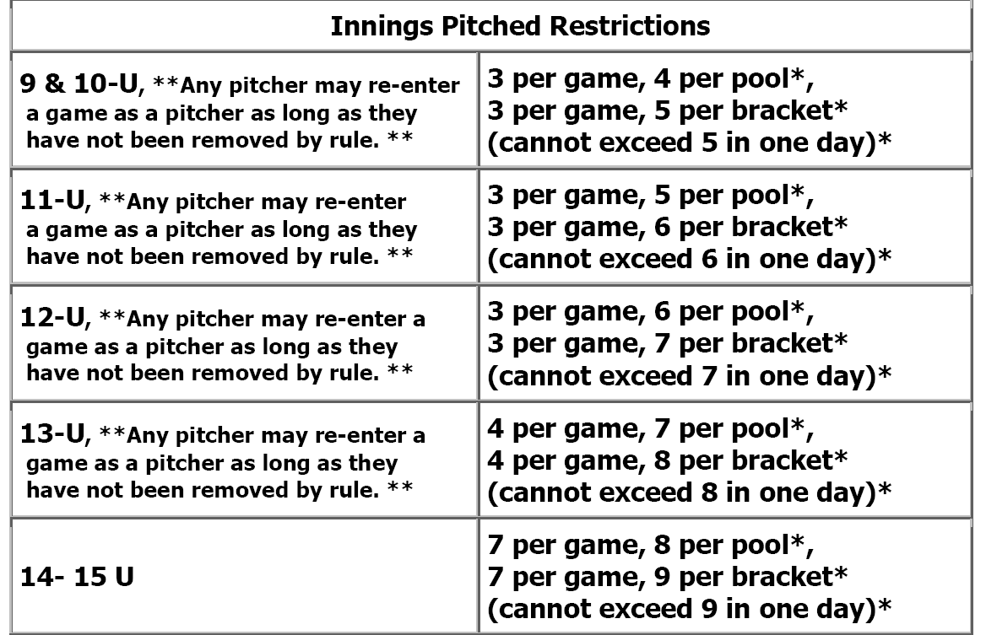

ALL GAMES AT RIVER FALLS HIGH SCHOOL
www.riverfallsyouthbaseball.org

