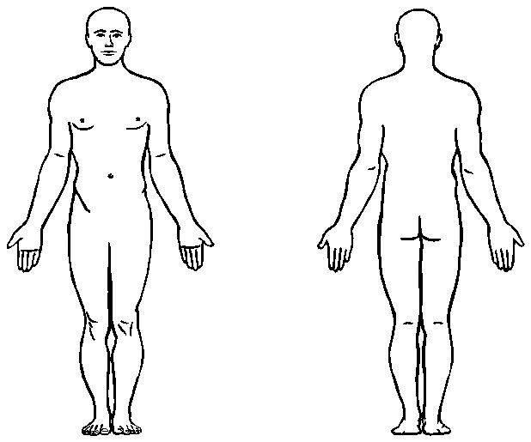
HISTORY OF AUTO ACCIDENT/SUBSEQUENT SYMPTOMS

Patient Name:_____________________________________________________________________________

Date of accident: __________________ Time: __________am/pm # of people in vehicle:__________

Circle One:
You were the:
Driver or Passenger: Front Rear: Behind Driver Middle Behind Passenger

Your car:
Hit another car or Was hit in the … Rear Front Side

Where was the accident?
City: _________________Street: ______________________ Cross Street:_________________

Type of car you were in: ___________________ other vehicle(s):__________________________________

Description of Accident:
__________________________________________________________________________________________
____________________________________________________________________________________________________________________________________________________________________________________________________________________________________________________________________________

Did the police or ambulance come to the accident scene? No Yes

Were you wearing a seatbelt? No Yes AirbagsDeployed? No Yes

Did you brace for the impact? No Yes

Explain Head/arm/body position at time of impact: __________________________________________________________________________________________

Did any part of your body hit inside the vehicle? No Yes Explain:___________________________________________________________________________________

Did you get any cuts or bruises? No Yes
Where?__________________________________________________________________________________________

Did you go to hospital or see another doctor? No Yes Date of 1st visit: ______________________

Were x-rays/MRI’s taken? No Yes Explain:___________________________________________________________________________________

Were you given treatment? No Yes
If yes, what type of Treatment?________________________________________________________________
Do you feel you can work without pain? No Yes
What is your job? ___________________________________________________________________________

Similar symptoms in the past? No Yes Explain:___________________________________________________________________________________

Past Health History

Do you take any medications? No Yes Explain:___________________________________________________________________________________

Past Surgeries/Hospital Stays? No Yes Explain:___________________________________________________________________________________

Past Injuries or Broken Bones? No Yes
Explain:___________________________________________________________________________________

Previous and Current Illnesses? No Yes Explain:___________________________________________________________________________________

Family History:
__________________________________________________________________________________________
__________________________________________________________________________________________
Current Complaints: Indicate P = Pain. T= Tightness, S= Swelling, B= Burning, L= Limited Movement

Other notes:

