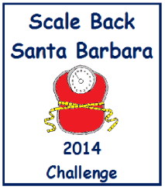
How to be a Scale Back Recruiter
Tell People about the Challenge!!!
1. Read the information on the Website at: ScaleBackSB.org
2. You don’t have to be an expert just enthusiastic.
3. Give people an overview of the challenge.
4. Give people the Website address.
5. Walk people through the GOAL CARDS and the WEIGHT LOSS IDEA CHART.
6. Sign people up to join.

