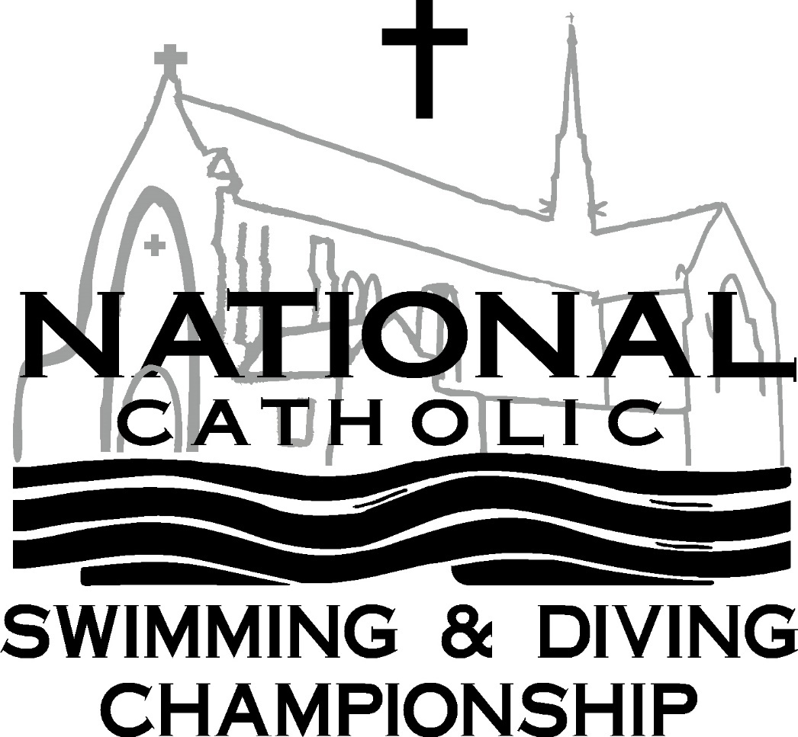

**Swimming and Diving Championship**

Prelims

Saturday, January 11, 2025

Finals

Sunday, January 12, 2025

Hosted by:

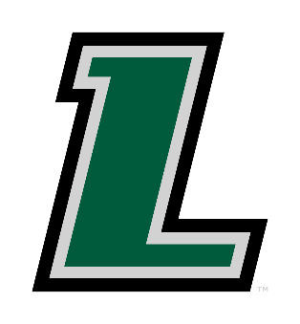

Loyola University Maryland  
Baltimore, Maryland

Dear Teams,

Loyola University Maryland is proud to host the 88th National Catholic Swimming and Diving Championship Meet.

The National Catholic Championships will be held on the weekend of January 11th & 12th, 2025 at the Mangione Aquatic Center on the Evergreen campus of Loyola University Maryland in Baltimore. All pre-meet information is included in this packet.

If a swimmer makes one time standard, he or she may swim in one other individual event in which he or she does not have the standard, but he or she may not exceed four events in the meet, including individual and relay events, of which no more than two may be individual events. A swimmer that is entered as part of a relay that qualifies may also compete in two individual events without the time standard.

Non-scoring B relays may be entered for any team that has entered an A relay. These B relays do not have to achieve the time standard to be included. Swimmers on the B relay may also swim in two individual events without the time standard. These exhibition relays cannot advance to the Final or Consolation heat unless these heats are not filled with A relays. Swimmers that compete on B relays may advance to A relays.

This meet will be both a H.S. sanctioned meet as well as USA swimming observed meet.

Best wishes for a successful season. We hope to see you at the National Catholic Meet!

Sincerely,

Brian Loeffler (410-979-4528 Cell)

bloeffler@loyola.edu

Meet Director

**Meet Format**

**Saturday, January 11, 2025**

The following times are tentative, but we will try to adhere to it as closely as possible

***SWIMMING PRELIMS FOR GIRLS AND BOYS:***

Girls: Morning Session

Warm-up: 7:00am

Sprint & Pace Lanes Open: 7:45am

**Coaches Meeting: 7:45am in Pool Vestibule**

Pool Cleared: 8:15am

Girls Meet Begins: 8:30am

Boys: Afternoon Session

Warm-up: 12:30pm

Sprint & Pace Lanes Open: 1:15pm

**Coaches Meeting: 1:15pm in Pool Vestibule**

Pool Cleared: 1:45pm

Boys Meet Begins: 2:00pm

***DIVING FOR GIRLS:***

Girls: Diving Session

Warm-up: 5:30pm

Meet Begins: 6:30pm

**Sunday, January 12, 2025**

***DIVING FOR BOYS:***

Boys: Diving Session

Warm-up: 7:00am

Meet Begins: 8:00am

***SWIMMING FINALS FOR GIRLS AND BOYS***:

Girls & Boys Finals

Warm-up: 10:15am - 11:45am

Finals Begin: 12:00 noon

**Meet Information**

**Site:**  Loyola University Maryland Fitness and Aquatic Center – Mangione Aquatic Center

**Meet Director:** Brian Loeffler phone: 410 979 4528 cell email: bloeffler@loyola.edu

**Pool:**  The pool is located in the Fitness and Aquatic Center on the Campus of Loyola University Maryland. 4900 N. Charles Street Baltimore, Maryland.

**Parking:** Limited parking is available in main lot at Fitness and Aquatic Center. Additional parking is available on Charles Street (adhere to City signage) and at the Cathedral of Mary Our Queen (lower tier only). Parking in “No Loyola Parking” posted areas will result in ticketing and towing.

**Locker Rooms:** Daily use lockers are available, but no locks or towels will be provided.

**Staging Area:** There will be no staging area, swimmers will arrive to starting blocks prior to event.

**Hotel:** Special Meet Rate $110 / Complimentary Buffet Breakfast, parking, WIFI, Microwave and Mini Fridge  
Contact: Ayush Khadka - 701-630-1114 / sales@bmhg.net  
Holiday Inn Express Towson - Baltimore North

1100 Cromwell Bridge Rd Towson, MD 21286

**Programs &**  There will be a $5.00 admission fee for all spectators for each session.

**Admission:**  Children under 10 are free. Programs for each session will be $3.00 (Morning is considered one session and afternoon another session)

NOTE: The gallery will hold no more than 600 spectators based on fire occupancy limits. The pool deck will hold no more than 436 swimmers/coaches/officials based on fire occupancy.

**Concessions:** Concessions will be available at the Fitness and Aquatic Center.

**USA Swimming:** This meet will be observed for USA Swimming. Please be sure you include the correct USA Swim ID.

**TM Export entries are due by Monday,**

**January 6, 2025!**

**Swimming Events and Qualifying Times**

Event Girls Boys

200 medley relay 2:09.49 1:49.50

200 freestyle 2:15.50 1:57.50

200 IM 2:35.00 2:14.00

50 freestyle 28.95 24.95

100 butterfly 1:10.50 58.50

100 freestyle 1:01.50 53.50

500 freestyle 5:45.00 – Must have cut to enter 5:25.00 – Must have cut to enter

200 freestyle relay 1:49.50 1:38.00

100 backstroke 1:10.00 1:01.00

100 breaststroke 1:18.00 1:07.50

400 freestyle relay 4:21.00 3:40.00

**Entries & Fees**

* All entries must be received by Monday, January 6, 2025. Entry fees can be brought to the meet – Make checks payable to Greyhounds Aquatics
* Hy-Tek Team Manager entries should be used to enter team. Team Manager file will be sent.

Email entries to [bloeffler@Loyola.edu](mailto:bloeffler@Loyola.edu). Please contact me if you are unable to submit entries electronically.

* The current High School Federation rules will be used.
* If a swimmer makes one time standard, he or she may swim in one other individual event in which he or she does not have the qualifying time standard. If a swimmer is part of an A relay that qualifies or an exhibition B relay they may swim in 2 individual events.
* Each swimmer may enter a maximum of four events, of which no more than two may be individual events.
* Each team may enter an unlimited number of swimmers in each individual event, however only the top 4 from each team will advance to Finals or Consolation Heats.
* One meter diving for boys and girls will be competed on separate days. The event will be 1 Voluntary dive and 5 optional dives. Required dive is the front category. Any front with a max dd of 1.8-if the dive has a higher dd, you can still use that dive, just change the dd to a max of 1.8. If they do any front with a lower dd use the assigned dd.

**Fees:**  $7.50 per athlete surcharge

$10.00 per individual swimming event  
 $20.00 per individual diving event

$30.00 per relay

Make checks payable to: **GREYHOUND AQUATICS**

**Scoring:** The top 16 finishers in each preliminary swimming event will qualify for the finals on Sunday. Eight swimmers will swim in the consolation finals and eight will swim in the championship finals. Heats will be awarded points for 1st - 16th place as follows:

Individual 20-17-16-15-14-13-12-11-9-7-6-5-4-3-2-1

Relay 40-34-32-30-28-26-24-22-18-14-12-10-8-6-4-2

**Livestreaming:** The meet will be live streamed. Link will be provided at a later time.

**Awards:** Individual Medals will be awarded for 1st - 8th place.

Relay Medals will be awards for 1st, 2nd, & 3rd place:

* Team 1st, 2nd, & 3rd place teams (both boys and girls)
* Special Most Outstanding Swimmer (1 Boy, 1 Girl)
* Coach Coach of the Year (1 Boy, 1 Girl)