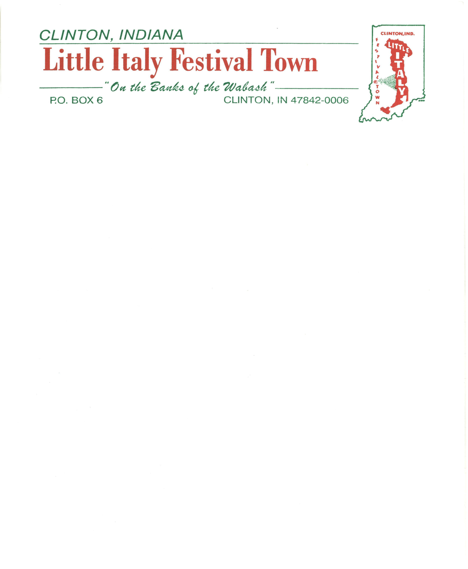

Dear Community Member:

Can you believe it is almost time for our 54th Little Italy Festival? Clinton and the surrounding area is rich in history, diverse ethnic cultures, and traditions. We want to celebrate our heritage and make this another year for visitors to remember as all involved with LIFT, in the past, intended. **Again, we need the support and help from the community.**

Many of you have asked what your sponsorship in LIFT will pay for during festival’s preparation. One of our major expenses is insurance, which runs approximately $13,500 per year. This covers all of the LIFT properties throughout the year, but it also offers coverage during festival weekend. Another large expense is publicity, which is budgeted at $5,500 for the festival. Other major expenses, include; sound systems, entertainment, clean-up, lawn care, electricity, water, upkeep of our various properties, ice, and supplies can easily equal $95,000. **This means that we need approximately $114,000 to run everything for a calendar year. This is hard to do on a festival that is 3 ½ days. LIFT doesn’t just put on the Little Italy Festival, we also care for 5 museum, 2 fountains, and the upkeep of the Wine Garden area. If, at any time, you have questions about how your donations are spent please let a board member know and we would be happy to answer any questions.**

The sponsorships are as follows:

* **Individuale Sponsorships** are $10.00 per person.
* **Regolare Sponsorships** are $25.00.
* **Media Sponsorships** are $50.00.
* **Superiore Sponsorships** are $100.00.
* **Amico Sponsorships** (Friends of the Festival) are $500.00.
* **Sponsorizzazione** **Sponsorships** are $1000.00.

As always, for the sponsorships of $500 or more, your company's name or individual names will be announced numerous times during the festival. All sponsorship s give our community and visitors an opportunity to enjoy quality entertainment at no cost and to experience the history of the area through LIFT's museum s: Little Italian Ho use, Mercato, Winery Museum , Coal Town and Train Muse um , and the Freight Depot .

Little Italy Festival Town, Inc. has a miss ion to keep and promote the history of Clint on, and we need your help in order to maintain our historical buildings. Your help will be greatly appreciated. LIFT's Directors would like to remind you that we are a **501(c) (3) corporation.** Our status allows individual and business contributors to deduct donations from their own tax returns. Please help us by supporting this year’s Little Italy Festival.

**Please make your financial contribution by June 30, 2019.** You can mail your check, payable to LIFT, to:

LIFT

Attn: Lynell McCracken

PO Box 6

Clinton, IN 47842-0006

Sincerely,

The LIFT Board