SPECIAL MEETING
JUNE 4, 2020

A Public Hearing and a Special Meeting of the Town Board of the Town of Hampton, County of Washington and the State of New York was held at the Town Hall, 2629 State Route 22A, Hampton, New York on the 4th day of June 2020.

Due to the Corona Virus, occupancy inside the Town Hall is limited at this time. Supervisor O’Brien did provide a link to join the Zoom meeting.

PRESENT: David K. O’Brien------------Supervisor
Tamme Taran----------------Councilwoman- absent
Donald Sady-----------------Councilman
Andrea Sweeney------------Councilwoman-absent
Michael Pietryka------------Councilman
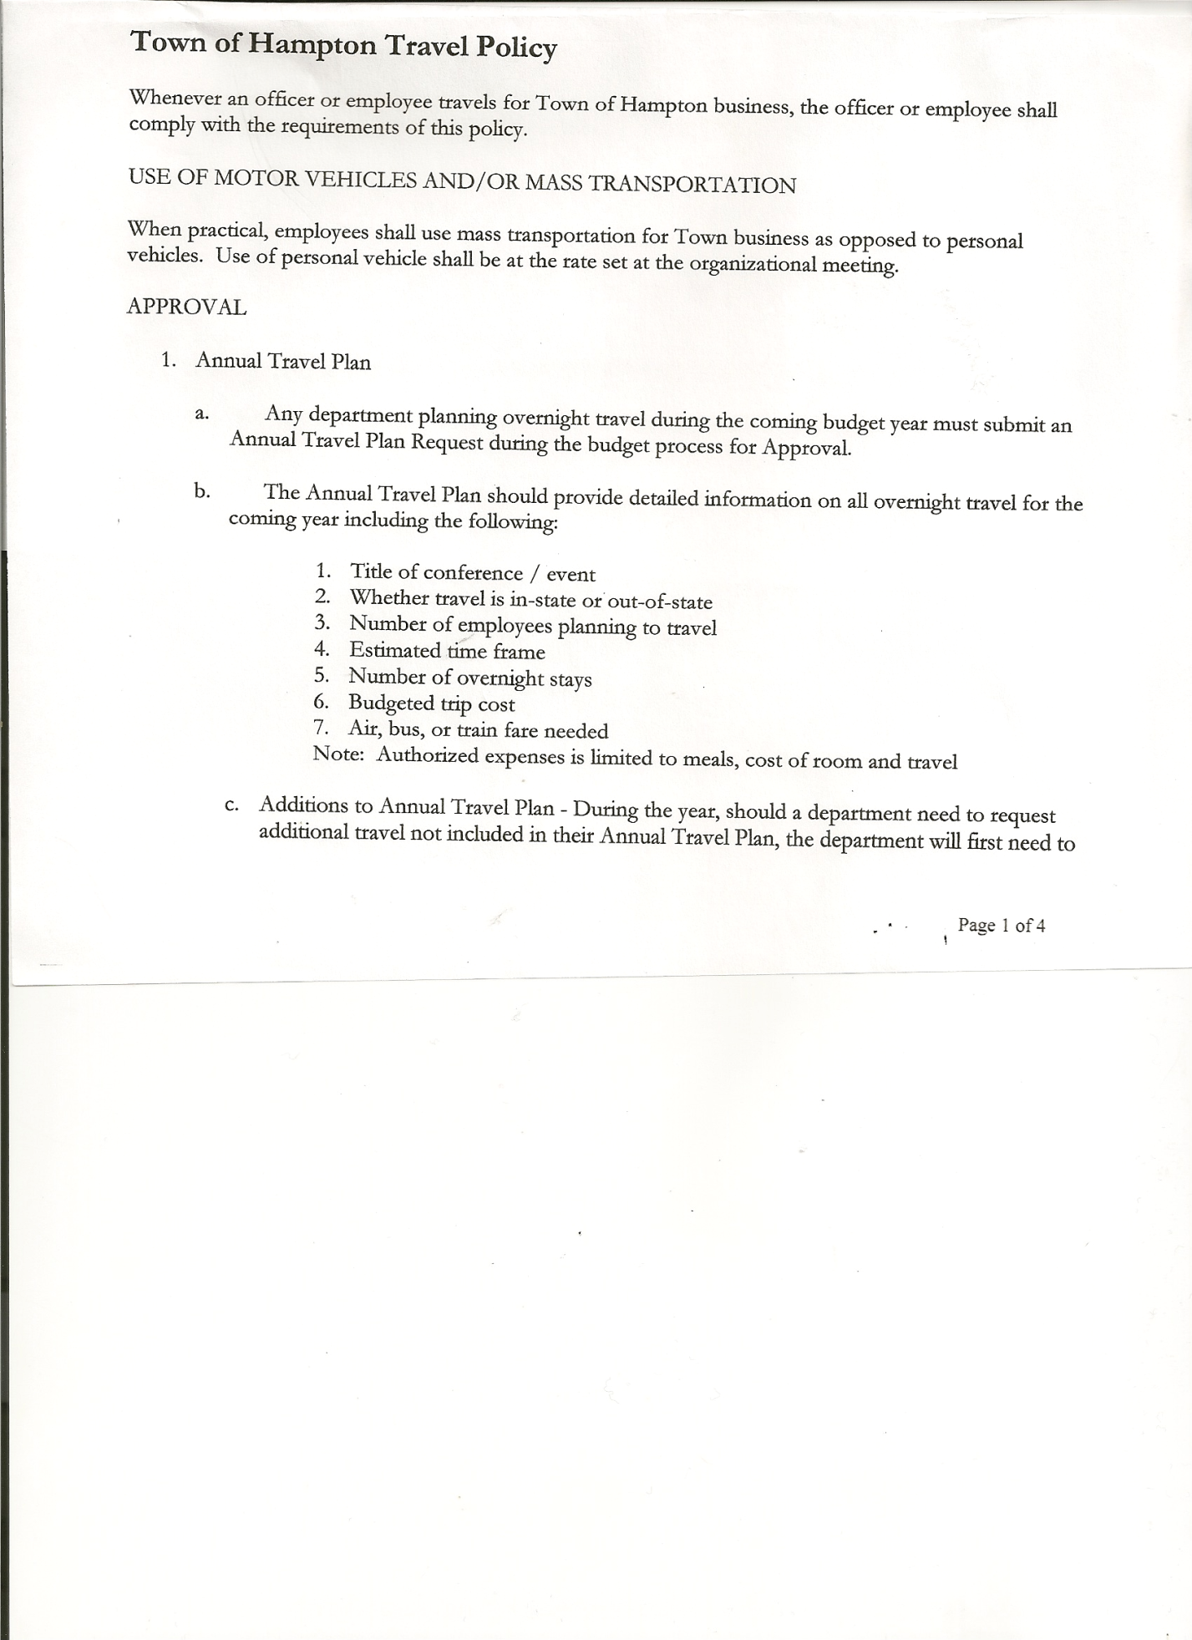
Rebecca Jones---------------Town Clerk
Camilla Shaw----------------Tax Collector/Deputy Town Clerk-via Zoom
Herbert Sady, Jr.-------------Highway Superintendent

Planning Board Member(s): Bonnie Hawley, Chair and Renee Rountree via Zoom

Also present: Kevin Egan, Director of Government Affairs for Spectrum; Ed Connolly,
Bob & Jen Johnson, and John Mashak all via Zoom. Patti Panebianco at the Town Hall.

The Public Hearing was called to order by Supervisor O’Brien at 7:04pm

Town Clerk Jones read the Legal Notice of Public Hearing (copy attached), which was published in The Post-Star on 5/27/2020 regarding granting a cable television franchise agreement by and between the Town of Hampton and Spectrum Northeast, LLC.

Supervisor O’Brien explained that the Company does not announce where they are expanding. Only companies that offer Cable TV need a franchise agreement. Those offering Internet and phone do not need said agreement.

Supervisor O’Brien then introduced Kevin Egan, Director of Government Affairs for Spectrum to answer any questions people had.
- Ed Connolly…. Will they provide internet too? Yes cable & internet. Infrastructure will support all internet, TV and phone. Customers can pick and choose services.
- Bob Johnson….What is the internet speed? Service level structure is the same over all areas they serve. Standard 100 mgb download speed
- Jen Johnson…..Contract lengths, cancellation fees? No contract terms, there are special offerings. No early termination penalty. Not sure if there is an installation fee.
- Ed Connolly….cost to the town for the franchise? No cost to the Town. There could have been an added fee that went to the Town, Supervisor O’Brien declined going that way with Spectrum.

All persons desiring to be heard, having been heard, the Public Hearing was closed at 7:24pm.

SPECIAL MEETING
The Special Meeting was called to order by Supervisor O’Brien at 7:24pm, followed by the Pledge of Allegiance. Location of Fire Exits were given. Quorum of board members present.

Supervisor O’Brien asked for a moment of silence in memory of Maureen Young, Low Hampton and Gladys Monger (Town Clerk Jones’ Aunt)

TOWN BOARD MEETING
JUNE 4, 2020 PAGE 2

Franchise Agreement….SEQRA Form
RESOLUTION NO. 45-2020
MOTION BY: Councilman Donald Sady
SECONDED BY: Councilman Michael Pietryka
RESOLUTION OF THE TOWN BOARD OF THE TOWN OF HAMPTON
ADOPTING A NEGATIVE DECLARATION PURSUANT TO THE
STATE ENVIRONMENTAL QUALITY REVIEW ACT
DETERMINING THAT THE AWARD OF A FRANCHISE AGREEMENT
TO SPECTRUM NORTHEAST, LLC WILL NOT HAVE A
SIGNIFICANT ADVERSE IMPACT ON THE ENVIRONMENT
WHEREAS, the Town Board of the Town of Hampton is considering the award of a cable television franchise to Spectrum Northeast, LLC, an indirect subsidiary of Charter Communications, Inc., (“Spectrum”) pursuant to a Franchise Agreement with the Town of Hampton (the “Action”); and
WHEREAS, pursuant to the State Environmental Quality Review Act and the regulations adopted pursuant thereto (“SEQRA”), the Town Board is required to determine whether an action is subject to SEQRA, and if so, whether it may result in a significant adverse environmental impact; and
WHEREAS, the Action is an Unlisted action under SEQRA in accordance with Part 617 of Title 6 of the New York Code of Rules and Regulations; and
WHEREAS, the Town Board has reviewed a short Environmental Assessment Form (“EAF”) prepared for the purpose of assisting the Town Board in making a determination of significance with respect to the Action; that is, a determination of whether the activities undertaken by Spectrum pursuant to the Franchise Agreement will have a significant adverse impact on the environment; and
WHEREAS, the Town Board caused notice of a public hearing to hear all persons interested in the award of the franchise to be published in The Post-Star, and that the public hearing was held on June 4th, 2020, at the Town of Hampton Town Hall to hear comments on the award of the franchise agreement, and that public comments were heard and the hearing was closed on that date; and
WHEREAS, the Town Board considered the potential for reasonably related impacts of the Action; and
WHEREAS, the Town Board reviewed the criteria for determining significance of an action set forth at 6 NYCRR §617.7(c); and
WHEREAS, having considered the Action and the potential environmental impacts associated with such action;
NOW, THEREFORE, BE IT RESOLVED that the Town Board of the Town of Hampton finds that the proposed Action is subject to SEQRA, and that the Action constitutes an Unlisted action as defined under SEQRA; and
BE IT FURTHER RESOLVED, that the Town Board identified and analyzed all relevant areas of environmental concern; and
TOWN BOARD MEETING
JUNE 4, 2020 PAGE 3
BE IT FURTHER RESOLVED, that the Town Board finds that the Action will not have a significant adverse impact on the environment and will not require the preparation of an environmental impact statement; and
BE IT FURTHER RESOLVED, that the Town Board adopts the findings, conclusions and rationale relating to the probable environmental impacts of the Action contained within Part 2 of the EAF and authorizes the Town Supervisor to execute Part 3 of the EAF and file the Negative Declaration-Notice of Non-significance in accordance with the applicable provisions of law; and
BE IT FURTHER RESOLVED, that this resolution shall take effect immediately.
DATED: June 4th, 2020 Dave O’Brien, Town Supervisor AYE
Donald Sady, Councilmember AYE
Michael Pietryka, Councilmember AYE
Tamme Taran, Councilmember ABSENT
Andrea Sweeney, Councilmember ABSENT

RESOLUTION NO. 46-2020
FRANCHISE AGREEMENT
On a motion of Councilman Pietryka, seconded by Councilman Sady, the following resolution was ADOPTED:
BY ROLL CALL VOTE: Supervisor O’Brien AYE
Councilman Sady AYE
Councilman Pietryka AYE
Councilwoman Taran ABSENT
Councilwoman Sweeney ABSENT
RESOLVED, to accept the Franchise Agreement as presented between the Town of Hampton and Spectrum Northeast, LLC

Highway Department….
Discussion regarding Hickey Road Full Depth Reclamation(FDR)
- Stone $9/ton + $7/ton to have shipped here or could use tailings (scrap from other blacktop jobs) is $6/ton.
- ½ mile FDR………$20,618.00 + $3,696.00 (trucking) = $24,314.00
- ¾ mile FDR……....$30,364.50 + $5,544.00 (trucking) = $35,908.50
- 1 mile FDR……….$39,691.00 + $7,392.00 (trucking) = $47,083.00
- 1 ½ miles FDR…...$58,764.00 + $11,088.00 (trucking)= $69,852.00
- 2 miles FDR……...$77,837.00 + $14,784.00 (trucking)= $92,621.00

- Blacktop for 1 mile would cost approximately $99,655.00

Best to set a date now, if money does not come in, we can adjust the distance to be done. At this time hoping to be able to do 1 ½ miles.
Further discussion, Peckam stone over the tailings. Not sure of the availability of the tailings.
Following the above discussion, the following resolution was made

TOWN BOARD MEETING
JUNE 4, 2020 PAGE 4

RESOLUTION NO. 47-2020
AGREEMENT TO SPEND TOWN HIGHWAY FUNDS
On a motion of Councilman Sady, seconded by Councilman Pietryka, the following resolution was ADOPTED:
BY ROLL CALL VOTE: Supervisor O’Brien AYE
Councilman Sady AYE
Councilman Pietryka AYE
Councilwoman Taran ABSENT
Councilwoman Sweeney ABSENT
RESOLVED, to accept the Agreement to Spend Town Highway Funds modified. (Copy is attached).

Discussion on Loader….
- Bond over five years or
- Lease over five years with $1 purchase option at the end
Questions/suggestions….how long is the warranty for?
….benefit to pay the lease off early?
….could the Equipment fund be used to purchase or to use some of
it to reduce the interest?
….purchasing a trailer would save wear and tear, consider purchase in
the future
After a lengthy discussion, it was decided to table any further action until the regular Town Board Meeting on June 18th, when more of the Board members maybe in attendance and questions can be answered. Supervisor O’Brien would rather not touch the Equipment Fund.

RESOLUTION NO. 48-2020
COUNTY ROADSIDE MOWING CONTRACT
On a motion of Councilman Sady, seconded by Councilman Pietryka, the following resolution was ADOPTED:
BY ROLL CALL VOTE: Supervisor O’Brien AYE
Councilman Sady AYE
Councilman Pietryka AYE
Councilwoman Taran ABSENT
Councilwoman Sweeney ABSENT
RESOLVED, that Herb Sady, Highway Superintendent, be authorized to sign the Washington County Mowing Contract for 2020.

RESOLUTION NO. 49-2020
MEETING ADJOURNED
On a motion of Councilman Pietryka, seconded by Councilman Sady, the following resolution was ADOPTED:
By Roll Call Vote: Supervisor O’Brien AYE
Councilman Sady AYE
Councilman Pietryka AYE
Councilwoman Taran ABSENT
Councilwoman Sweeney ABSENT
RESOLVED that the meeting adjourned at 8:32pm.

Respectfully submitted,

Rebecca S. Jones, RMC/Town Clerk

