Rock City Church Unoffendables
Curriculum

Contents

Introduction………………………………………………………………………..........Page 4

Table of Contents

Lesson 1: “A Clean Heart”……………………………………..………………….....Page
Lesson 2: “It’s Not Fair”...........…………………………………………………….. Page
Lesson 3: “Mad at Dad: When Fathers upset us.…………………………..Page
Lesson 4: “Because I say so”………...……………………………………….........Page
Lesson 5: “Stronger than the Giant”…………………………………………….Page
Lesson 6: “A Precious Stone”…………..…………….………………………........Page
Lesson 7: “Building others up”..………………………………..…………..........Page
Lesson 8: “Forgiving others” ………………………...........................................Page
Lesson 9: “He is My Defender”………….………………………………………...Page
Lesson 10: “Don’t Judge Others”……………………………………………........Page
Lesson 11: “Getting It Right”.........………………………………………………..Page
Lesson 12: “Will you Forgive Me?”……………………….................................Page
Lesson 13: “Walking in Forgiveness”…………………………………………...Page

Stronger than The Giant.
1 Samuel 17:47

KINGDOM KADETS: FALL LESSON 5
AGE: NURSERY (INFANTS & TODDDLERS 0-2)
Adopted From Bait of Satan by John Bevere

Lesson Topic: Stronger Than The Giant.

LESSON | WHAT CHILDREN DO | SUPPLIES | OVERVIEW
1  Getting Started | Introduction/Ice Breaker:  Knock down the Cups | -Plastic cups (6 or more)  -Small ball | Toddlers will take turns knocking down the cups.
2  Bible Exploration.  Key Verse Activity | Key Verse:  1 Samuel 17:47  Bible Story:  Five Smooth Stones  1 Samuel 17:38-50 MSG | No Supplies Needed  Kids Bible | No Preparation Needed
 | Bible Activity For Infants:  Maracas  Bible Activity for Toddlers:  Defeating the Giant. | -Plasticeggs.  (Easter eggs)  -Plastic spoons.  -Fun and Colorful duct tape or washi tape.  - Small stones.  - Hot Glue Gun.  - Kids Bible  -Kids bible.  -Picture of a giant.  -Small soft ball.  -Kids Bible. | The stones we use in this activity are a reminder of the five stones that David used to kill the Giant.  Kids will pretend to be David defeating the Giant.
LESSON | WHAT CHILDREN DO | SUPPLIES | OVERVIEW
3  Weaving Faith  Into Life | Craft/Make and Take For Toddlers: David’s Slingshot | -Craft Sticks.  -Small pom poms.  -Pipe cleaners.  -Construction Paper -Sheets.  -Black Marker.  -Glue. | Kids will learn how a slingshot looks like and be reminded that the battle is the Lord’s.
Prayer Points:
Asking God to help you face offenses and not run from them.

 | Faith at Home:  Talk about how to share what they learned with their families. |  | What parents can do at home:  Teach your kids how to be reconciled after a disagreement with a friend or a sibling.
4
Lasting Impressions

Lesson Topic: Stronger Than the Giant.

Lesson Background/Foundation for Teachers:
Refuse to run from problems, face those who are offensive and be reconciled. An offense can become a big giant in our lives, but like King David, we have to face the problem and trust in God’s power to overcome. The things that Goliath said were very offensive to David and Israel but instead of bucking up like everyone else, David confronted the Giant in faith and with confidence.

Introduction Activity: Knock down the Cups.
Supplies needed:
-Plastic cups (6 or more)
-Small ball

Directions:
-Stack cups.
-Ask the kids to throw the ball and knock the cups down.

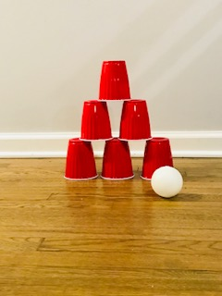

Praise & Worship:
- Song 1: Nothing my God Can Not Do
- Song 2: Super Wonderful (Little Praise Party)
- Song 3: I’m in the Lord’s Army (Heritage Kids)

Key Verse:

1 Samuel 17:47 New International Version (NIV)
⁴⁷ All those gathered here will know that it is not by sword or spear that the Lord saves; for the battle is the Lord’s, and he will give all of you into our hands.”

Bible Story:
- Scripture Reference: 1 Samuel 17:38-50 MSG
- Narrative of Story: Five Smooth Stones
³⁸⁻³⁹ Saul outfitted David as a soldier in armor. He put his bronze helmet on his head and belted his sword on him over the armor. David tried to walk but he could hardly budge.
David told Saul, “I can’t even move with all this stuff on me. I’m not used to this.” And he took it all off.
⁴⁰ Then David took his shepherd’s staff, selected five smooth stones from the brook, and put them in the pocket of his shepherd’s pack, and with his sling in his hand approached Goliath.
⁴¹⁻⁴² As the Philistine paced back and forth, his shield bearer in front of him, he noticed David. He took one look down on him and sneered—a mere youngster, apple-cheeked and peach-fuzzed.
⁴³ The Philistine ridiculed David. “Am I a dog that you come after me with a stick?” And he cursed him by his gods.
⁴⁴ “Come on,” said the Philistine. “I’ll make roadkill of you for the buzzards. I’ll turn you into a tasty morsel for the field mice.”
⁴⁵⁻⁴⁷ David answered, “You come at me with sword and spear and battle-ax. I come at you in the name of God-of-the-Angel-Armies, the God of Israel’s troops, whom you curse and mock. This very day God is handing you over to me. I’m about to kill you, cut off your head, and serve up your body and the bodies of your Philistine buddies to the crows and coyotes. The whole earth will know that there’s an extraordinary God in Israel. And everyone gathered here will learn that God doesn’t save by means of sword or spear. The battle belongs to God—he’s handing you to us on a platter!”
⁴⁸⁻⁴⁹ That roused the Philistine, and he started toward David. David took off from the front line, running toward the Philistine. David reached into his pocket for a stone, slung it, and hit the Philistine hard in the forehead, embedding the stone deeply. The Philistine crashed, facedown in the dirt.
⁵⁰ That’s how David beat the Philistine—with a sling and a stone. He hit him and killed him. No sword for David!
Bible Activity for Infants: Maracas

Supplies Needed:
-Plastic eggs. (Easter eggs)
-Plastic spoons.
- Fun and Colorful duct tape or washi tape.
- Small stones.
- Hot Glue Gun.
- Kids Bible

NOTE: Make a maraca for each baby to play in the classroom and take home after class.

Directions:
Put stones inside the egg. Don’t put too many stones inside the egg, you want the stones to be able to move around.
Use a hot glue gun to go around the inside rim of the top egg and place it onto the bottom wiping away any excess glue. Be sure the two halves meet up and are closed tightly. Allow to dry.
Once you have filled and sealed the egg, place it between two plastic spoons and wrap a few times in duct tape or washi tape.
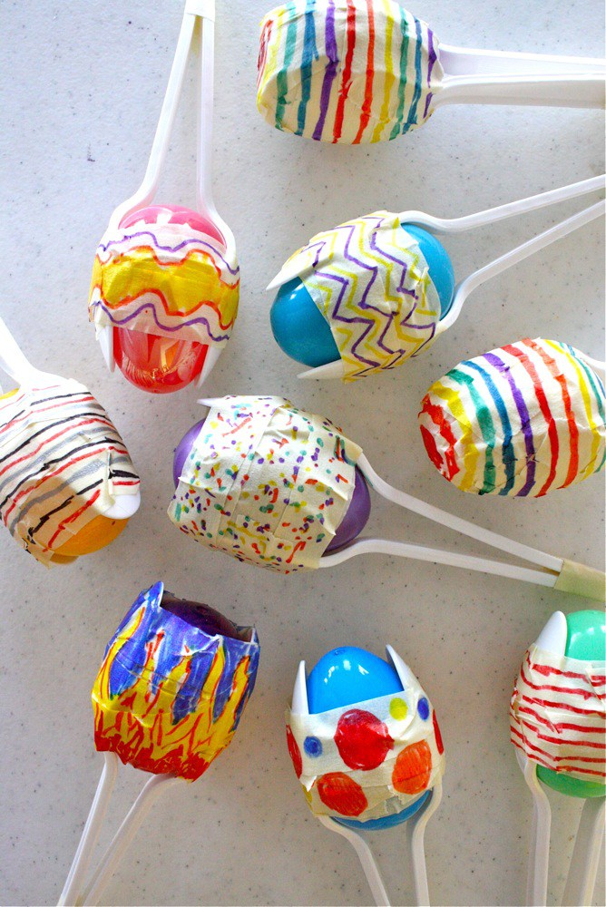
Read the bible story of David and Goliath with the baby, talk about the pictures. Tell the baby that God will help them defeat any offenses in the same way he helped David to defeat the giant.

Activity taken from athriftymom.com

Bible Activity for Toddlers: Defeating the Giant.

Supplies Needed:
-Kids bible.
-Picture of a giant.
-Small soft ball.
-Kids Bible.

Directions:
Read the bible story of David and Goliath with the kids, talk about the pictures. Tell the kids that God will help them defeat any offenses in the same way he helped David to defeat the giant.
Put a picture of a Giant on the wall, Give the toddlers a small soft ball and encourage them to hit the giant with the ball.

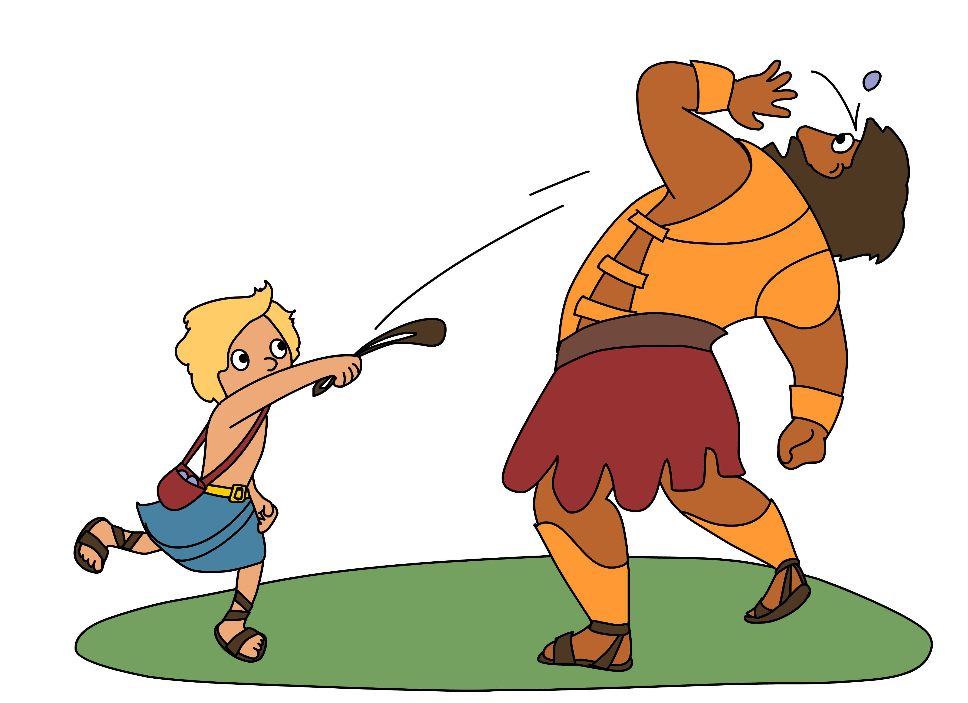

Craft/Make & Take for Toddlers:

Title: David’s Slingshot

Supplies Needed:
-Craft Sticks.
- Small pom poms.
- Pipe cleaners.
- Construction Paper Sheets.
-Black Marker.
- Glue.
Directions:
-Write the Key Verse on the paper with a black marker.
-Wrap the pipe cleaner around the craft sticks and help the toddlers glue it on the paper creating a “V” shape, then glue vertically the third craft stick on the paper to form a “Y” shape creating a slingshot.
- Tell the kids to glue the five stones (pom poms) around the slingshot.

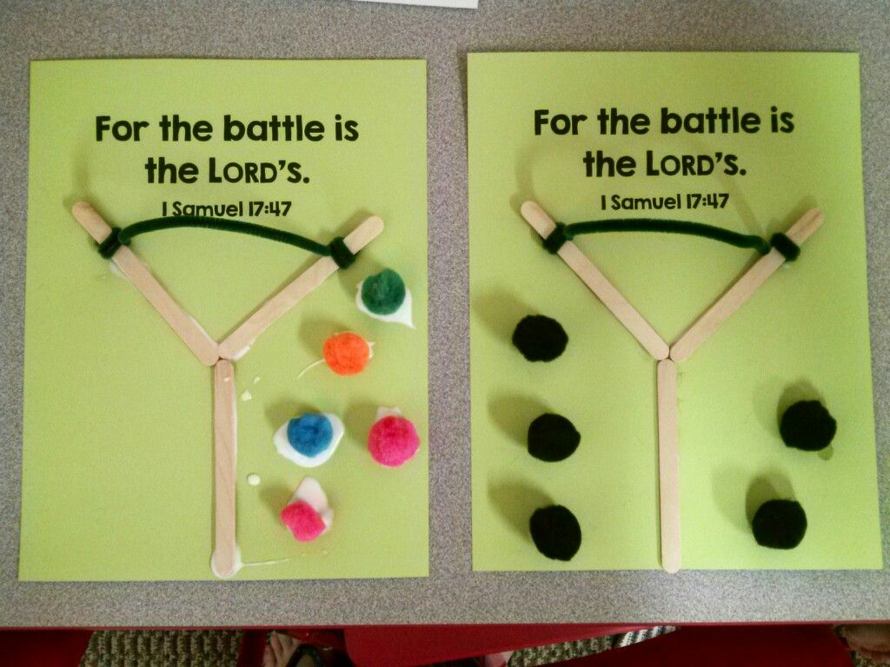
Activity taken from Pinterest.

Closing Prayer:
Asking God to help you face offenses and not run from them.

Faith At Home:
- Description: Teach your kids how to be reconciled after a disagreement with a friend or a sibling.

