Berkeley-Morgan County Health Dept
SOME TIPS FOR OUR FIRST RESPONDER FRIENDS
TO HELP THEM PROTECT THEIR FAMILIES
CLOSED CONTAINERS
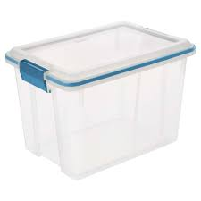
Have a closed container outside your home to put your work clothes in.
When going to wash those clothes, carry it straight to the washing machine and then right back outside.
Have a separate container for your shoes; once you take your shoes off, use hand sanitizer then wash your hands once you get inside.

HOUSEHOLD SURFACES
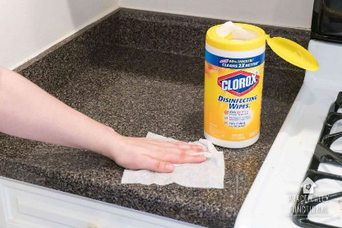
Wipe down countertops and other commonly used surfaces thoroughly and frequently with sanitizing wipes.
When bringing groceries into your home, wipe down all canned goods & other food items if possible, prior to putting them away & then wipe down the counterspace the groceries were on.
This Photo by Unknown Author is licensed under CC BY-SA-NC
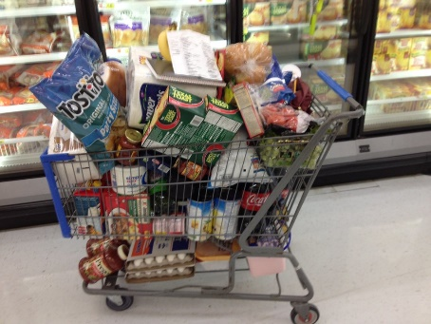

Something to think about…
We know that COVID-19 lives on surfaces for hours to days and is easily killed with proper cleaning methods. Droplets live on surfaces for hours as they are smaller and dry faster. The virus can live for days in sputum, as it takes longer to dry up, and still has viable virus in it if it is wet.

How much human spit do we walk through in ONE workday? Shoe hygiene is important to prevent us from exposing ourselves!

