SPECIAL MEETING
SEPTEMBER 27, 2018

A Special Meeting of the Town Board of the Town of Hampton, County of Washington and the State of New York was held at the Town Hall, 2629 State Route 22A, Hampton, New York on the 27th day of September, 2018.

PRESENT: David K. O’Brien-----------Supervisor
Tamme Taran----------------Councilwoman
Donald Sady-----------------Councilman
Andrea Sweeney------------ Councilwoman
Roger Weeden---------------Councilman
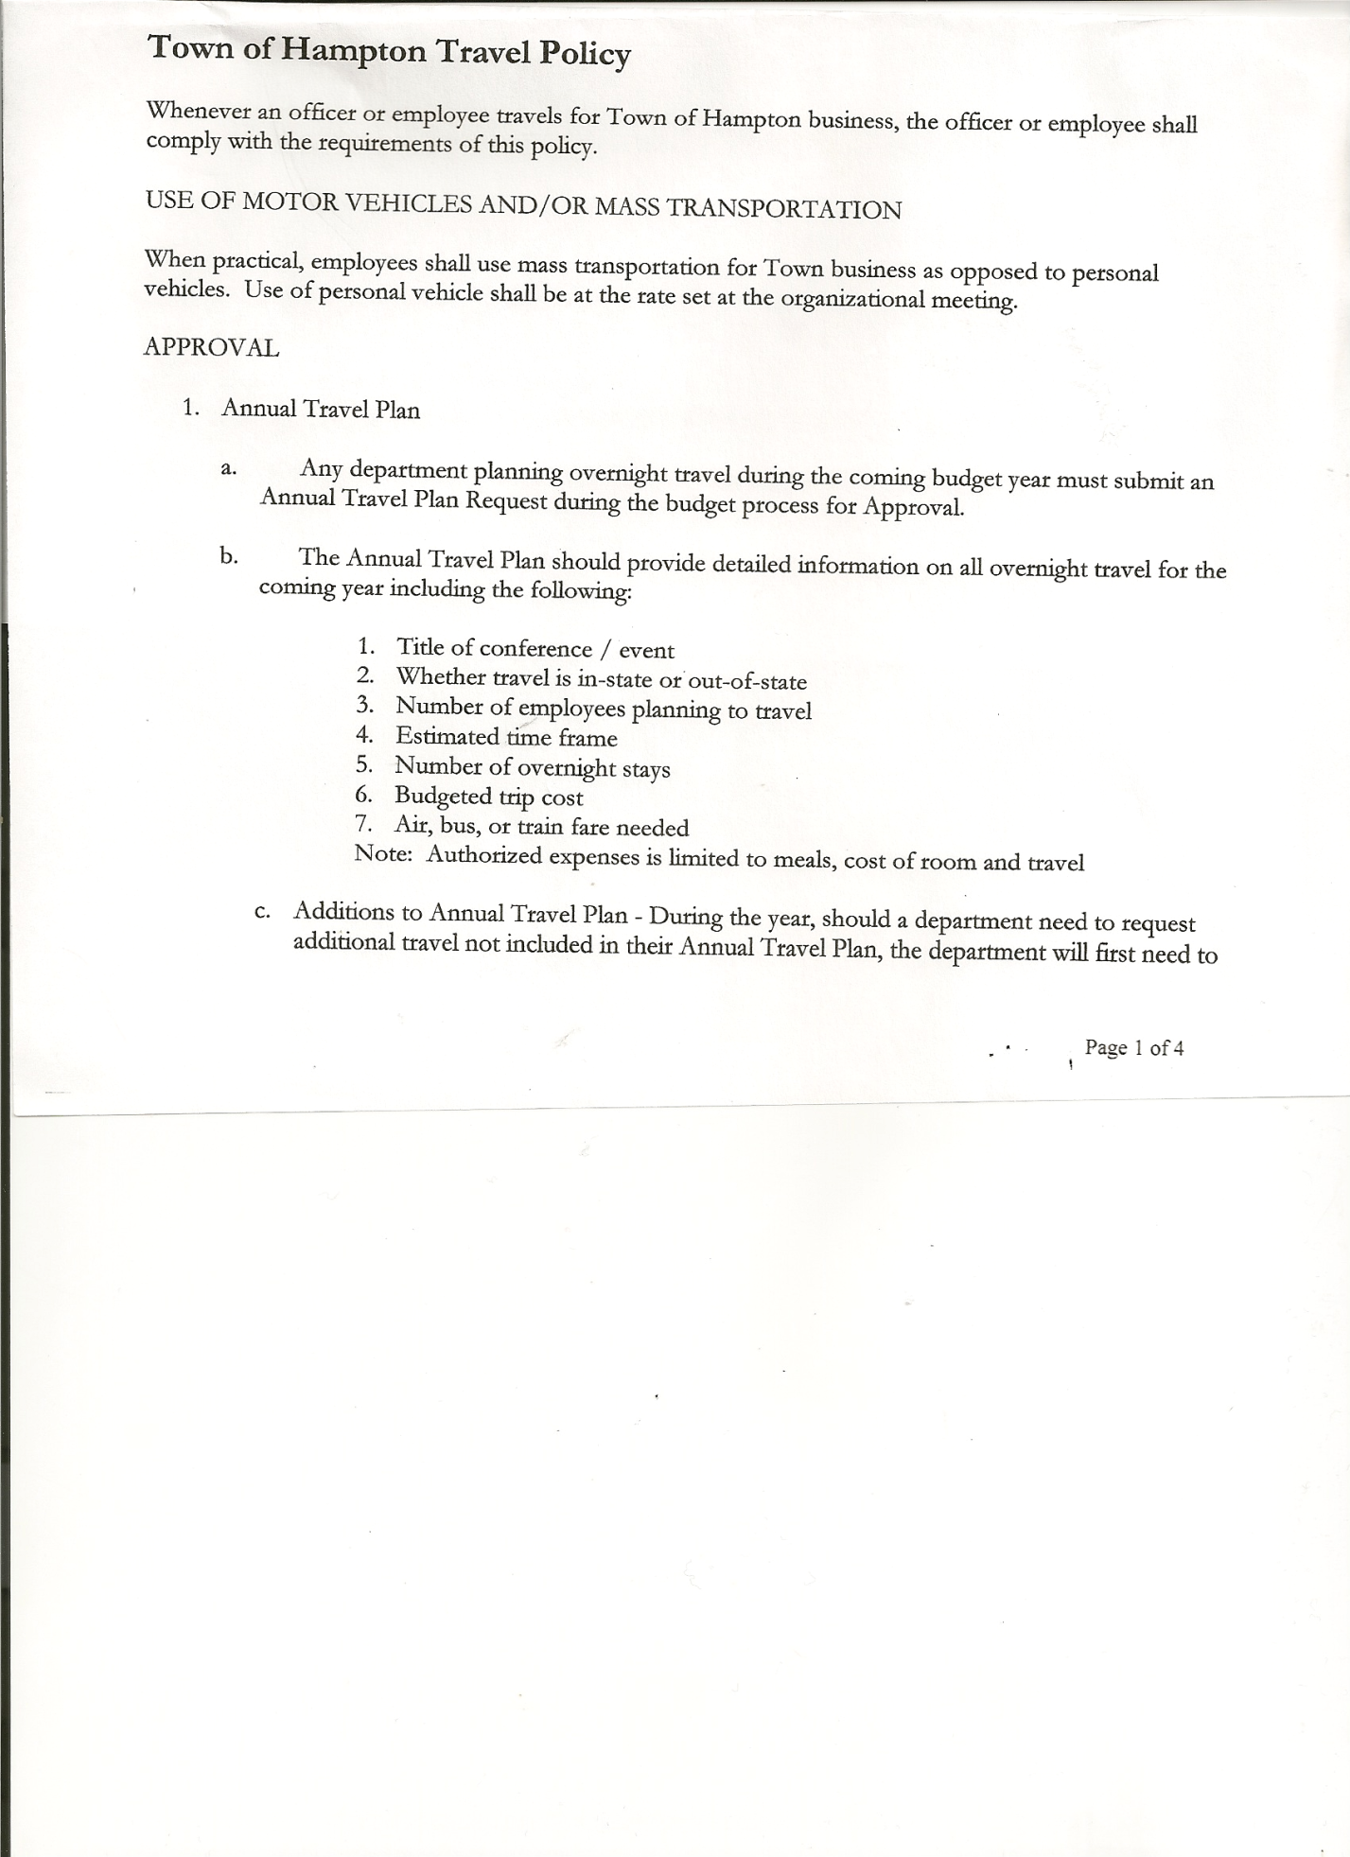
Rebecca Jones---------------Town Clerk
Camilla Shaw----------------Tax Collector/Deputy Town Clerk
Herbert Sady, Jr.-------------Highway Superintendent

Planning Board Members: Bonnie Hawley, Chairperson; Renee Rountree & Matthew Pratt

Also present: See attached list

The Special Meeting was called to order by Supervisor O’Brien at 7:34pm, followed by the Pledge of Allegiance. Location of Fire Exits were given. Quorum of board members present.

Supervisor O’Brien went thru the Budget process

RESOLUTION NO. 63-2018

MOTION BY: Councilwoman Andrea Sweeney
SECONDED BY: Councilman Roger Weeden

RESOLUTION INTRODUCING PROPOSED LOCAL LAW
TO OVERRIDE THE TAX LEVY LIMIT ESTABLISHED IN GENERAL MUNICIPAL LAW SECTION 3-c

WHEREAS, pursuant to Section 10 of Municipal Home Rule Law, the Town Board of the Town of Hampton (the “Town”) has the authority to adopt local laws; and

WHEREAS, pursuant to General Municipal Law Section 3-c, the Town Board of the Town of Hampton has the authority to adopt a budget that requires a tax levy that is greater than the tax levy limit for the coming fiscal year by adopting a local law by a vote of sixty percent (60%) of the total voting power of the Town Board of the Town to override such limit for such coming fiscal year only; and

WHEREAS, a proposed Local Law has been prepared by the Town Attorney, a copy of which is attached hereto; and

WHEREAS, the Town Board is desirous of proceeding with the review and consideration of this proposed Local Law.

NOW, THEREFORE BE IT RESOLVED that the proposed Local Law is hereby accepted for introduction to the Town Board. A public hearing shall be scheduled for the consideration of the proposed Local Law to be held by the Town Board on October 18, 2018 at 7:00p.m. at the Town Hall located at 2629 State Route 22A, Hampton, New York. Copies of the Local Law shall be available at the Town Clerk’s office for review; and be it further

TOWN BOARD MEETING
SEPTEMBER 27, 2018 PAGE 2

RESOLVED, that the Town Clerk is directed to post and publish a notice of said public hearing in the Manchester Newspapers (The Granville Sentinel/The Whitehall Times) at least five (5) days before the hearing; and be it further

RESOLVED, that the consideration and proposed adoption of this Local Law is an action under the New York State Environmental Quality Review Act (SEQRA). The Town Board hereby declares that this action is a Type II action pursuant to 6 NYCRR 617.5(20) and (27) and declares that the action does not have a significant impact on the environment and the action is hereby precluded from further environmental review; and be it further

RESOLVED, that this resolution shall take effect immediately.

DATED: September 27, 2018 Supervisor O’Brien AYE
Councilwoman Taran AYE
Councilman Sady AYE
Councilwoman Sweeney AYE
Councilman Weeden AYE

RESOLUTION NO. 64-2018
PUBLIC HEARING ON HAMPTON FIRE DISTRICT NUMBER 1
On a motion of Councilman Sady, seconded by Councilwoman Sweeney, the following resolution was ADOPTED: AYES 5 O’Brien, Taran, Sady, Sweeney, Weeden
NAYS 0
RESOLVED, to set the Public Hearing to discuss the proposed contract between the Town on behalf of the Town of Hampton Fire Protection District Number 1 and the Hampton Volunteer Fire Company for October 18th, 2018 at 7:15pm.

RESOLUTION NO. 65-2018
PUBLIC HEARING ON HAMPTON FIRE DISTRICT NUMBER 2
On a motion of Councilman Sady, seconded by Councilwoman Sweeney, the following resolution was ADOPTED: AYES 5 O’Brien, Taran, Sady, Sweeney, Weeden NAYS 0
RESOLVED, to set the Public Hearing to discuss the proposed contract between the Town on behalf of the Town of Hampton Fire Protection District Number 2 and the Hampton Volunteer Fire Company for October 18th, 2018 at 7:20pm.

Discussed, reviewed and modified Tentative Budget.
Health Insurance options for Highway Employees was discussed.
Information sheet from the Hampton Volunteer Fire Co., Inc 2018 Budget Facts handed out to Board members.

RESOLUTION NO. 66-2018
ADOPTION OF TENTATIVE BUDGET
On a motion of Councilman Sady, seconded by Councilwoman Taran, the following resolution was ADOPTED: AYES 5 O’Brien, Taran, Sady, Sweeney, Weeden NAYS 0
RESOLVED, that the 2019 Tentative Budget be adopted and becomes the 2019 Preliminary
Budget for the Town of Hampton.

TOWN BOARD MEETING
SEPTEMBER 27, 2018 PAGE 3

RESOLUTION NO. 67-2017
PUBLIC HEARING ON PRELIMINARY BUDGET FOR 2019
On a motion of Councilwoman Taran, seconded by Councilman Sady, the following resolution was ADOPTED: AYES 5 O’Brien, Taran, Sady, Sweeney, Weeden
NAYS 0
RESOLVED, to set the Public Hearing on the Preliminary Budget for 2019 for October 18th, 2017 at 6:30pm.

On a motion of Councilman Sady, seconded by Councilwoman Taran the meeting adjourned at 9:04pm. All in favor AYE.

Respectfully submitted,

Rebecca S. Jones, RMC
Town Clerk

