Line 41 – SANITATION ZONES

Definition of “sanitation zone”….area that is not necessarily your immediate workstation, but an area in the general vicinity that you will be responsible for when you are assigned to the operation.

You should be commended for your outstanding progress toward sanitation this past fiscal year, however, in order to improve upon our current level of cleanliness, and to ensure that we are adhering to Good Manufacturing Practices (GMPs) – sanitation zones have been created for each line. In doing so, we can capture the majority of the items that are essential to maintaining GMPs, as well as, making sure that items subject to audit are being monitored, and cared for on a regular basis. If you anticipate, or advised that the line will be down for an extended period, please take the opportunity to familiarize yourself with the photos below to grasp what each sanitation zone looks like for the operations on Line 41. If the situation dictates or if your supervisor instructs you – clean your zone accordingly, i.e. wipe down stainless, clean floor, put away items that are out of place, store lubricants in the appropriate cabinet, etc. If you have any questions at all about what to do in your sanitation zone, do not hesitate to ask your TA.
Keep up the GREAT work!!!

UNCASER – From unscrambler through accumulation table, green mile, to electrical cabinets
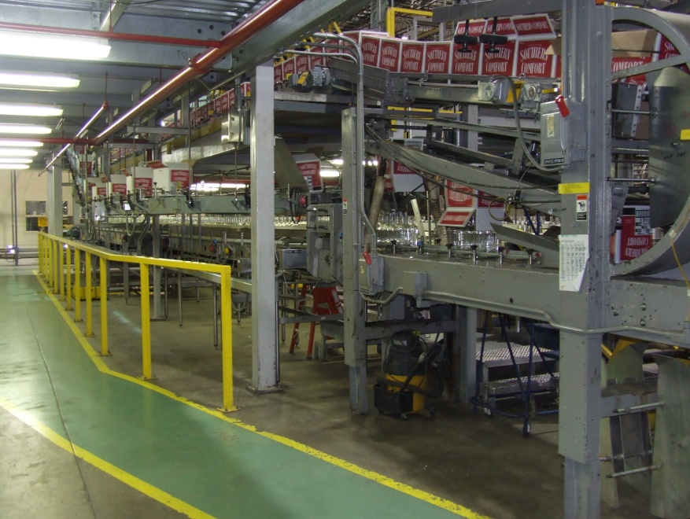
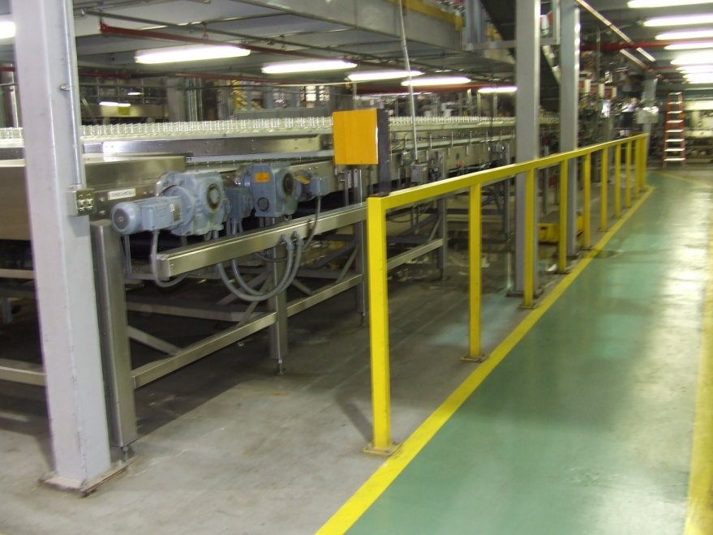
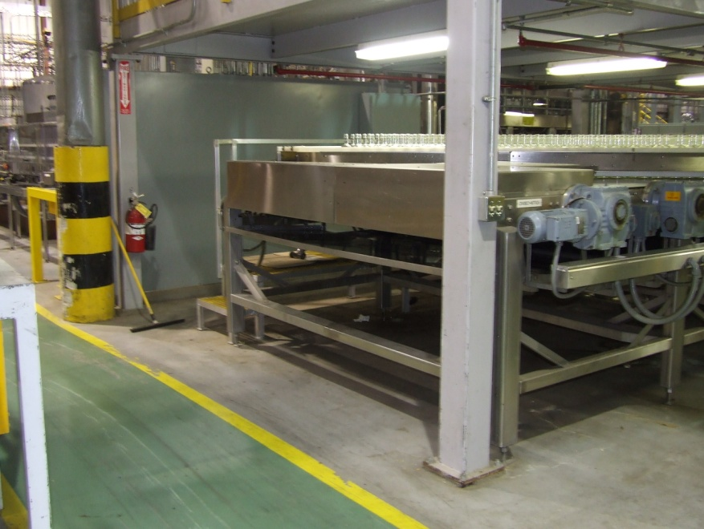
FILLER – Entire area from green mile to full bottle accumulation, from electrical cabinets to green mile on opposite wall

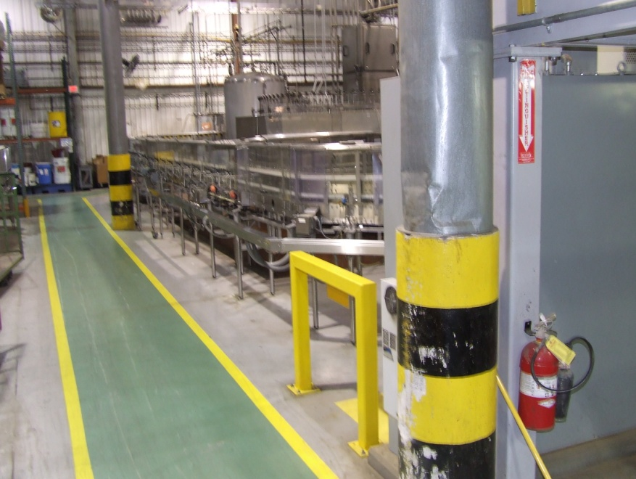
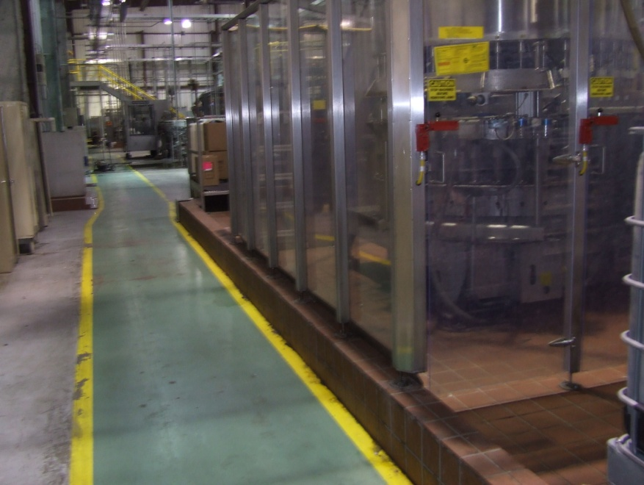

LABELER – Orientor to second heat tunnel, including full bottle accumulation
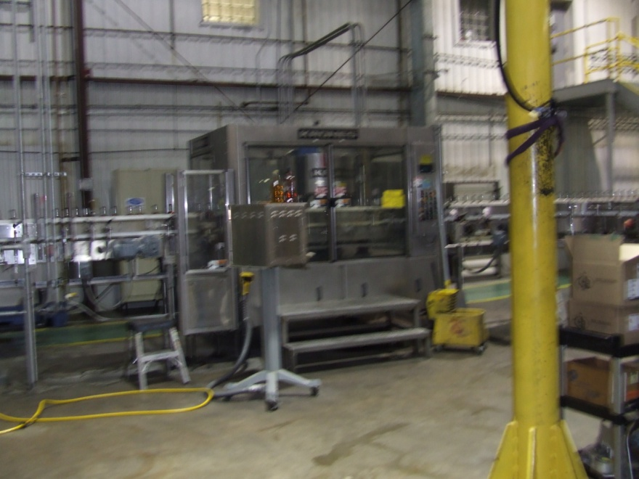 Orientor
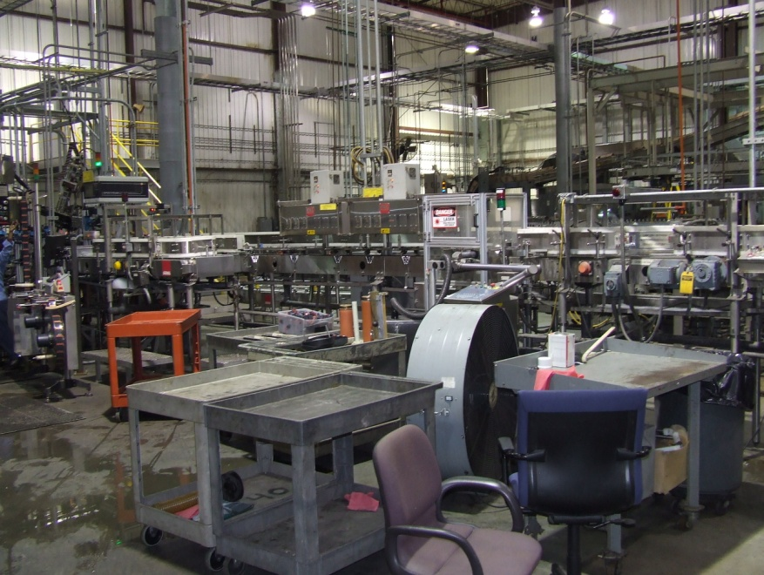 1st Heat Tunel
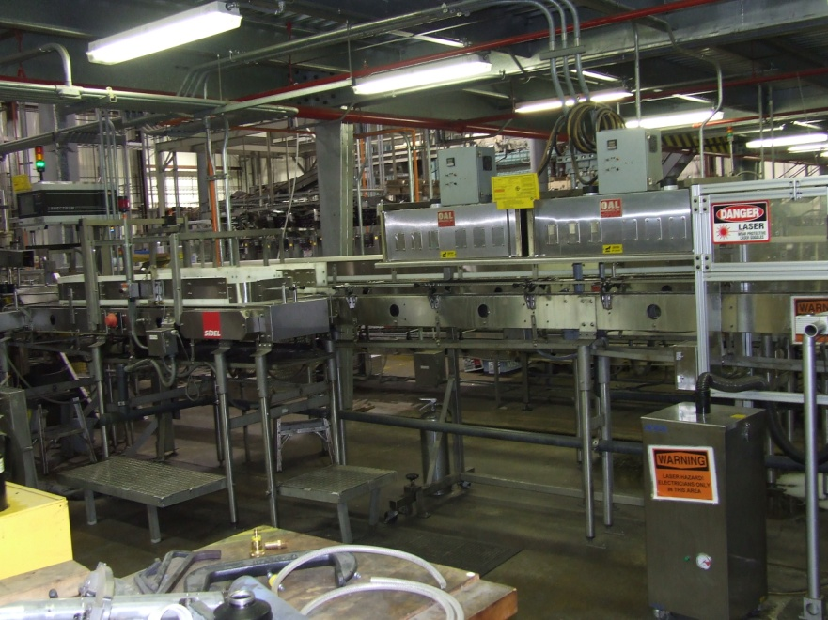 2nd Heat Tunnel

MONITOR – to end of line and around to case decline

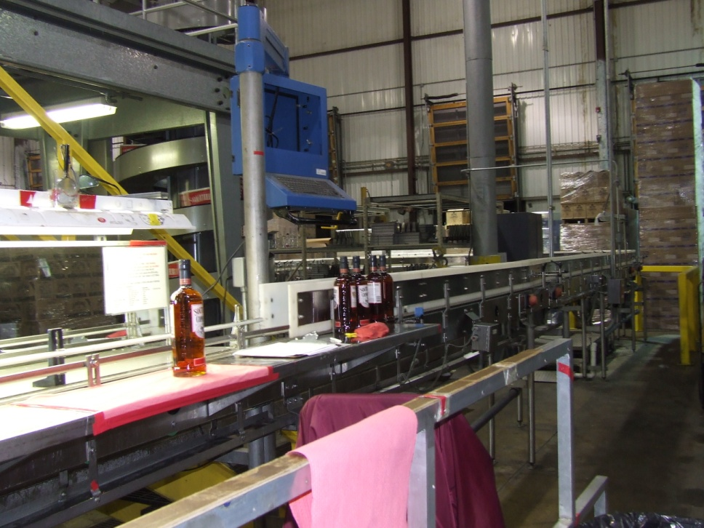
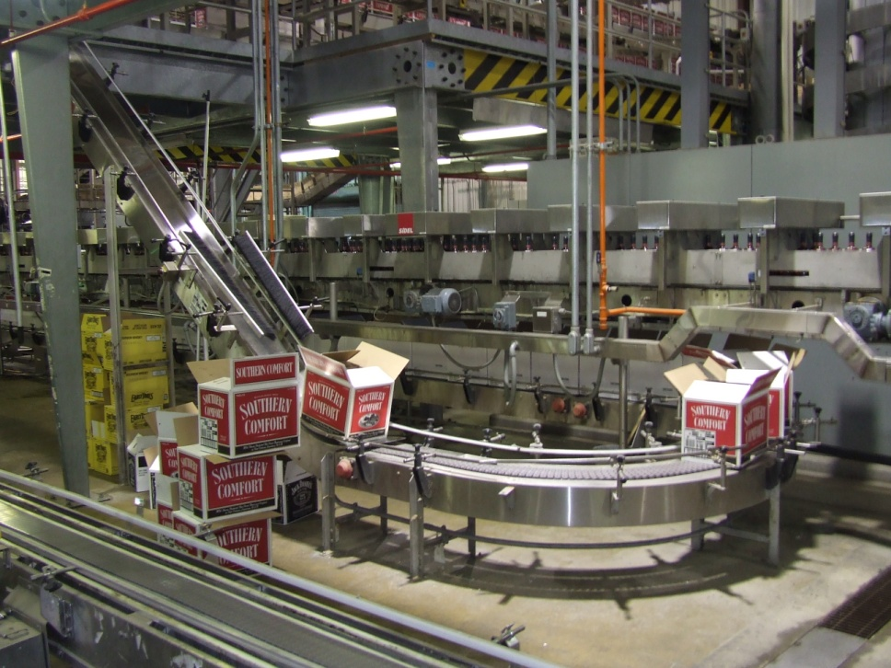

PACKER – wall behind stairs to Hueft laner, labeler to line 42
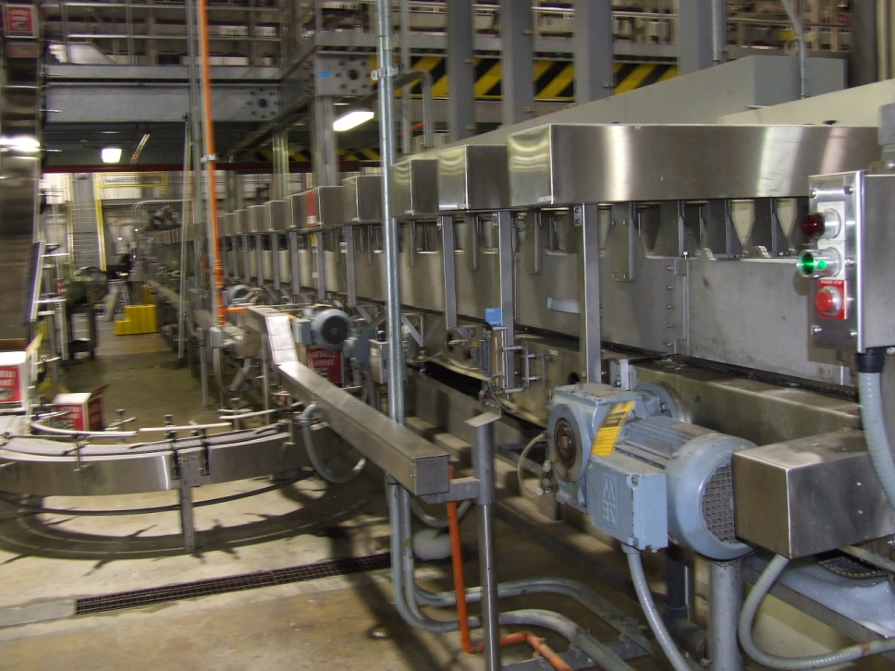
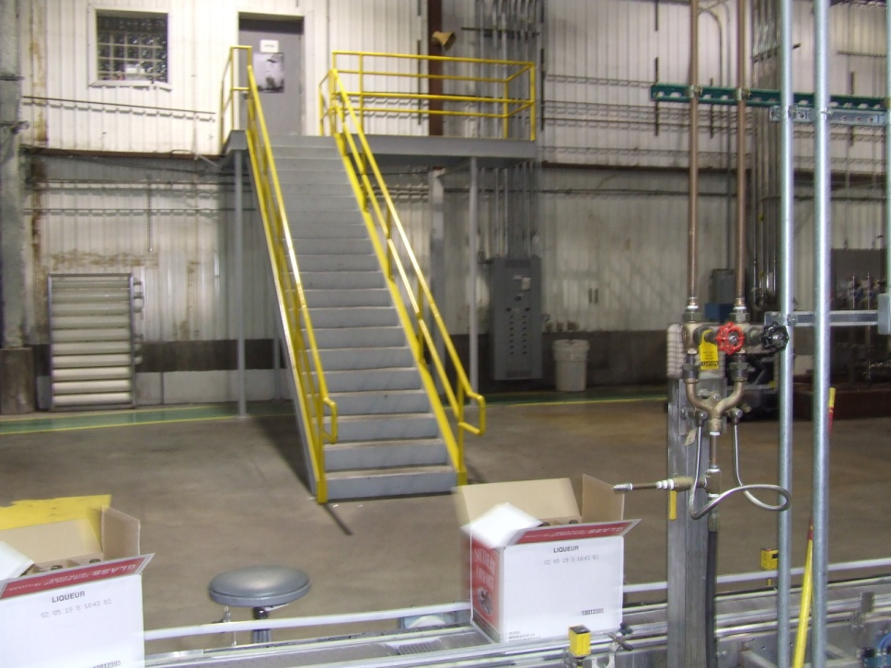

DISTRIBUTION –
-Rachel Hampton
-Diane Patton
-Stephanie Willing-Hurst
-Michael Beeler
-Benjamin Brodufuer
-Janis Bibb
-Booker Jones

