Assertive Communication Format

Sending

When I feel

Behavior Feeling
Because .
Impact or loss the behavior has caused

I want, I would like, I request

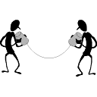

Reflective Listening


Sounds like you feel

I am hearing .

