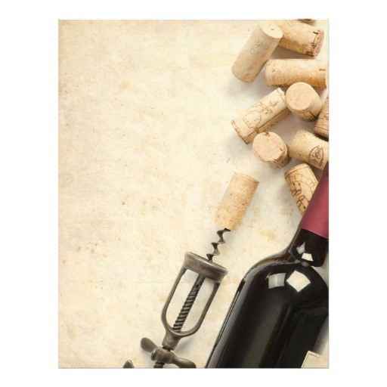

Scampi e Ortaggi

Skewers of shrimp, and vegetables of our garden with orange Agrumato

Pairing Wine:

Pinot Grigio, Sant Helena -Friuli

----------

Focaccia con Uva

Grilled Italian flatbread, Fiorucci prosciutto, goat cheese, grape marmalade

Pairing Wine:

Barbera, Giacomo Borgogno-Piemonte

----------

Gnocchi alla crema di Zucca

Homemade gnocchi, roasted pumkin,pancetta,

Pairing Wine:

Aglianico, Teodosio-Basilicata

----------

Arrosto di Lonza

Tuscan Porchetta style pork loin filled with sausage, fennel rosemary in bed of braised Tuscan kale cannellini beans

Pairing Wine:

Rigoleto, Colle Massari-Toscana

----------

**Crepes con la Crema di Ricotta e Prugne**

Finish the evening with a glass of deceptively simple yet seductive handcrafted **Limoncello from Chef Nicola**

Wednesday, September,30th, 2015

7:00 ~ 9:00 | $49 per person

Harvest Wine Dinner