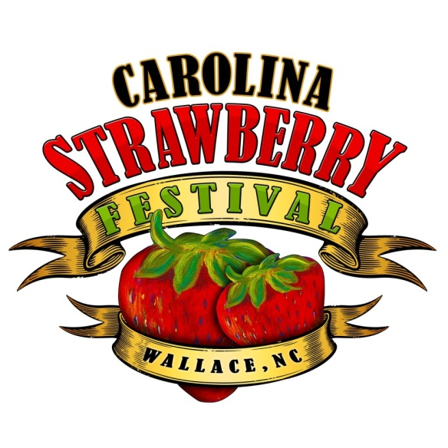

5th Annual Recipe Contest

The Carolina Strawberry Festival will be hosting the 5th annual Strawberry Recipe Contest. The contest will be held on Friday, May 8, 2015, at the Wallace Woman’s Club Building. Cash prizes will be awarded in 4 categories.

Strawberry Competition Rules:
1. The contest will be divided into categories, as follows-
- Appetizers, Salads, and Entrees
- Breads ( biscuits, muffins, breads, scones)
- Desserts (cobblers, crisps, cakes, pies, cookies, candy)
- Youth (recipe featuring strawberries)

2. Each entry must be original and contain at least 1 cup of fresh, NC Strawberries.

3. Type your recipe and submit with the Strawberry Entry on the day of the event. Recipe must include ingredients, correct sizes of measurements, and method of preparation. The recipe becomes the property of the Carolina Strawberry Festival. Additionally, email your recipe to susancarone@live.com

4. The recipe should include the participant’s name, address, and daytime/evening phone number in the upper right hand corner of the recipe page on an 8 ½ by 11 sheet of white paper.

5. One entry per person will be allowed in each category.

6. Prepared recipes will be received at the Wallace Woman’s Club building on Friday, May 8, between 12 noon and 2:00 PM. The judging will take place from 3:00 PM to 5:00 PM. The exhibit will be closed to the public during judging.

7. Participants must collect their dishes from 5:00-7:00. No food will be returned to contestants.

Winners of each category will be awarded cash prizes as follows:
1st $50.00
2nd $25.00
3rd $15.00
Overall Best In Show $75

8. Winners will be announced at the Carolina Strawberry Festival, on Saturday, May 9th during the opening ceremony, beginning at 11:00 AM. Awards will be mailed to the address provided.

9. Entries will be judged on the following:
- Taste/Appeal 35%
- Presentation 25%
- Originality/Creativity 20%
- Ease of Preparation 20%

For more information, please contact
Susan Carone at 910-296-4316

