Ladies in Training:Session 5– December 5th, 2014
Today’s lesson was all about food!
Academics
Today, we learned about the different ways to pronounce, read, and write french words that were all about food! Simple ingredients like bread and milk were taught to the class, and afterwards we learned their different pronunciations. In the end, we took a little quiz to see how everyone did!
Creative and Teamwork Skill
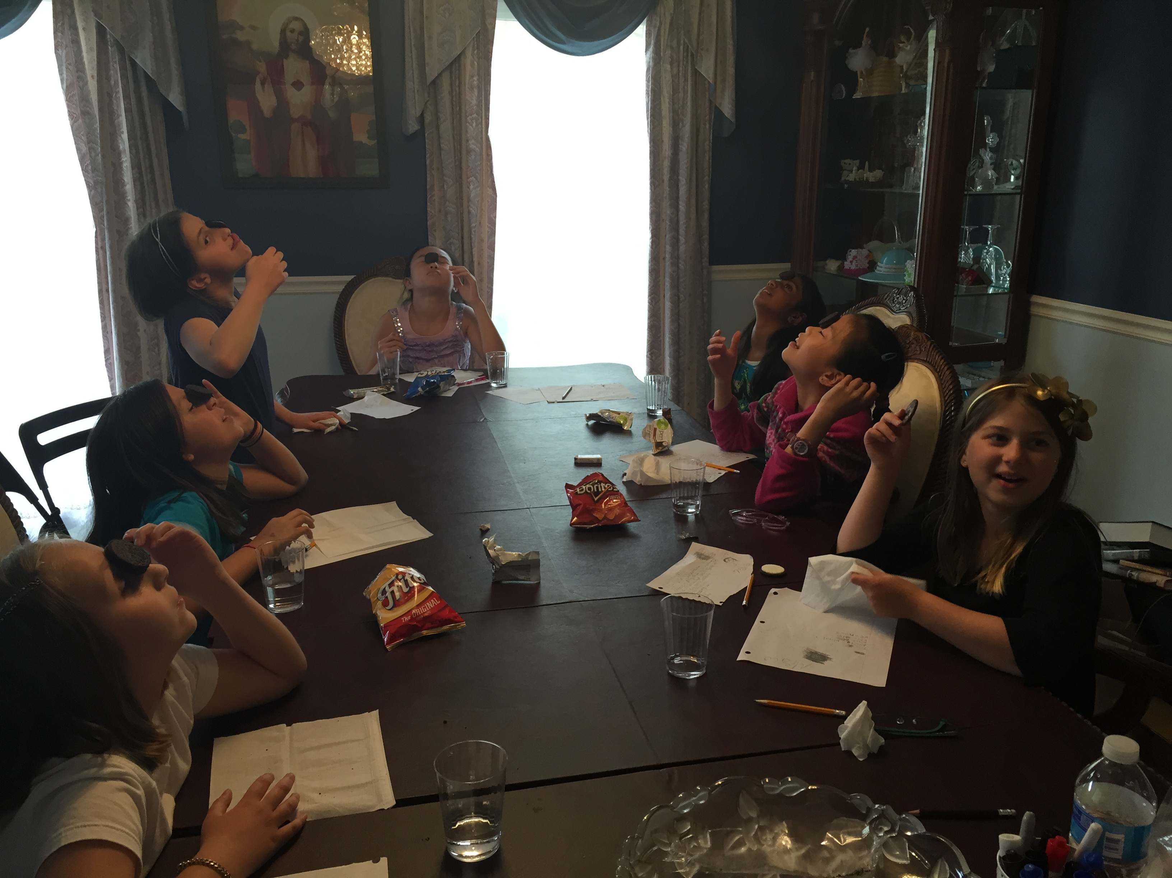
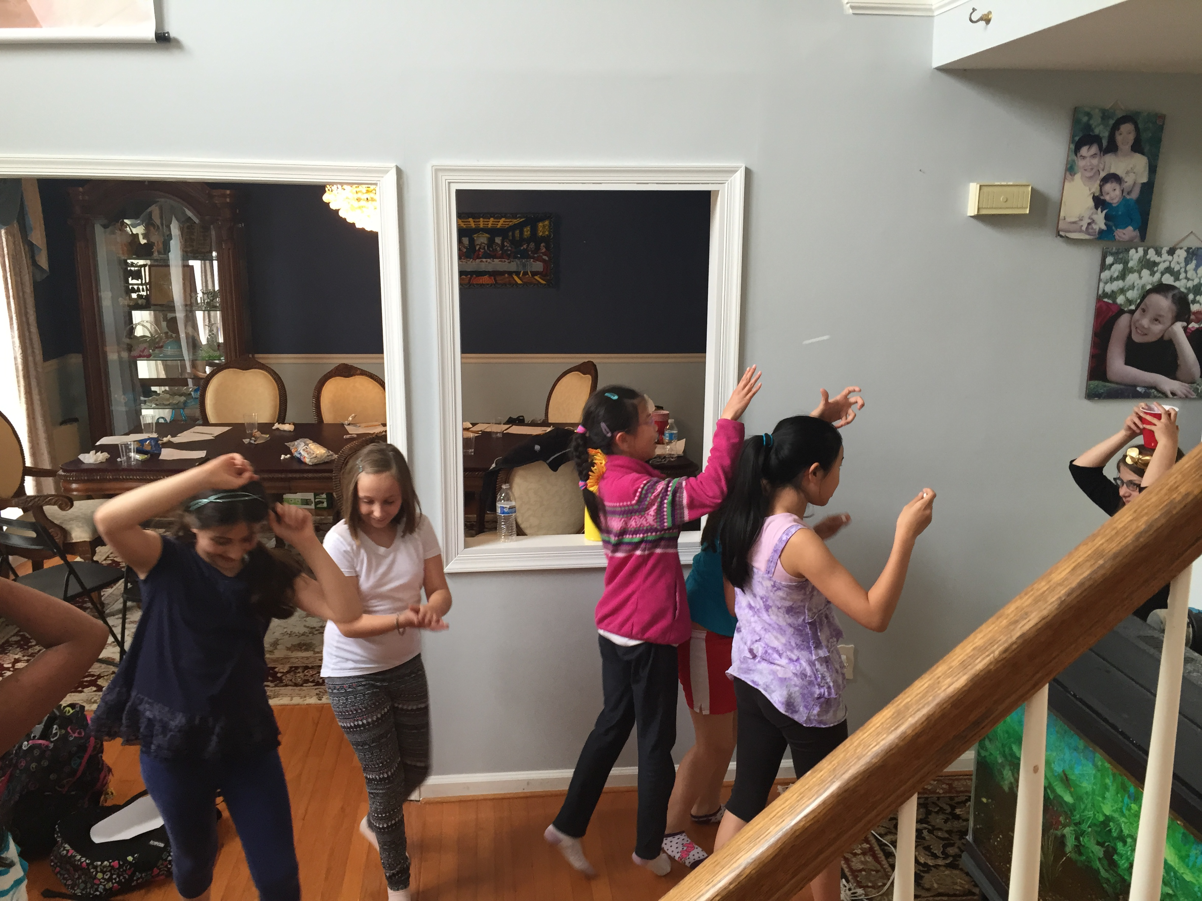
Since this week was all about food, we led the girls in three different food related activities: some just for fun, while others associated with teamwork skills. First, we had an oreo eating competition, but with a catch: they had to eat from their own faces! By sliding the cookie down their face, the girls got to enjoy a delicious oreo cookie.

Next, we played a few bonding exercises. One person placed a cup on their head while the others threw marshmallows from a good distance away. The girls were split into teams and competed to see who could get the most marshmallows into the cups. Afterwards, the girls played a small game where they used straws to blow a plastic cup across a surface. These two activities emphasized healthy competition and teamwork!

