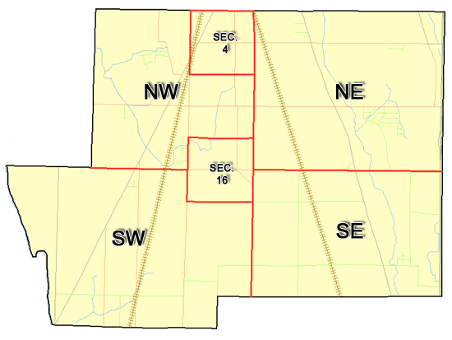 | Pleasant Township  Zoning Commission Minutes  1035 Owens Rd W.  Marion, Ohio 43302
Meeting called by: | Scheduled | Type of meeting: | Regular Monthly
Co-Chairperson: | Mr. Leib | Secretary: | Stephanie Barkley
Timekeeper: |  | Date: Sept 21st,2023 | Time 7:30 pm
Call to Order by: | Mr. Holler Moment of silence followed by the pledge to the flag.
Roll Call: | Jack Dean, Harry Holler, Tom Leib, Dwight Williams, Joe Thompson, Tyron Canterbury  Stephanie Barkley
Minutes: | Read and approve minutes from previous meeting.  Motion to approve minutes by: Mr. Thompson Seconded by Mr. Williams: All approved
Attendees Address Board: Have sign in sheet on desk by door.
Type in attendees and addresses: see attached.
.
----- Agenda Topics -----
Business
Zoning Reports: | Zoning Inspector goes over reports and provides copy to board.
Unfinished:
New:
Announcements: | Next meeting will be Oct 19th, 2023
Adjournment: | Motion to adjourn by: Mr. Williams and seconded by Mr. Thompson all in favor all approved

Pleasant Township
Zoning Commission Minutes

1035 Owens Rd W.
Marion, Ohio 43302
Business Notes:

 | Discussion:
 | Conclusions:
 | Action items: |  | Minutes signed by: | Date approved:
 | Provide copy of approved minutes to Zoning |  | Chairperson:
 | Inspector. File original in township office. |  | Secretary:
Other Information
Trustees Present: |  | Mr. Creasap , Mr. Schrote
Zoning Inspector: |  | Tom Baker
Special Guests:

Minutes
The Pleasant Township Zoning Commission met for their regularly scheduled monthly meeting Sept 21st, 2023, at the Pleasant Township Senior Centre Zoning Commission Board Members were present: Mr. Dean, Mr. Leib, Mr. Thompson, Mr. Williams, Mr. Canterbury, Mr. Holler and Secretary Miss Barkley and Zoning Inspector Tom Baker trustee Mr. Creasap and Mr. Schrote.
- Minutes were read from the Aug 17th, 2023 regularly scheduled Zoning Commission meeting. There were no corrections to be made. A motion to approve the minutes was made by Mr. Williams and second by Mr. Thompson motion carried.
- Mr. Tom Baker Pleasant Township Zoning Inspector gave the Zoning report were 8 permits for August. Mr. Baker requested when updating the zoning book to double check that shipping containers isn’t permitted on properties. The zoning for county wide permit applications process is changing with new forms. Mr. Baker gave the update for the appeal that was passed by the appeals board regarding Rodney Hensel of Hensel Ready Mix wants to put his business on his property, but he needs put up a barrier or fencing on his property with conditional use per the appeals board and will need to come back to the zoning commission board to get this approved. Mr. Baker will be sending out more violations. Mr. Creasap report there was only 1 yard that needed to be mowed that the township was responsible for. After some discussion on how to on how to work on the language on the zoning book Mr. Holler will contact someone from regional planning to see if she able to attend one of the Zoning Meeting.
4. There being no additional business for discussion Mr. Williams made motion to adjourn, seconded by Mr. Canterbury all members in attendance agreed and the meeting was adjourned. The next Board Meeting will be held on Oct 19th ,2023 at 7:30 PM.

