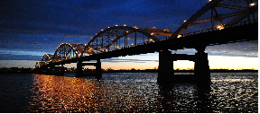
QUAD CITIES MISSING PERSONS NETWORK
TRIVIA NIGHT!
Registration Form

When: Friday, October 23, 2020, 6-10 PM
Where: CASI 1035 West Kimberly Road, Davenport IA 52806
Doors open at 6:00 PM, Game starts at 7:00 PM
Cost: $80.00 per table or $10.00 per person, payable in advance
Cash bar available; food can be brought in
Checks should be made payable to QCMPN, and can be mailed to:
QCMPN, 2754 12th street, Rock Island, IL 61201
(Individuals may be added to tables with less than 8 people)

Team Name: ________________________________________________________
Player 1 ___________________________________________________________
Player 2 ___________________________________________________________
Player 3___________________________________________________________
Player 4 ___________________________________________________________
Player 5___________________________________________________________
Player 6___________________________________________________________
Player 7___________________________________________________________
Player 8___________________________________________________________

