SUNDAY | MONDAY | TUESDAY | WEDNESDAY | THURSDAY | FRIDAY | SATURDAY
2 | 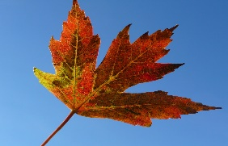  This Photo by Unknown Author is licensed under CC BY-SA-NC  3 | FA  4 | LL  5 | 6  5 | 7 | 1____________  8  1
66 9 | 10 | BRE  11 BOARD MEETING 4PM | AK  12 | 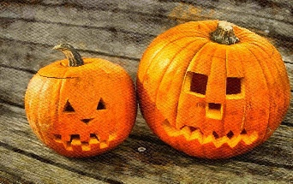  13 | 14 | 15
16 | 17  REPORT CARDS DUE | 18  BOOKMOBILE 2:30 | 19  J.O.Y. 4-5:30pm | 20  3PM  AWARDS ASSEMBLY  St. Patrick’s Day | 21 | 22
eA  23  1 | 24  ************ | 25  ******* PAPA | 26  MURPHY’S  J.O.Y. 4-5:30pm  pm | 27  FUNDRAISER | 28 | 29
30 | 31  HAPPY HALLOWEEN  HARVEST FESTIVAL  2 – 3:30PM |  | 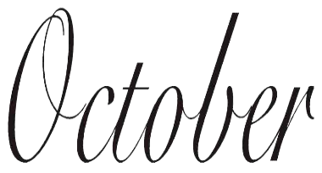  nownun | 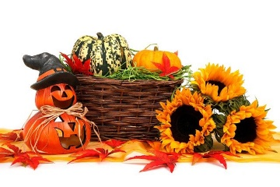
AUTUMN CARRIES MORE GOLD IN ITS POCKET THAN ALL THE OTHER SEASONS
10/3 – 10/13 NO SCHOOL
10/20 AWARDS ASSEMBLY 3PM
10/24 -27 PAPA MURPHY’S FUNDRAISER ONLINE SALES ONLY USE PROMO CODE GIVE40
10/31 HARVEST FESTIVAL 2-3:30PM

