Lancashire Local History Federation  ‘At Home’  with Ribchester Local History Society  in Ribchester Village Hall  Saturday 10th June 2023  Programme  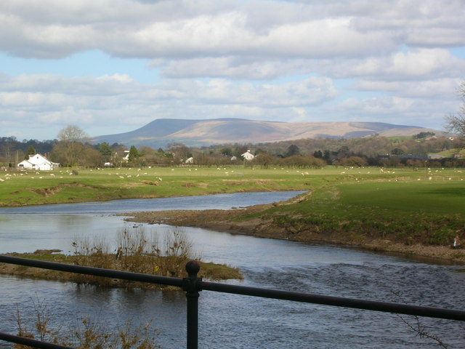  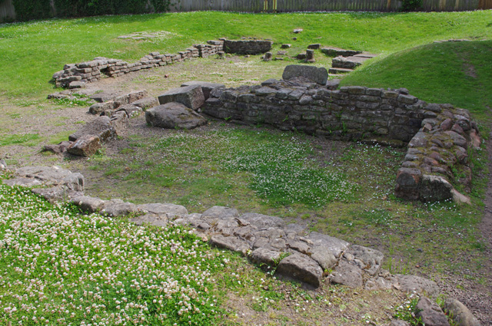 | 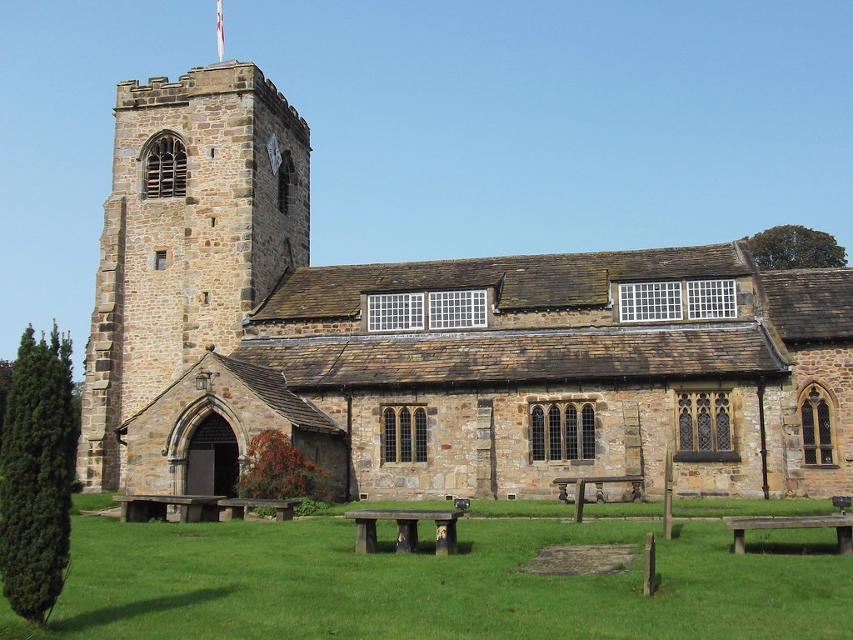
9.30-9.50am - Arrival and registration with refreshments
9.50- 10.00am Welcome and outline of the day
10.00-11.00am – Speaker 1: Dr Jim Morris
‘The Ribchester Archaeological Project’
11.00 – 11.30am – break
11.30-12.30pm - Speaker 2: Sir Peter Openshaw KC
‘St Saviours Stydd’
12.30- 1.15pm – Lunch
1.15- 4.00pm Visit to Ribchester Roman Museum (entry included in ticket)
Visit to St Wilfrid’s Church
Guided Ribchester Village trail including visit to St Saviours Stydd
Exhibition in Village Hall: ‘Mills of the Ribchester and Knowle Green’

Speakers and contributors :
Dr Jim Morris: Senior Lecturer in Archaeology UCLAN. Dr Morris directed the Ribchester Project and archaeological dig in Ribchester 2014- 19.
Sir Peter Openshaw KC: Sir Peter has a keen interest in the history of the Ribchester area and has researched various topics relating to the area.
Roy Skilbeck: Roy is the Societys’ President and an authority on the history of Ribchester area. Roy Skilbeck has produced the exhibition and will be available to answer questions.

Ribchester Local History Society
Email: ribchesterlhs@gmail.com
https://e-voice.org.uk/ribchesterhistory/

The Venue: Ribchester Village Hall PR3 3XS

Directions:
From A59 :
Follow signs for Ribchester from the lights on A59
Cross the river Ribble and continue into the village. At the T-junction by the Black Bull public house turn left onto Church street. *Take the next right for Pope’s Croft public pay and display car park.
Once parked, return to Church street and turn right. Follow the road passed the White bull public house towards the river and continue as the road bends to the right. Pass the Rectory and the Village hall is off the small car park on your right next to the museum. This car park is for church use and has limited space so we request that these spaces are left for those with mobility difficulties.

From Longridge:
Enter Village and go straight on at the T-junction between the Black Bull and Spar. Then follow directions detailed above from *.

Map to be inserted

‘At Home’ with Ribchester Local History Society
Saturday 10th June 2023

Please complete all sections and post to be received by Thursday 25th May 2023 to:
Mrs Alison Forde, 4, Eastgate, Ribchester, Preston PR3 3ZN
Or Email: ribchesterlhs@gmail.com

Please print clearly in capital letters
Please note price includes entry to Ribchester Roman Museum
Please reserve ………….. places with finger buffet lunch at £22 per person ……………………..
Please reserve …………..places without lunch (but inc. tea/ coffee) at £15 per person……….
Special access/ parking requirements……………………………………………………………………………….
Special dietary requirements…………………………………………………………………………………………….
Cheque enclosed for……………… made payable to Ribchester Local History Society

Name(s)……………………………………………………………………………………………………………………………
…………………………………………………………………………………………………………………………………………
Contact address:………………………………………………………………………………………………………………
………………………………………………………………………………………………Tel: ………………………………….
Email: ………………………………………………………………………………………………………………………………
Confirmation and further details will be sent by email whenever possible

