REGULAR MEETING
FEBRUARY 20, 2020
A Regular Meeting of the Town Board of the Town of Hampton, County of Washington and the State of New York was held at the Town Hall, 2629 State Route 22A, Hampton, New York on the 20th day of February 2020.

PRESENT: David K. O’Brien------------Supervisor
Tamme Taran----------------Councilwoman
Donald Sady-----------------Councilman
Andrea Sweeney------------Councilwoman
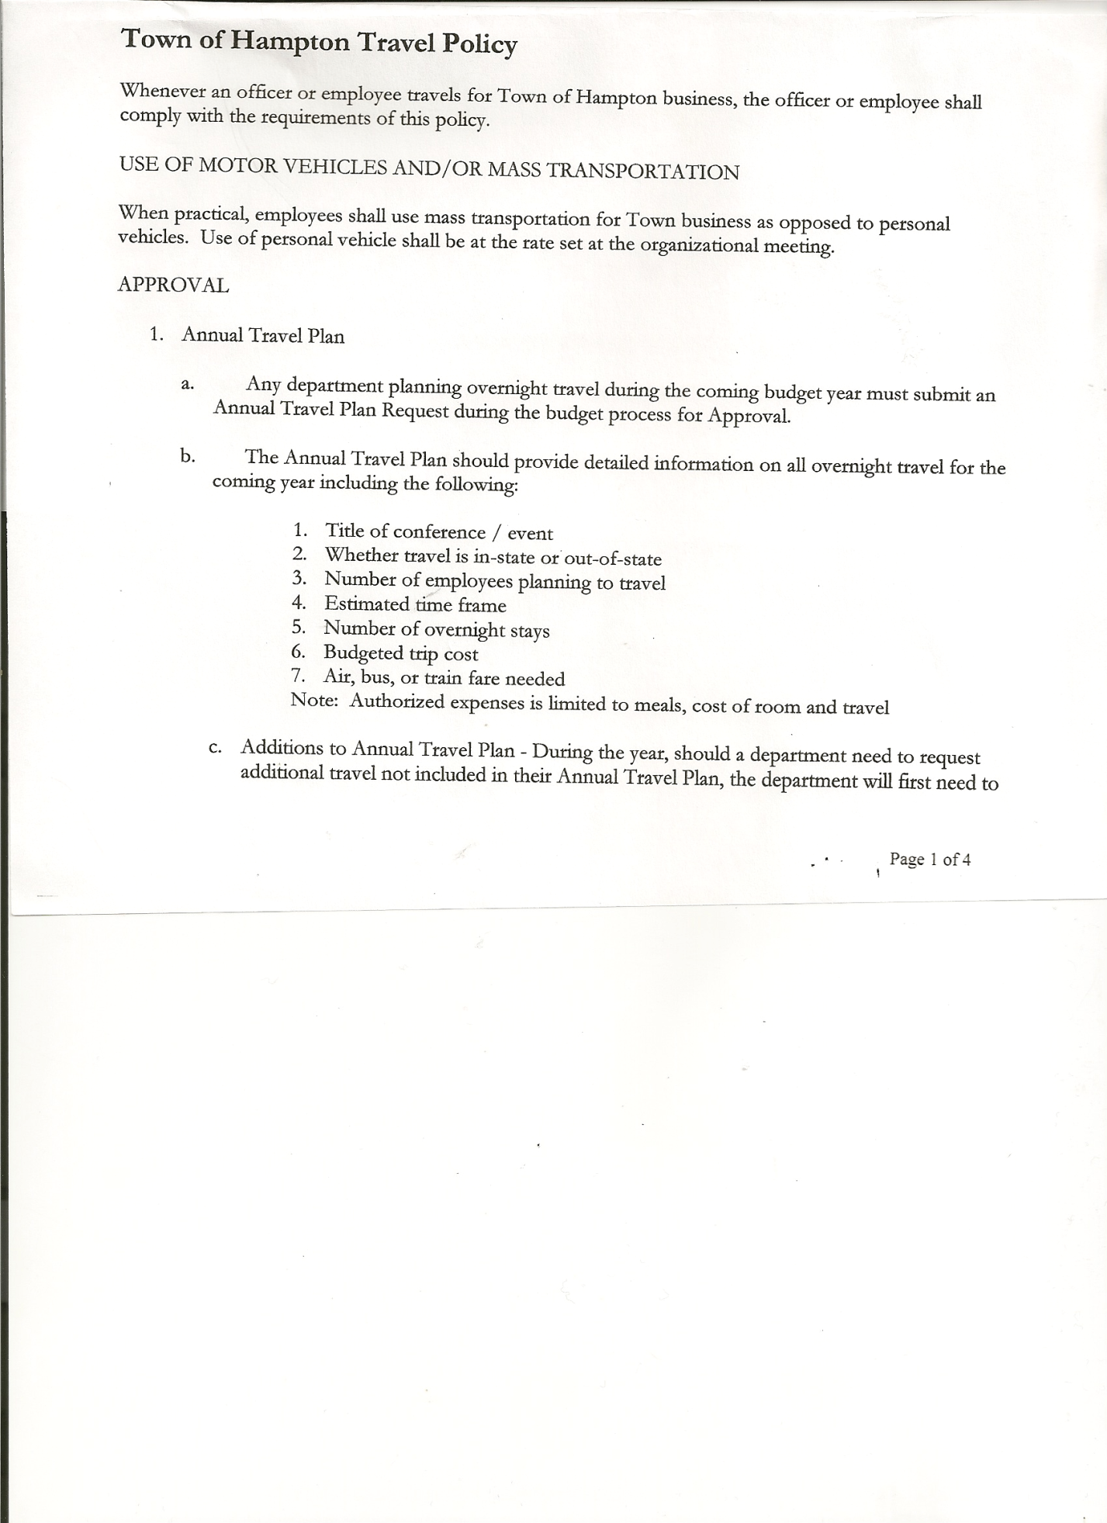
Michael Pietryka------------Councilman - absent
Rebecca Jones---------------Town Clerk
Camilla Shaw----------------Tax Collector/Deputy Town Clerk
Herbert Sady, Jr.-------------Highway Superintendent

Planning Board Member(s): Bonnie Hawley, Matthew Pratt and Renee Rountree

Also present: Richard Cole, President-Hampton Fire Co.;
Tyler McClure, Hampton Highway Employee;
Matthew Saari, Reporter with Manchester Newspapers and
Artie Pratt

The Regular Meeting was called to order by Supervisor O’Brien at 7:30pm, followed by the Pledge of Allegiance. Location of Fire Exits were given. Quorum of board members present.

Supervisor O’Brien asked for a moment of silence in memory of James Mead, Jr. (Jimbo),
Patti Horvath and Raymond Packard.

RESOLUTION NO. 18-2020
APPROVAL OF THE MINUTES
On a motion of Councilwoman Taran, seconded by Councilman Sady, the following resolution was ADOPTED: Ayes 4 O’Brien, Sady, Taran, Sweeney, Pietryka
Nays 0
Absent 1 Pietryka
RESOLVED, that the Regular Town Board Minutes for January 16th, 2020 are approved.

Larry Carman, Dog Control Officer submitted his report, which was read by Supervisor O’Brien, copy of report is attached for 01/12/20-02/15/20

Camilla Shaw, Tax Collector – 575 parcels have been paid. Submitted January 2020 report to the Board. Also submitted Bank Statement to the Board for review and signatures.

Bonnie Hawley, Chair gave Planning Board Report…
Copy of report is attached.
- Town Historian John Mead is planning on coming to March Planning Board
Meeting to discuss the history of the Town
- Next meeting will be February 26th, 2020 @ 7:00pm at the Town Hall.

TOWN BOARD MEETING
FEBRUARY 20, 2020 PAGE 2

Herbert Sady, Jr., Highway Superintendent submitted his report, copy of which, is attached.
- Regarding the figures received for Extended Warranty on the 2020 Western Star from Tracey’s….
$2450.00 5 year 100,000 miles or
$4315.00 7 year 100,000 miles
Herb found out that Labor is included in the above figures. The following resolution was introduced.
RESOLUTION NO. 19-2020
EXTENDED WARRANTY-APPROVED
On a motion of Councilman Sady, seconded by Councilwoman Sweeney, the following resolution was ADOPTED: Ayes 4 O’Brien, Sady, Taran, Sweeney, Pietryka
Nays 0
Absent 1 Pietryka
RESOLVED, to authorize purchasing the 7-year 100,000 mile Extended Warranty on the 2020 Western Star for $4315.00.

Received from NYS Department of Transportation a Shared Services Agreement, which was signed by Highway Superintendent Herb Sady.

SUPERVISOR’S REPORT/COUNTY UPDATES/COMMUNICATIONS

Regarding Robert Woods, there was a Court Order signed on December 6th, 2019 to have his 20+ cars removed.
Court Grant was approved for $4420.00 toward a roof over the handicap ramp.
Monies in the State Budget…PAVE NY was put back in the budget and waiting to hear about the Winter Emergency Repair.

RESOLUTION NO. 20-2020
APPROVAL OF SUPERVISOR’S MONTHLY REPORT
On a motion of Councilwoman Taran, seconded by Councilman Sady, the following resolution was ADOPTED: Ayes 4 O’Brien, Sady, Taran, Sweeney
Nays 0
Absent 1 Pietryka
RESOLVED that, the Supervisor’s Monthly report be accepted as submitted for JANUARY
12/31/19 01/31/20
ACCOUNT BALANCE RECEIPTS DISBURSEMENTS BALANCE
General Fund $ 39,850.83 $ 4,989.88 $ 11,203.51 $ 33,637.20
Highway Fund $ 9,912.40 $ 155,093.13 $ 20,577.39 $ 144,428.14
Equipment Reserve $ 29,854.42 $ 1.26 $ 0.00 $ 29,855.68
Fire #1 $ 0.00 $ 0.00 $ 0.00 $ 0.00
Fire #2 $ 0.00 $ 0.00 $ 0.00 $ 0.00
Cemetery $ 1,726.50 $ .07 $ 0.00 $ 1,726.57
Totals $ 81,344.15 $ 160,084.34 $ 31,780.90 $209,647.59
All Board Members present signed Supervisor’s Report.

TOWN BOARD MEETING
FEBRUARY 20, 2020 PAGE 3

RESOLUTION NO. 21-2020
BUDGET AMENDMENTS-HIGHWAY FUND
On a motion of Councilman Sady, seconded by Councilwoman Taran, the following resolution was ADOPTED:
By Roll Call Vote: Supervisor O’Brien AYE
Councilman Sady AYE
Councilwoman Taran AYE
Councilwoman Sweeney AYE
Councilman Pietryka ABSENT
RESOLVED that, the following Budget Amendments to the Highway Fund are approved:
Decrease Unexpended Balance in the amount of $10,087.60
Decrease General Repairs CE Account DA5110.4 in the amount of $2,748.10
Increase Amount Due From State Account DA410 in the amount of $7,339.50

RESOLUTION NO. 22-2020
BUDGET AMENDMENTS-GENERAL FUND
On a motion of Councilwoman Taran, seconded by Councilwoman Sweeney, the following resolution was ADOPTED:
By Roll Call Vote: Supervisor O’Brien AYE
Councilman Sady AYE
Councilwoman Taran AYE
Councilwoman Sweeney AYE
Councilman Pietryka ABSENT
RESOLVED that, the following Budget Amendments to the General Fund are approved:
Increase Unexpended Balance in the amount of $14,850.83
Increase Contingent Fund Account A1990.4 in the amount of $14,850.83

RESOLUTION NO. 23-2020
APPROVAL TO TRANSFER FUNDS
On a motion of Councilman Sady, seconded by Councilwoman Taran, the following resolution was ADOPTED:
By Roll Call Vote: Supervisor O’Brien AYE
Councilman Sady AYE
Councilwoman Taran AYE
Councilwoman Sweeney AYE
Councilman Pietryka ABSENT
RESOLVED, to transfer the amount of $10,000 from Contingent Fund to
Capital Reserve Fund.

TOWN BOARD MEETING
FEBRUARY 20, 2020 PAGE 4

RESOLUTION NO. 24-2020
APPROVAL OF SUPERVISOR’S 2019 YEARLY REPORT
On a motion of Councilwoman Taran, seconded by Councilman Sady, the following resolution was ADOPTED: Ayes 4 O’Brien, Sady, Taran, Sweeney
Nays 0
Absent 1 Pietryka
RESOLVED that, the Supervisor’s YEARLY report be accepted as submitted for 2019
01/01/19 12/31/19
ACCOUNT BALANCE RECEIPTS DISBURSEMENTS BALANCE
General Fund $ 48,359.04 $ 102,127.96 $ 110,636.17 $ 39,850.83
Highway Fund $ 29,507.09 $ 281,053.51 $ 300,648.20 $ 9,912.40
Equipment Reserve $ 94,148.38 $ 129,541.04 $ 193,835.00 $ 29,854.42
Fire #1 $ 0.00 $ 41,6160.00 $ 41,616.00 $ 0.00
Fire #2 $ 0.00 $ 7,756.00 $ 7,756.00 $ 0.00
Cemetery $ 1,710.82 $ 15.68 $ 0.00 $ 1,726.50
Totals $173,725.33 $ 562,110.19 $ 654,491.37 $ 81,344.15
All Board Members present signed Supervisor’s Report.

Town Clerk Jones gave the Oath of Office to Arthur and Matthew Pratt as Fire Police of the Hampton Fire Company.

RESOLUTION NO. 25-2020
TOWN HALL USE
On a motion of Councilman Sady, seconded by Councilwoman Taran, the following resolution was ADOPTED: Ayes 4 O’Brien, Sady, Taran, Sweeney
Nays 0
Absent 1 Pietryka
RESOLVED, to approve the request from Bonnie Hawley to use the Town Hall on Saturday, February 22nd, 2020 for a Hampton Roundtable Meeting.

The following resolution was introduced following Susan Perry’s resignation as Senior Advisory Representative
RESOLUTION NO. 26-2020
SENIOR ADVISORY REPRESENTATIVE APPOINTMENT
On a motion of Councilman Sady, seconded by Councilwoman Taran, the following resolution was ADOPTED: Ayes 4 O’Brien, Sady, Taran, Sweeney
Nays 0
Absent 1 Pietryka
RESOLVED, to appoint Renee Rountree as the Hampton Representative and Dianne Sofia as the At Large Representative.

Town Clerk Rebecca Jones submitted her 2019 Annual Report to the Board.

Financial Statements for 2018 and 2019 were received from Fair Haven Volunteer Rescue
Squad, Inc. Also number of calls by fiscal year from 2013-14 thru 2018-19 to towns they covered.

TOWN BOARD MEETING
FEBRUARY 20, 2020 PAGE 5

There was a lengthy discussion regarding our Rescue Squad situation. Supervisor O’Brien will see if Dan Stec and/or Betty Little will come to a future meeting to hear and discuss our concerns.

Correspondence and a rough draft of the manual for the bookkeeper position was received from Kim Perry. Kim would like to rescind her resignation that was effective 3/31/20. The following resolution was introduced.
RESOLUTION 27-2020
RESIGNATION RECINDED
On a motion of Councilwoman Taran, seconded by Councilwoman Sweeney, the following resolution was ADOPTED: Ayes 4 O’Brien, Sady, Taran, Sweeney
Nays 0
Absent 1 Pietryka
RESOLVED, to accept Kim Perry’s letter rescinding her resignation.

RESOLUTION 28-2020
BULLETIN BOARD AGREEMENT
On a motion of Councilman Sady, seconded by Councilwoman Taran, the following resolution was ADOPTED: Ayes 4 O’Brien, Sady, Taran, Sweeney
Nays 0
Absent 1 Pietryka
RESOLVED, to authorize Supervisor O’Brien to sign a Bulletin Board Agreement with the Hampton Volunteer Fire Co. (Copy of Agreement is attached).

The Town Clerk’s report for January 2020 was submitted to the Board. The Town Clerk had Board Members review and sign bank reconciliation statements for the Town Clerk Account and Special Clerk Account dated January 31st, 2020.

RESOLUTION NO. 29-2020
AUDIT OF CLAIMS
On a motion of Councilman Sady, seconded by Councilwoman Taran, the following resolution was ADOPTED: Ayes 4 O’Brien, Sady, Taran, Sweeney
Nays 0
Absent 1 Pietryka
RESOLVED that the bills have been reviewed by the Town Board and are authorized for payment in the following amounts.
General Fund No. 17 through No. 29 $ 11,910.26
Highway Fund No. 12 through No. 23 $ 6,787.36
Total both funds $ 18,697.62

On a motion of Councilwoman Taran, seconded by Councilwoman Sweeney, the meeting adjourned at 9:03pm All in favor Aye.

Respectfully submitted,

Rebecca S. Jones, RMC
Town Clerk

