CCUMC COMMUNICATES cCCommunicates
ISSUE
5

June 2021


In This Issue
Pg 1 & 2 Pastor’s Page
Pg 3 Important Announcements
& Upcoming Events
Pg 4 VBS T-Shirt Order & Bible
Study Groups
Pg 5 Church Information



To say a lot has been happening in the world since our last newsletter would be an understatement. The divisions within the United States and the United Methodist church have only gotten wider. If you listen to any news, it is obvious that there are forces at work intent on dividing us even further with no end in sight of this pitting of one group against another. During the past month I have been asked, “How did we get here, where things are so crazy, and everyone is so mad?”
I find the answer to that question in the scriptures, in 1 Corinthians 1:19 Paul writes, for it is written: “I will destroy the wisdom of the wise; the intelligence of the intelligent I will frustrate.” Paul is referring to Isaiah 29:14 but I like to refer to Isaiah 29:13-14, The Lord says: “These people come near to me with their mouth and honor me with their lips, but their hearts are far from me. Their worship of me is based on merely human rules they have been taught. Therefore, once more I will astound these people with wonder upon wonder; the wisdom of the wise will perish, the intelligence of the intelligent will vanish.” Another scripture relevant to our question, “How did we get here, where things are so crazy, and everyone is so mad?” is Isaiah 5:20-21, “Woe to those who call evil good and good evil, who put darkness for light and light for darkness, who put bitter for sweet and sweet for bitter. Woe to those who are wise in their own eyes and clever in their own sight.

(continued on page 2)
(Pastor’s Page cont’d)

These are not comforting scriptures I know but they do reaffirm that scripture will be fulfilled, God’s word can be trusted. We are seeing the fulfillment of these scriptures before our very eyes. So, what scriptures offer us some hope currently, why the very words of Christ and the Apostles. Jesus says in Luke 21:33, “Heaven and earth will pass away, but my words will never pass away.” Now that’s comforting because that means when Jesus says in John 10-27-30, “27 My sheep listen to my voice; I know them, and they follow me. 28 I give them eternal life, and they shall never perish; no one will snatch them out of my hand. 29 My Father, who has given them to me, is greater than all no one can snatch them out of my Father’s hand. 30 I and the Father are one.” Now that’s comforting isn’t it that because of our belief in Jesus, Jesus holds us in his hand and nothing happening in the world today can take us away from Jesus. Another comforting scripture is John 1:12-13, “Yet to all who did receive him, to those who believed in his name, he gave the right to become children of God— children born not of natural descent, nor of human decision or a husband’s will, but born of God.” Our belief in Jesus makes us children of God not because of who we are or anything the world has done but simply because we believe in Jesus, God see’s us as brothers and sisters with Jesus. In Mark 3:33-35, “Who are my mother and my brothers?” he asked. Then he looked at those seated in a circle around him and said, “Here are my mother and my brothers! Whoever does God’s will is my brother and sister and mother.”
So even during these turbulent times there is comfort to be found in the scriptures, as God lets those who are wise in their own sight make a mess of things for those of us who believe in the Jesus Christ revealed in the scriptures there is nothing to fear.

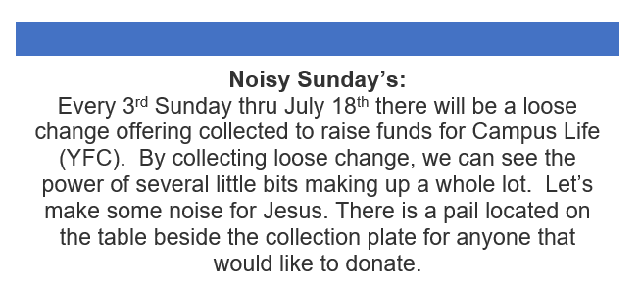

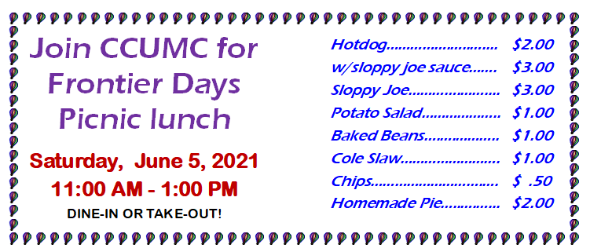


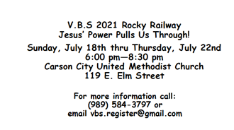


Name _________________________________
_________________________________
Phone #________________________________

Please pre-order no later than Sunday, June 27th, & the shirts will be available Sunday, July 18th, the 1st evening of VBS.

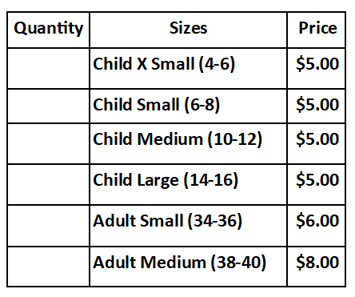
Total:____________

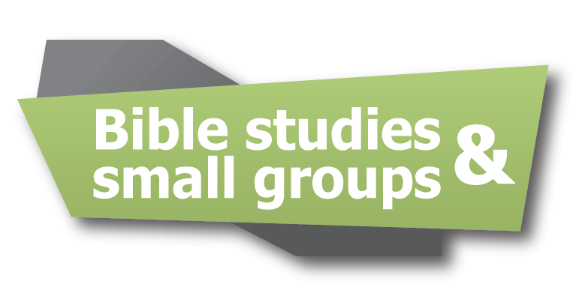


Class meets Monday nights @ 6:30 pm or can join from a Facebook group. Currently, we are studying Moses by Adam Hamiltion. There is a video which takes us to places Moses would have been. The book delves into his life and shows us how God used this ordinary man to do extraordinary things. Startin July 6th we will be watching family movies.

CCUMC will hold their
Easter Sunday Services
on April 4th, 2021
@ 9:00 am & 11:00 am





Carson City United Methodist Church
Phone: 989-584-3797
Email: carsoncityumc@gmail.com
Website: carsoncityumc.com
Office Hours: Monday, 9:00 am-2:00 pm
Tuesday-Thursday, 9:00 am-12:00 pm
Pastor: Ian McDonald (906) 322-5318
Secretary: Bonnie Seaman (989) 763-1674


Seeds of Faith - daily devotion on Facebook by Pastor Ian McDonald. The pastor will be giving a four to five minute devotional on a portion of scripture that speaks to our faith.

Online giving available - on CCUMC Website: http://www.carsoncityumc.com/donate.html

Stay connected! Follow us on:
Join Us Each Sunday

Worship Services 10:00 am

(masks are optional)
Weekly Sunday Bulletin now available on our website
at www.carsoncityumc.com

