Bismarck/Mandan Breastfeeding Partnership
Meeting Minutes – May 4, 2016
Members Present: Chelsea Trebas, Connie Schwartz, Alyse Erbele, Nancy Overson, and Jeanine Wall-Hebert

Alyse mentioned that the Doula’s Baby Expo will be October 21 and 22nd.

The main focus of today’s meeting is about World Breastfeeding Week.
- We decided to have another billboard made. Destination to be determined. Nancy talked to Bruce about the vision on the billboard. This is the final result.
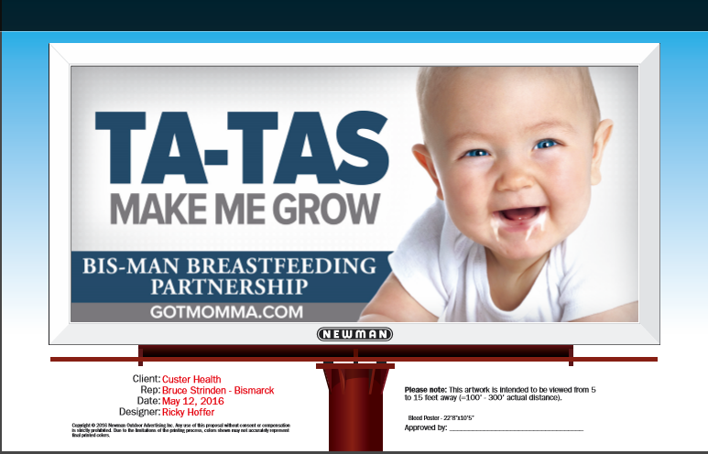

-We will also donate a book to the Bismarck Public Library. The book last year was strictly about breastfeeding and has not been checked out of the library yet. So this year, we will try a book that isn’t so “in your face” about breastfeeding. The book found is “Nursies When the Sun Shines” by Katherine Havener. We will also set up a table at the public library again during the week of WBW.

