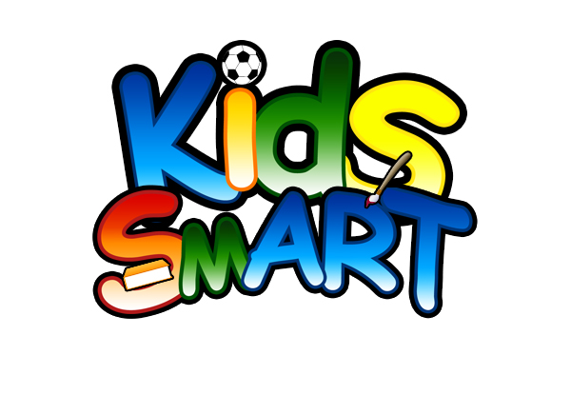

SUNSCREEN AGREEMENT
2020

This agreement is in place for 2020 summer camp programming for the following children:

______________________________________________________

*Please initial one option and sign at the bottom.

________ I would like to provide my own sunscreen for my child(ren) that is at least SPF 30 for the entire duration of their time in the Kids SmART summer camp. I will provide at least one labeled bottle at the start of camp, and will continue to replenish the supply as needed. I understand that if I fail to provide enough sunscreen for my child(ren) to have applied every 90minutes that they are outside my children’s safety is at risk (due to sun exposure and high risk of sunburn), and I may be required to pick my child up from camp until sunscreen is provided.

_______ I would like to have Kids SmART provide sunscreen of at least 45 SPF (brand and application may vary) to my children for summer camp. I agree to pay the one-time $30/child sunscreen fee that will cover the cost of this sunscreen. I understand that this fee is non-refundable and is not pro-rated in any way or based on attendance. Kids SmART sunscreen will be applied at least every 90minutes that they are outside to all exposed areas.

_______________________________ ____________________
Parent/Guardian Date

