Pleasant Township Board of Trustees Meeting Highlights
Date __For meeting on January 12, 2021 Next Resolution No.__ 16---01-12-21______

- Call to Order (A Special meeting was held this day at 6:30 pm to reorganize, 15 resolutions were made to determine officers, approve banks, investments, meeting rules, etc)
- Please stand for moment of silence----Pledge of Allegiance-----Roll Call (Paula will not be attending due to illness)
SPECIAL NOTE: DUE TO THE COVID-19 PANDEMIC AND THE GOVENOR’S REQUIREMENTS, WE WILL PRACTICE SOCIAL DISTANCING AND ALSO CONDUCT A VIRTUAL MEETING FOR THE PUBLIC TO JOIN USING WEBX.
- Minutes to approve- none
- Financial Reports – Due to Paula’s illness we will hold a special meeting later to pay Expenditures
Visitors – (Hannah Poling with the Messenger via WebX)
- Department Reports
- Franklin County Sheriff’s Report-Deputy Travis Carter (will be attending the second meeting of the month)
- (on going) Dealing with complaints of speeders and ATVs riding on the roads in the area of Gardner, Robroy and Riebel Roads.
- (on going) Speed trailer for Lambert Rd. – FCSO has a PO opened for the hitch, waiting on the garage to order it, and put it on.
- Road Department- Robert Bausch
  - Unresolved, 8787 Alkire Rd. about drainage caused by The Rails to Trails project behind his house. His backyard floods and so does his two neighbors to the west of him problems (7-14-20 -- I talked to these residents couple weeks ago, the heavy rain we had seemed to back up the standing water more but it went away in a couple days.)
Blue is On going/unresolved
  - Updates for 5590 Thornhill Ct. drainage problems.
  - Updates on Ebenezer Cemetery. – Still need to plan a dedication when COVID restrictions are lifted
  - Snow and ice
  - Fill potholes
  - New drainage easement Johnson Rd. To do a lot split the property owner donated property for an easement,
  - 9300 Gerich Lily right of way---property is in Pleasant Twp. the entrance to this address is in Madison County. Working with Franklin County Engineers for right of way.
  - ODOT sign grant—applying for this grant, going to contact Harrisburg to see if they would like to be included to update their street signs.
- Fire Dept. – Chief Taylor
- Pierce Mfg called today. They will be sending a truck to ship E-232 to Pierce for the long awaited frame repairs. Once there, they stated they will have the truck for 90-120 days to complete the repairs.
- Hiring for a fulltime firefighter position notice is up with a deadline of next Tuesday for applications.
- We are slowly putting the station back together from the floor project. We are trying to rearrange and eliminate unnecessary items. We will be boxing up old records for storage and trying to essentially de-clutter the building to some degree.
- Resolution____16________ honoring FF John Beard for 34 years of service and retirement.
- Bid Opening for the new ambulance—Two bids received. Lifeline Emergency Vehicles at $259,865.00 and Braun Penn Care at $257,326.00. Committee will be reviewing the bids. Also, Chief Taylor has secured a $250,000.00 for this therefore the cost of the new medic will be very minimal to the taxpayers.
- Ask Chief if he has updated the payment information for Go Daddy? I forwarded a couple emails with the link to update. Yes, the card was out of date.
- Old Business –
- To clear up how SWACO worded that statement about Rumpke accepting recycling. The statement was: “Today marks a big day in recycling! Rumpke will officially begin accepting plastic tubs & yogurt containers today”. Here is the updated image that shows what you can and cannot recycle.” There was a comment that said, “That's nice for residents that are served by Rumpke. Pleasant Township has a contract with Local Waste Services.” This is how I responded: Pleasant Township has a contract with Local Waste Services for trash hauling and recycle pick up. All residents in Pleasant Township use Local Waste for trash and recycling. Rumpke operates the only recycling facility in this area. Trash Haulers such as Local Waste must contract with Rumpke's Recycling Facility to accept collected recycling materials. Everyone in Pleasant Township can now recycle plastic tubs and yogurt containers.
- New Business –
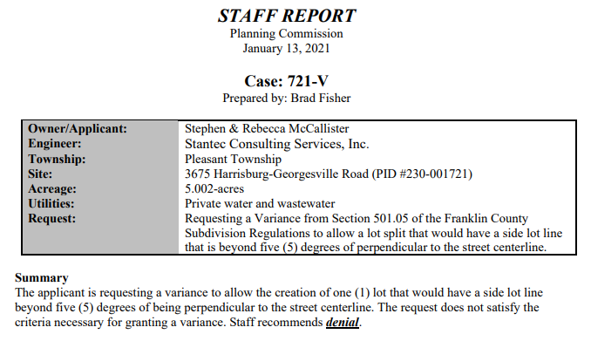
  - The following is on the agenda for the Planning Commission

- Announcements-
  - We had some residents on Lambert Rd. who did not get their recycling picked up last week. A resident called Local Waste to find out why, he was told they went early on Lambert Rd. that day, logged at 7:41 am. Pick up time for Pleasant Township starts at 7:00 a.m. Local Waste advised to put trash and recycling out before 7:00 am or the night before.
  - Received a list of 28 carts that Local was not able to collect. They’ve applied a $75 lost cart fee for each, but if a customer contacts them for removal and they are able to get the carts back they will credit their accounts for the fee. They just had to get the charges on this invoice because waiting until April would make it much more difficult.
- Clerk Updates-

- Speaker Sheets-

- Executive Session – (if needed)

  - “I move to go into Executive Session according to Ohio Revised Code Section 121.22 (G)( ? ) for the ___________________. Do I have a second?” ROLL CALL VOTE

  - Reconvene
Under the Ohio Revised Code Section 121.22(G), I move to come out of Executive Session, do I have a second? ROLL CALL VOTE
- Adjournment

