1978 Cessna T210
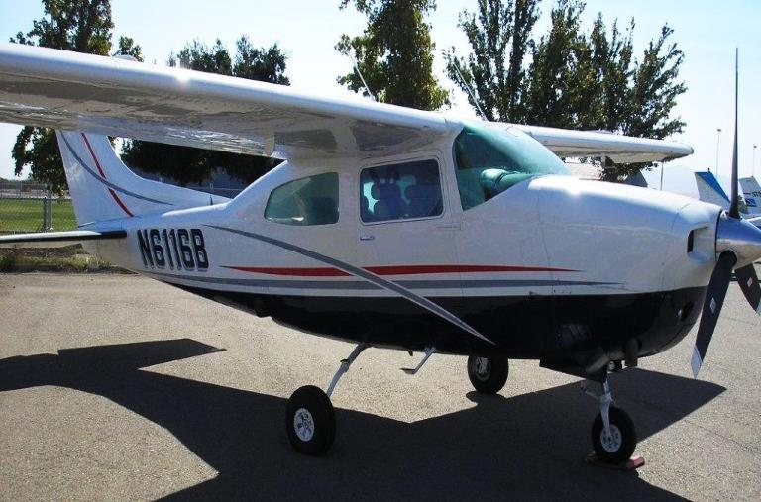
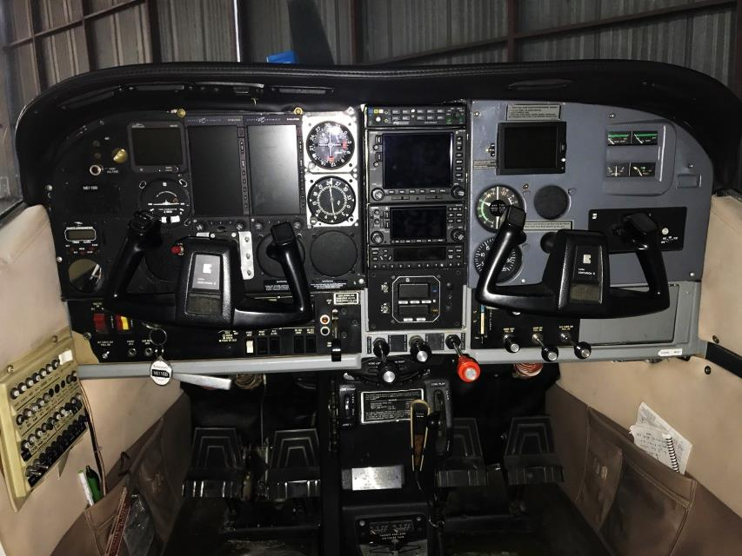
$199,000

- TTAF: 5424.2
- Engine SMOH: 512.9
- STOH 5
- Propeller SPOH: 512.9

- Annual Done 11/18
- New Interior 2017

1978 Cessna T210
Operational Specs

Registration: N6116B
Serial Number: 21062686
TTAF: 5424.2
Engine & Propeller
- SMOH: 512.9
- STOH 5
- SPOH 512.9
Avionics:
- Dual Aspen Evolution EFD 1000’s
- Sandi SAI-340 Quattro 4 in one backup instrument
- JPI EDM-830 Engine Monitoring System
- PS Engineering 7000 Audio Panel
- Garmin 430WAAS
- Garmin 530 WAAS- coupled to auto pilot
- Garmin GDL88 ADS-B In & Out
- GTX 127 Transponder
- Cessna 300 ADF
- STEC 60-2 Auto Pilot System
- Digital Clock
- 6 Place Oxygen
- 6 Place Intercom System
Exterior:
- 2012 Paint
- Horton Stol Kit
Interior:
- New Seats Oct. 2017

For more information contact info@skyviewaviation.com
Or call at 209-830-7666
FAX 209-835-7667

