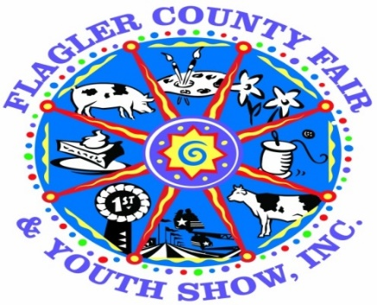
The Flagler County Fair & Youth Show is proud to announce the Annual
“Dorothy Wright Bullard Award”
The purpose of this award is to:
- Encourage more youth participation and increase entries in the Flagler County Fair and Youth Show’s educational programs.
- Encourage currently participating youth to explore other divisions
ALL livestock exhibitors are REQUIRED to participate in at least 3 categories.
Requirements:
- Must be a resident of Flagler County or attend a Flagler County School AND be a member of an appropriate Flagler County 4H Club or FFA Chapter. Exhibitor must meet minimum membership requirements of the respective club/chapter as accepted by the Flagler County Fair and Youth Show.
Age Requirements AS OF SEPTEMBER 1, 2021
Cloverbuds 5 to 7 years Junior 8 to 10 years Intermediate 11 to 13 years Senior 14 to 18 years
- Any youth participating in any livestock exhibition (including rabbits and chickens) must participate in at least 3 or more of the following programs:
  - Horticulture (see individual rules)
  - Home and Family Division (a list will be provided of each division within this division - you can enter this division numerous times) (see individual rules)
  - Shoe Box Float(see individual rules)
  - Country Critter(see individual rules)
- All entries must be turned in on Monday April 5th from 1 to 6 pm at the Cattlemans Hall
- Pickup: Once judging and ribbons are complete.
(Please see the rules for each division you are entering in.) If you have not met this requirement, you WILL NOT be permitted to show or sell your animal.
- Points awarded based on placing in each division – Please note that points will be based on age appropriate entries. (If a cloverbud enters a shoe box float and it appears to have been made by an adult, points will be deducted. If the entry is age appropriate additional points will be awarded.
1st place – Blue Ribbon 20 Points
2nd Place – Red Ribbon 15 Points
3rd place – White Ribbon 10 points
Best of Show 50 points
- Tie Breaker: In an event of a tie the tie breaker will be the person with the most entries entered.
- Cash Awards for each age division
1st Place - $20.00 2nd Place - $10.00 3rd Place - $5.00
BEST OF SHOW OVERALL $50.00

