**Why it is Never Flip Flops Weather**

It was a long winter. As winter has turned into spring it has gotten noticeably warmer, with many signs of this everywhere; buds are beginning to form on trees, birds are singing and people are taking off layers of clothes and getting rid of those winter boots. What we’re also seeing coming out soon enough (if not already for some) are sandals.

*(*Definition: While all flip flops are sandals, not all sandals are flip flops. If a thong holds the foot in place it’s a flip flop, whereas a sandal is held to the foot by a thong or strap(s).)*

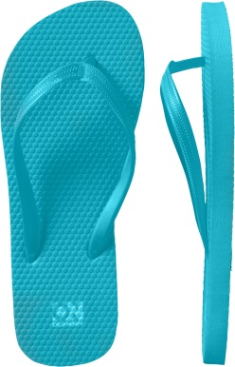

Now I know that it’s nice to air out our feet after months of winter boots and feel the warmth of the sun on our toes, but flip flops often aren’t a good answer. I’m not against open shoes; it’s just that flip flops don’t provide the support that one needs to walk around in. Always popular are the Old Navy flip flops that one can buy for $5. The problem is that there is a reason that they only cost $5 - there is nothing to them. A plastic thong to hold a thin piece of rubber on your foot and that’s it. The sole is perfectly flat on the bottom and top, no arch, no heel cushion, there is nothing to them. This would be fine if our feet were perfectly flat and with each step we landed with equal weight on each part of the foot, but we don’t.

As someone reading this has probably thought, ‘not all flip flops are created like that’, and that is what I want to get to. While wearing a good pair of running sneakers is almost always going to be better than wearing a pair of flip flops, there are different brands and kinds of flip flops and there are some that are better than others to wear.

I once walked across Boston wearing Nike sandals. They had a wide secure band anchoring my foot to the sole. One benefit of sandals (those that have something other than a thong) is that generally the foot is more securely held to the sole. It’s always nice to take a step and have one’s sandal squarely beneath them. These sandals also had a thicker heal and arch support, they were essentially mimicking a sneaker, but with a lot more breathability. The arch support prevented me from rolling my ankle inwards with every step I took, which in-turn helps one to avoid knee and low back problems, while the thicker heel cushioned each step to cause less stress to the legs and low back.

Now I’m not saying that I would walk for 2 hours in sandals any time soon, but it makes sense that if you’re going to want to wear sandals this summer that you should wear a pair that will support you. This means something with some arch support (not a flat rubber sole), some cushion (thicker at the heel then rest of the foot) and the ability to stay securely on with each step (optimally not a flip flop).

Just because the warmer weather is here doesn’t mean we should sacrifice the health of our bodies to enjoy it.

**Feel Free To Forward This Information To A Friend!**   
**Justin Welch, D.C.   
627 College Hwy   
Southwick, MA 01077   
(413) 998-3482**

This information is solely advisory, and should not be substituted for medical or chiropractic advice.  Any and all health care concerns, decisions, and actions must be done through the advice and counsel of a health care professional who is familiar with your updated medical history.