Saint Paul’s Episcopal Church

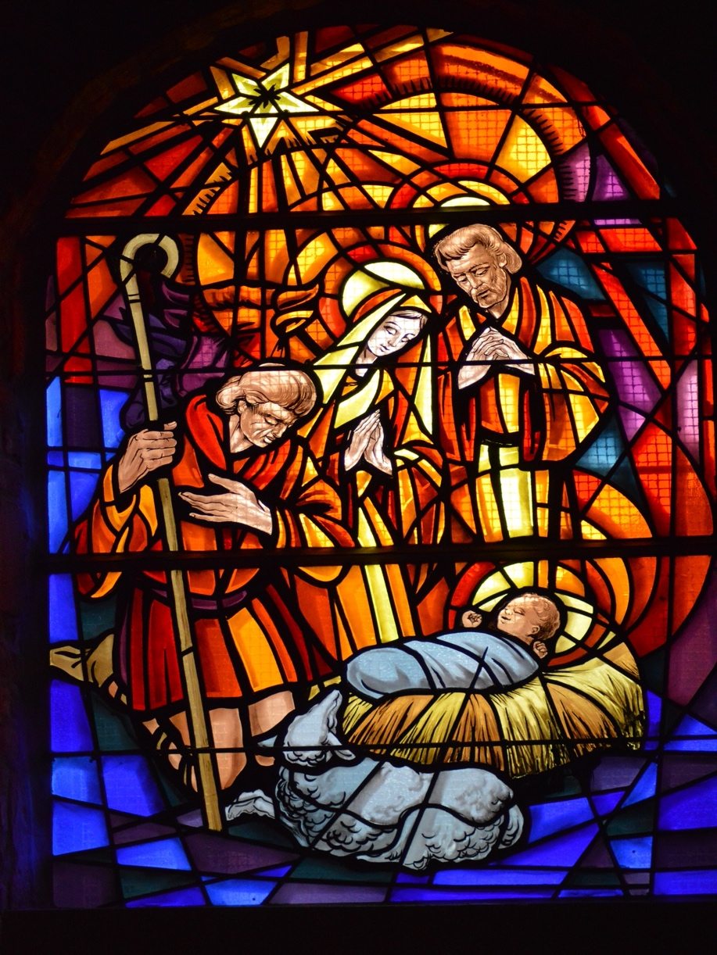

The Nativity of Our Lord

Christmas Eve

December 24, 2021

Pastor Dan Wilfrid

79 Cross Street, Gardner, Massachusetts ~ 01440
Merry Christmas and welcome to St. Paul’s. We’re glad that you have joined us for our Christmas Eve worship, either in person or livestreamed on our YouTube channel. For as long as COVID infection rates remain elevated in our area, we ask everyone attending in person to wear a mask in worship and to sit safely distanced from people not from your household. At the distribution of Holy Communion (bread only), please come forward one at a time, and return to your seat through the door to your right and from the rear of the nave down the center aisle. Worship leaders are all vaccinated and will only unmask while speaking. Words in boldface type are the congregation’s responses.

Prelude: Angels Christmas Medley ~ Arr. Gary Lanier – French Horn and Piano Duet Once in Royal David’s City ~ Choir

Lighting the Advent Wreath
Advent Prayer – Verses 1-5 (see page 16)

Christmas Proclamation
On the Twenty-fifth Day of December, when ages beyond number had run their course from the creation of the world, when God in the beginning created heaven and earth, and formed humans in his own likeness; when century upon century had passed since the Almighty set his bow in the clouds after the Great Flood,
as a sign of covenant and peace; long since God called Abraham and Sarah, in the thirteenth century since the People of Israel were led by Moses in the Exodus from Egypt; around the thousandth year since David was anointed King; in the year seven hundred and fifty-two since the foundation of the City of Rome; in the forty-second year of the reign of Caesar Augustus, the whole world being at peace, Jesus Christ, eternal God and Son of the eternal Father, was conceived by the Holy Spirit, and when nine months had passed since his conception, was born of the Virgin Mary in Bethlehem of Judah, and was made human. This gathering is to celebrate the Nativity of Our Lord Jesus Christ according to the flesh.
Processional Hymn: O Come, All Ye Faithful, #83

1. O come, all ye faithful, joyful and triumphant!
O come ye, O come ye to Bethlehem!
Come and behold him, born the King of angels.
O come, let us adore him, O come, let us adore him,
O come, let us adore him, Christ the Lord!

2. God from God, Light from Light eternal,
lo! He abhors not the Virgin’s womb;
Only-begotten Son of God the Father:
O come, let us adore him, O come, let us adore him,
O come, let us adore him, Christ the Lord!

3. Sing, choirs of angels, sing in exultation,
sing, all ye citizens of heav’n above!
Glory to God, all glory in the highest:
O come, let us adore him, O come, let us adore him,
O come, let us adore him, Christ the Lord!

4. See how the shepherd’s, summoned to his cradle,
Leaving their flocks, draw nigh to gaze;
We too will thither bend our joyful footsteps;
O come, let us adore him, O come, let us adore him,
O come, let us adore him, Christ the Lord!
5. Child, for us sinners poor and in the manger,
We would embrace thee, with love and awe;
Who would not love thee, loving us so dearly?
O come, let us adore him, O come, let us adore him,
O come, let us adore him, Christ the Lord!

6. Yea, Lord, we greet thee, born this happy morning;
Jesus, to thee be glory given;
Word of the Father, now in flesh appearing;
O come, let us adore him, O come, let us adore him,
O come, let us adore him, Christ the Lord!

The Word of God

Blessed be God: Father, Son, and Holy Spirit.
And blessed be his kingdom, now and forever. Amen.

Collect for Purity
Almighty God, to you all hearts are open, all desires known, and from you no secrets are hid: Cleanse the thoughts of our hearts by the inspiration of your Holy Spirit, that we may perfectly love you, and worthily magnify your holy Name; through Christ our Lord. Amen

Gloria in Excelsis: S 204 (Old Scottish Chant)
Glory be to God on high, and on earth peace, good will toward men.
We praise Thee, we bless Thee, we worship Thee, we glorify Thee,
we give thanks to Thee for Thy great glory:
O Lord God, heavenly King; God the Father Almighty.
O Lord, the only begotten Son, Jesus Christ;
O Lord God, Lamb of God, Son of the Father:
That takest away the sins of the world, have mercy upon us.
Thou that takest away the sins of the world, receive our prayer.
Thou that sittest at the right hand of God the Father, have mercy upon us.
For Thou only art holy; Thou only art the Lord;
Thou only, O Christ, with the Holy Ghost,
art the most high in the glory of God the Father. Amen.

The Lord be with you.

And also with you.

Let us pray.
O God, you have caused this holy night to shine with the brightness of the true Light: Grant that we, who have known the mystery of that Light on earth, may also enjoy him perfectly in heaven; where with you and the Holy Spirit he lives and reigns, one God, in glory everlasting. Amen.

First Reading: Isaiah 9:2-7
The people who walked in darkness
have seen a great light;
those who lived in a land of deep darkness--
on them light has shined.
You have multiplied the nation,
you have increased its joy;
they rejoice before you
as with joy at the harvest,
as people exult when dividing plunder.
For the yoke of their burden,
and the bar across their shoulders,
the rod of their oppressor,
you have broken as on the day of Midian.
For all the boots of the tramping warriors
and all the garments rolled in blood
shall be burned as fuel for the fire.
For a child has been born for us,
a son given to us;
authority rests upon his shoulders;
and he is named
Wonderful Counselor, Mighty God,
Everlasting Father, Prince of Peace.
His authority shall grow continually,
and there shall be endless peace
for the throne of David and his kingdom.
He will establish and uphold it
with justice and with righteousness
from this time onward and forevermore.
The zeal of the Lord of hosts will do this.

The word of the Lord.
Thanks be to God.

Psalm 96 Cantate Domino

¹ Sing to the Lord a new song; *
sing to the Lord, all the whole earth.
² Sing to the Lord and bless his Name; *
proclaim the good news of his salvation from day to day.
³ Declare his glory among the nations *
and his wonders among all peoples.
⁴ For great is the Lord and greatly to be praised; *
he is more to be feared than all gods.
⁵ As for all the gods of the nations, they are but idols; *
but it is the Lord who made the heavens.
⁶ Oh, the majesty and magnificence of his presence! *
Oh, the power and the splendor of his sanctuary!
⁷ Ascribe to the Lord, you families of the peoples; *
ascribe to the Lord honor and power.
⁸ Ascribe to the Lord the honor due his Name; *
bring offerings and come into his courts.
⁹ Worship the Lord in the beauty of holiness; *
let the whole earth tremble before him.
¹⁰ Tell it out among the nations: "The Lord is King! *
he has made the world so firm that it cannot be moved;
he will judge the peoples with equity."
¹¹ Let the heavens rejoice, and let the earth be glad;
let the sea thunder and all that is in it; *
let the field be joyful and all that is therein.
¹² Then shall all the trees of the wood shout for joy
before the Lord when he comes, *
when he comes to judge the earth.
¹³ He will judge the world with righteousness *
and the peoples with his truth. Amen.

Second Reading: Titus 2:11-14

For the grace of God has appeared, bringing salvation to all, training us to renounce impiety and worldly passions, and in the present age to live lives that are self-controlled, upright, and godly, while we wait for the blessed hope and the manifestation of the glory of our great God and Savior, Jesus Christ. He it is who gave himself for us that he might redeem us from all iniquity and purify for himself a people of his own who are zealous for good deeds.

The word of the Lord.
Thanks be to God.

Alleluia Verse: Jubilate Deo (Sung by Choir)

Gospel Reading: Luke 2:1-20

The Holy Gospel of our Lord Jesus Christ according to Luke.
Glory to you, Lord Christ.
In those days a decree went out from Emperor Augustus that all the world should be registered. This was the first registration and was taken while Quirinius was governor of Syria. All went to their own towns to be registered. Joseph also went from the town of Nazareth in Galilee to Judea, to the city of David called Bethlehem, because he was descended from the house and family of David. He went to be registered with Mary, to whom he was engaged and who was expecting a child. While they were there, the time came for her to deliver her child. And she gave birth to her firstborn son and wrapped him in bands of cloth, and laid him in a manger, because there was no place for them in the inn.
In that region there were shepherds living in the fields, keeping watch over their flock by night. Then an angel of the Lord stood before them, and the glory of the Lord shone around them, and they were terrified. But the angel said to them, "Do not be afraid; for see-- I am bringing you good news of great joy for all the people: to you is born this day in the city of David a Savior, who is the Messiah, the Lord. This will be a sign for you: you will find a child wrapped in bands of cloth and lying in a manger." And suddenly there was with the angel a multitude of the heavenly host, praising God and saying, "Glory to God in the highest heaven, and on earth peace among those whom he favors!"
When the angels had left them and gone into heaven, the shepherds said to one another, "Let us go now to Bethlehem and see this thing that has taken place, which the Lord has made known to us." So they went with haste and found Mary and Joseph, and the child lying in the manger. When they saw this, they made known what had been told them about this child; and all who heard it were amazed at what the shepherds told them. But Mary treasured all these words and pondered them in her heart. The shepherds returned, glorifying and praising God for all they had heard and seen, as it had been told them.
The Gospel of the Lord. Praise to you, Lord Christ.

The Sermon ~ Pastor Dan Wilfrid

The Hymn: O Little Town of Bethlehem, #79 Verses 1,2,3,5
1. O little town of Bethlehem, how still we see thee lie!
Above thy deep and dreamless sleep the silent stars go by;
Yet in thy dark streets shineth the everlasting Light;
The hopes and fears of all the years are met in thee tonight

2. For Christ is born of Mary; and gathered all above,
while mortals sleep, the angels keep Their watch of wondering love.
O morning stars, together proclaim the holy birth!
And praises sing to God the King, and peace to men on earth.

3. How silently, how silently, the wondrous gift is given!
So God imparts to human hearts the blessings of His heaven.
No ear may hear his coming, but in this world of sin,
Where meek souls will receive him, still the dear Christ enters in.

5. O holy Child of Bethlehem, descend to us, we pray;
Cast out our sin and enter in, be born to us today.
We hear the Christmas angels the great glad tidings tell;
O come to us, abide with us Our Lord Emmanuel.
The Nicene Creed
We believe in one God, the Father, the Almighty, maker of heaven and earth, of all that is, seen and unseen.
We believe in one Lord, Jesus Christ, the only Son of God, eternally begotten of the Father, God from God, Light from Light, true God from true God, begotten, not made, of one Being with the Father. Through him all things were made.
For us and for our salvation he came down from heaven: by the power of the Holy Spirit he became incarnate from the Virgin Mary, and was made man.
For our sake he was crucified under Pontius Pilate; he suffered death and was buried. On the third day he rose again in accordance with the Scriptures; he ascended into heaven and is seated at the right hand of the Father. He will come again in glory to judge the living and the dead, and his kingdom will have no end.
We believe in the Holy Spirit, the Lord, the giver of life, who proceeds from the Father and the Son. With the Father and the Son, he is worshiped and glorified. He has spoken through the Prophets. We believe in one holy catholic and apostolic Church. We acknowledge one baptism for the forgiveness of sins. We look for the resurrection of the dead, and the life of the world to come. Amen.

Prayers of the People ~ Form III ~ The Book of Common Prayer, p. 387
Father, we pray for your holy Catholic Church;
That we all may be one.

Grant that every member of the Church may truly and humbly serve you;
That your Name may be glorified by all people.

We pray for all bishops, priests, and deacons;
That they may be faithful ministers of your Word and Sacraments.

We pray for all who govern and hold authority in the nations of the world;
That there may be justice and peace on the earth.

Give us grace to do your will in all that we undertake;
That our works may find favor in your sight.

Have compassion on those who suffer from any grief or trouble;
That they may be delivered from their distress.

Give to the departed eternal rest;
Let light perpetual shine upon them.

We praise you for your saints who have entered into joy;
May we also come to share in your heavenly kingdom.

Let us pray for the needs and concerns of this congregation and its people; especially for:

Jared Snyder Dwight Davis
Lisa Boulanger Michael Crowley
Cindy Richard Maureen Owens
Brandon Grenier Eveline Beauregard
Millie Williams Jay Hipkins
Jacob Decarolis Dawn Deluca
Cyndi Flanagan Andy LePage
Christopher Sharon Hamel
Elizabeth Williams-Taylor Bob and Lorene McLaughlin
Kathy Lewis Fred and Ginny Monette
Evelyn Wolenty Tom and Felicity Littlepage
Suzanna Cleveland Elizabeth Williams-Taylor
Robin Hatch and family
For those in military service.
For all people who suffer hunger, poverty or oppression.
For safety and welcome for refugees seeking asylum far from home.
For people who have suffered injury and loss from storms, fires and floods.
For our parishioners unable to be with us.
We pray for the repose of the soul of Robin Welles.
In thanksgiving for the Sanctuary Candle given by Cathy and Denis Meunier, in loving memory of Doris and Roger Meunier, Edward, Barbara and Bobby Richard, Ron, Craig and Randy Hamel, and Sandy and John Robichaud.
In thanksgiving for the Communion Wine, given by Sylvia Wells in memory of Frank Wells and by Jackie Gallant and her sons, in memory of Walfred & Eleonor Erickson.

The Collect
Almighty and Eternal God, ruler of all things in heaven and earth: Mercifully accept the prayers of your people, and strengthen us to do your will; through Jesus Christ, our Lord. Amen.

The Confession of Sin
Let us confess our sins against God and our neighbor.
Have mercy upon us, most merciful Father; in your compassion forgive us our sins, known and unknown, things done and left undone; and so uphold us by your Spirit that we may live and serve you in newness of life, to the honor and glory of your Name; through Jesus Christ our Lord. Amen.

The Absolution
Almighty God have mercy on you, forgive you all your sins through our Lord Jesus Christ, strengthen you in all goodness, and by the power of the Holy Spirit keep you in eternal life. Amen.

The Peace
The peace of the Lord be always with you. And also with you.

Announcements

The Holy Communion
Offertory Invitation
So bring him incense, gold and myrrh; come peasant, king, to own him. The King of kings salvation brings; let loving hearts enthrone him. Haste, haste to bring him laud, the babe, the son of Mary.

Offertory Anthem: Sleep, Holy Babe! ~ Thomas Keesecker, Composer

Offertory Prayer
Gracious God, we offer with joy and thanksgiving what you have first given us, - ourselves, our time, and our possessions, signs of your generosity and love.

Receive them for the sake of the one who offered himself for us, Jesus Christ our Lord. Amen.

Eucharistic Prayer B ~ from the Book of Common Prayer p. 367
The Lord be with you.
And also with you.
Lift up your hearts.
We lift them to the Lord.
Let us give thanks to the Lord our God.
It is right to give God thanks and praise.
It is right, and a good and joyful thing, always and everywhere to give thanks to you, Father Almighty, Creator of heaven and earth. Because you gave Jesus Christ, your only Son, to be born for us; who, by the mighty power of the Holy Spirit, was born of the flesh of the Virgin Mary his mother; so that we might be delivered from the bondage of sin, and receive power to become your children.
Therefore we praise you, joining our voices with Angels and Archangels and with all the company of heaven, who for ever sing this hymn to proclaim the glory of your Name:
The Sanctus S 130
Holy, holy, holy Lord, God of power and might,
Holy, holy, holy Lord, God of power and might,
heaven and earth are full, full of your glory.
Hosanna in the highest. Hosanna in the highest.
Blessed is he who comes in the name of the Lord.
Hosanna in the highest. Hosanna in the highest.

We give thanks to you, O God, for the goodness and love which you have made known to us in creation; in the calling of Israel to be your people; in your Word spoken through the prophets; and above all in the Word made flesh, Jesus, your Son. For in these last days you sent him to be incarnate from the Virgin Mary, to be the Savior and Redeemer of the world. In him, you have delivered us from evil, and made us worthy to stand before you. In him, you have brought us out of error into truth, out of sin into righteousness, out of death into life.
On the night before he died for us, our Lord Jesus Christ took bread; and when he had given thanks to you, he broke it, and gave it to his disciples, and said, “Take, eat: This is my Body, which is given for you. Do this for the remembrance of me.”
After supper he took the cup of wine; and when he had given thanks, he gave it to them, and said, “Drink this, all of you: This is my Blood of the new Covenant, which is shed for you and for many for the forgiveness of sins. Whenever you drink it, do this for the remembrance of me.”
Therefore, according to his command, O Father,
We remember his death.
We proclaim his resurrection.
We await his coming in glory.

And we offer our sacrifice of praise and thanksgiving to you, O Lord of all; presenting to you, from your creation, this bread and this wine.
We pray you, gracious God, to send your Holy Spirit upon these gifts that they may be the Sacrament of the Body of Christ and his Blood of the new Covenant. Unite us to your Son in his sacrifice, that we may be acceptable through him, being sanctified by the Holy Spirit. In the fullness of time, put all things in subjection under your Christ, and bring us to that heavenly country where, with all your saints, we may enter the everlasting heritage of your sons and daughters; through Jesus Christ our Lord, the firstborn of all creation, the head of the Church, and the author of our salvation.
By him, and with him, and in him, in the unity of the Holy Spirit all honor and glory is yours, Almighty Father, now and for ever. Amen
And now, as our Savior Christ has taught us, we are bold to say:
Our Father, who art in heaven, hallowed be thy Name,
thy kingdom come, thy will be done, on earth as it is in heaven.
Give us this day our daily bread. And forgive us our trespasses,
as we forgive those who trespass against us.
And lead us not into temptation, but deliver us from evil.
For thine is the kingdom, and the power, and the glory, forever and ever. Amen.

The Breaking of the Bread
Alleluia. Christ our Passover is sacrificed for us;
Therefore let us keep the feast. Alleluia.

Lamb of God (S 164)
Jesus, Lamb of God: have mercy on us.
Jesus, bearer of our sins: have mercy on us.
Jesus, redeemer, redeemer of the world:
Give us your peace, give us your peace.

The Distribution

Love is born! Come, share in the wonder.
Love is Jesus within and among us. Alleluia!

Communion Anthem: He is Here in the Breaking of Bread!
~ Mary Kay Beall, Words; Lloyd Larsen, Music

Post-Communion Prayer

Let us pray.
Eternal God, heavenly Father, you have graciously accepted us as living members of your Son our Savior Jesus Christ, and you have fed us with spiritual food in the Sacrament of his Body and Blood. Send us now into the world in peace, and grant us strength and courage to love and serve you with gladness and singleness of heart; through Christ our Lord. Amen.

Post-Communion Hymn Joy to the World, #100

1. Joy to the world, the Lord is come! Let earth receive her King;
let ev’ry heart prepare him room and heav’n and nature sing,
and heav’n and nature sing, and heav’n, and heav’n and nature sing.

2. Joy to the earth, the Savior reigns! Let men their songs employ,
while fields and floods, rocks, hills, and plains, repeat the sounding joy, repeat the sounding joy, repeat, repeat the sounding joy.

3. No more let sins and sorrows grow nor thorns infest the ground;
he comes to make his blessings flow far as the curse is found,
far as the curse is found, far as, far as the curse is found.

4. He rules the world with truth and grace and makes the nations prove
the glories of his righteousness and wonders of his love,
and wonders of his love, and wonders, wonders of his love.

The Blessing
Almighty God, Father, + Son, and Holy Spirit, bless you now and for ever. Amen

Candle Lighting Hymn: Silent Night, #111

1. Silent night, holy night! All is calm, all is bright
round yon virgin mother and child. Holy Infant, so tender and mild,
sleep in heavenly peace, sleep in heavenly peace.

2. Silent night, holy night! Shepherds quake at the sight.
Glories stream from heaven afar, heavenly hosts sing, Alleluia!
Christ, the Savior, is born! Christ, the Savior, is born!

3. Silent night, holy night! Son of God, love’s pure light
radiant beams from thy holy face, with the dawn of redeeming grace,
Jesus, Lord, at thy birth, Jesus, Lord, at thy birth.

Dismissal

Go in peace to love and serve the Lord.

Thanks be to God.

Postlude: Good Christian Men, Rejoice! ~ Arr. Gary Lanier – French Horn and Piano

Worship Leaders and Helpers Tonight

Presider/Preacher … Pastor Dan Wilfrid
Reader … Pam Harris LEM …Denis Meunier
Organist … Judy Greenlees French Horn… Tabitha Greenlees
Altar Guild … Denise Whitney Camera … Susan Hubbard/Linda Chipman

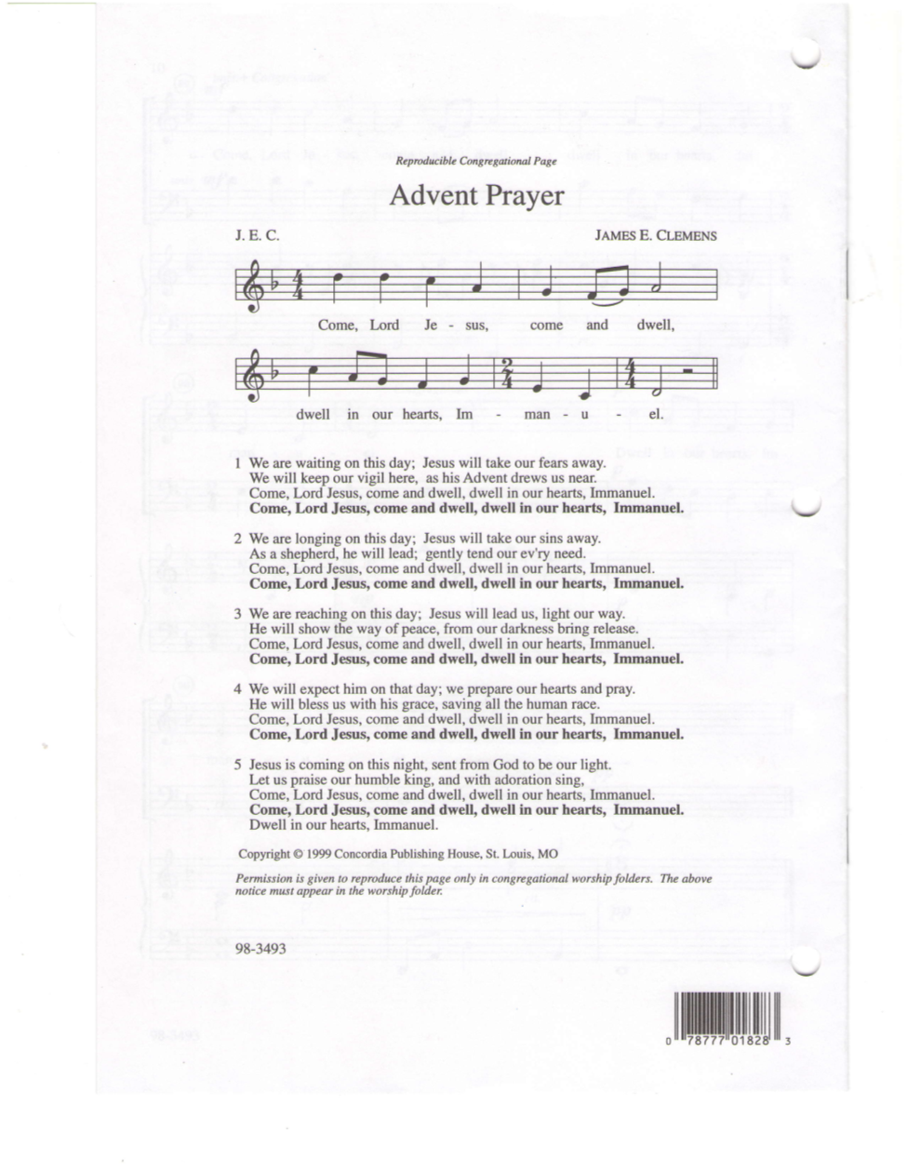

DECEMBER BIRTHDAYS |  | DECEMBER ANNIVERSARIES
Cole Theriault | Dec. 3 | -
Deanie Wilson | Dec. 5
Marilyn Brown | Dec. 6
Timothy Chipman | Dec. 15
Stacy Davis | Dec. 19
Katie Pulnik | Dec. 19
Lyn Carroll | Dec. 21
Collette Brown | Dec. 27

