FIFTEENTH SUNDAY IN ORDINARY TIME
JULY 14 & 15, 2018
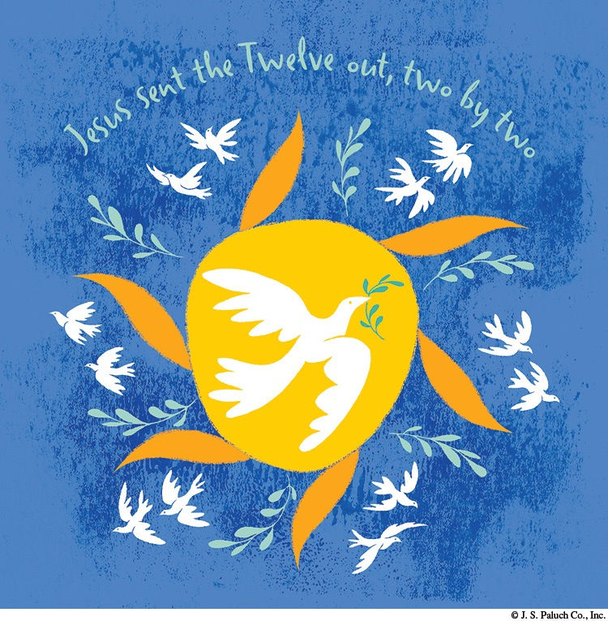
CALLED BY GOD

Today’s Scriptures invite us to listen to two calls. The first is the call issued by the LORD to the Prophet Amos, the “shepherd and a dresser of sycamores” (Amos 7: 14). The second is the call the Lord Jesus issued to the Twelve, whom he sent out “two by two” (Mark 6: 7). These faithful people responded to the call, prophesying and preaching to the people to whom they had been sent. Each of us received a call when we were Baptized. The Second Reading invites us to ponder that call as we are reminded that we are chosen in Christ and that, in love, God “destined us for adoption” (Ephesians 1: 5). As adopted daughters and sons of God, we are called to bring the Presence of Christ into our marriages, families, schools, and places of work. Let us be inspired today to say yes to the call we hear once again through God’s living word.

COUPLING
By Dennis Tavares

No one knows for sure what causes sexual attraction in humans. For the animals, from mice to elephants, the female chemically signals her readiness to reproduce and the male simply responds. But for humans who enter Catholic marriage something else is involved, something moves the human will to a lifelong commitment to a particular person. It’s not simply about biological reproduction. Marriage is in reality the forming of an exclusive society of two earthly persons; but which includes heavenly persons, namely God and His angels. It is God who brings them together and keeps them together. Those thus joined in matrimony are meant to share everything they have and encounter in life. God’s great plan is that from such unions come all the great advances in civil society that we treasure today. Thus to break up a marriage is socially tragic.

PLEASE PRAY FOR OUR SICK PARISHIONERS
Florencia Chávez, Refugio Yáñez, Tarcicio Garía, Sofía García, María de Jesús Mendoza, Ana García, Antonio Cazares, Evelyn Costa, Ryan Moore, Eileen Seeman, Marianne Brannan, Lilia Parrish, Nancy Smith, Julián Palomar, Luisa Martínez, Jennifer Vera, John Braet, Kim Koskinen, Margaret Valencia, Matthew Marcoulier, Dennis Tavares, Jose Freitas, Alfredo Sousa, Juana Arreguín, Aron Yasskin, Victoria Walzer, Fidela Yáñez Jara, Erika Ramos, Bill Gibson, Carla Tomas, Erasmo Yáñez, Memo Soria, Patricia Vargas, Fidela Yáñez, Rogelia Serrano, Elvia Flores, Camila Blanco-Cherrez, Yonel Ruíz, Angie Freitas, Russel Bryant, Derrick Heater, Luis Angel, Juan Barrera-Terán, Gabriel Hurtado, Gerald Butler, Helen Reynolds, Toni Clark, Ann Gallagher, Brianna Lopez, Margaret Milliken, Gina Pivirotto, Nick Quin, Mary Servis, Denis Sousa, Victor Venegas, Matty Walker, Charles Lorenz, Rebecca Lorenz, Ofelia Ibarra, Leonardo Naal, Gina Leal.

64TH ANNUAL CHICKEN BBQ
By OLGC BBQ Fundraiser Team

Our Lady of Good Counsel’s 64th Annual Church BBQ and Parish Carnival is Sunday, August 5th.
Please join us for a great day of community and family fun. Dinner is served from 11am until 5pm or until chicken is sold out.
Unable to join us that day? Despair not. You may still support the Parish by purchasing dinner tickets, or kids’ bracelets for unlimited rides after Mass today. Father Andre will see to it that deserving families in our Parish receive a free meal and/or all-day ride bracelets on August 5th.
All proceeds from this event will be used to finance our parish year-long up keep and various ministries.
Your generous donations are much appreciated!
Likewise, the helping hands of volunteers create the miracle of fun, camaraderie and community.

No one has to do a lot, if everyone does a little.
GO OLGC!

Thank you and may God bless you and your family.

PRAY FOR OUR FAMILY AND FRIENDS THAT ARE IN THE MILITARY SERVICE
Edgar Toscano, Marina González, Alondra Jara, Sonia Jara, Jason Lorenz, Matt Mills y Jared Schroeder

READINGS FOR THE WEEK

Monday: Is 1: 10-17; Ps 50: 8-9, 16bc-17, 21, 23; Mt 10: 34—11: 1
Tuesday: Is 7: 1-9; Ps 48: 2-8; Mt 11: 20-24
Wednesday: Is 10: 5-7, 13b-16; Ps 94: 5-10, 14- 15; Mt 11: 25-27
Thursday: Is 26: 7-9, 12, 16-19; Ps 102: 13- 14ab, 15-21; Mt 11: 28-30
Friday: Is 38: 1-6, 21-22, 7-8; Is 38: 10- 12abcd, 16; Mt 12: 1-8
Saturday: Mi 2: 1-5; Ps 10: 1-4, 7-8, 14; Mt 12:
14-21
Sunday: Jer 23: 1-6; Ps 23: 1-6; Eph 2: 13-18;
Mk 6: 30-34

WHEN OLD IS NEW
By Jane Vartanian

A teacher of pre-kindergarten children discovered a box in a classroom closet that had been left years ago by one of the room’s previous teachers. It contained materials for the telling of a fairy tale by use of a flannel-board.
We all know flannel as a cloth with a fuzzy surface, and it is this fuzziness that causes pieces of it to cling to one another. The box contained the large piece of background cloth and flat cutout characters for the story. The teacher should tell the story and place the flannel figures on the background as she spoke.
The present-day teacher wondered if her small internet-savvy students would sit still for such a performance. She had seen them handle i-pads and cell phones with ease and enjoyment, and a flannel board show seemed an anti-climax, to say the least. Nevertheless she felt it was worth a try.
The children seated themselves on their assigned seats on the classroom rug and stared expectantly at the large flannel sheet on the easel at the front of the room. The teacher placed the first piece of scenery on the cloth: a wide bridge that spanned a river, and the ugly troll that lived under the bridge. Each of three goats tried to cross the bridge, only to be challenged by the troll, who threatened to eat them!
There was absolute silence and rapt attention as the story unfolded. The children clapped for the clever goats and cheered when the evil troll was sent floating away on the wild river. They loved it! They had never seen anything like it!
Of course, they hadn’t. It was entertainment from another age. Just because something is old doesn’t mean that it still doesn’t interest and value!

OUR SILENT AUCTION NEEDS HELP

WE ARE ASKING EACH FAMILY TO CONSIDER MAKING A BASKET OR DONATING AN ITEM FOR THE AUCTION.
SOME SUGGESTIONS ARE: A SPA BASKET, MOVIE NIGHT BASKET, TOURIST BASKET, OR; ARTWORK, JEWELRY, AND VARIOUS TYPES OF WOODWORK, ETC.

UNITED CHRISTIAN WOMEN’S POTLUCK SALAD LUNCHEON

Saturday July 21, 2018
12:00 noon
CHAPEL OF THE REDWOODS
31201 COMPTCHE UKIAH ROAD,
COMPTCHE, CA

Please bring a salad and friends to share in this afternoon of Christian Fellowship
The Comptche Women will provide
drinks and desserts.

Please call the church at 937-0850 with your reservation

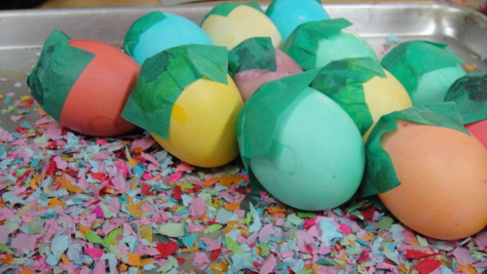
REMEMBER THAT WE NEED DONATIONS OF EGG SHELLS FOR OUR CARNIVAL.
YOU CAN BRING THEM TO THE OFFICE FROM
MONDAY TO FRIDAY, 10AM - 2PM.

MASS INTENTIONS
JULY 18 - 22, 2018
Wednesday (18)  Thursday (19)  Friday (20)  Saturday (21)  Sunday (22) | 12:05pm  12:05pm  12:05pm  5:00pm  6:30pm  8:00am  10:00am | Haig Vartanian †  Gerardo Escobedo  (b-day)  Mauricio Escobedo †  Martha & Norbert Pfeiffer †  Fred & Clara White †  Gerardo Escobedo  (b-day)  Mauricio Escobedo †  Antonio Hernandez †  Eugene & Alice Musladine †  Arthur Figueiredo †  Evelio Nieto †  Bryan Serpa †

VERY IMPORTANT

WE ARE UPDATING
OUR PARISH REGISTRATION LIST.
TAKE A FORM AND GIVE US YOUR CURRENT INFORMATION.
YOU CAN PUT IT IN THE COLLECTION BASKET, RETURN IT TO THE RECTORY, CALL US AT 707-964-0229 OR SEND US AN E-MAIL TO olgcinfb@gmail.com.

WEEKLY COLLECTION
JULY 7 & 8, 2018……$2,134.00
MAINTENANCE FUND…..$773.00

THIS WEEKEND’S SECOND COLLECTION:
BLACK AND INDIAN MISSION
NEXT WEEKEND’S SECOND COLLECTION:
YOUTH MINISTRY

THANK YOU FOR YOUR SUPPORT &
CHRISTIAN GENEROSITY

RELIGIOUS EDUCATION CONGRESS 2018

On Saturday, August 18th, the Diocese of Santa Rosa will present a day of prayer and fellowship for all adults in the Diocese. The event will be held at Cardinal Newman High School, 50 Ursuline Rd., Santa Rosa. The theme is “Called to be Holy Families.” The day will begin at 8:30 a.m. with Holy Mass by Bishop Robert F. Vasa. A variety of speakers will be presented at gym, throughout the day. This day is designed to bring spiritual nourishment to all Adults in the Diocese. Early Bird Registration is $30 deadline 8/1/18. After 8/1/18 the cost is $35.00.
For more information or to register, please contact Carmen Aanenson at the Diocesan Dept. of Rel. Ed. dre@srdiocese.org or 707-566-3366.

