Performance Hair and Make-up
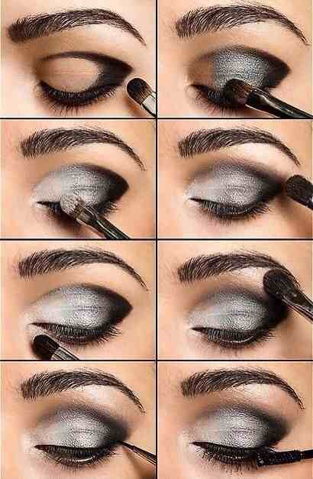
Eyes: All dancers must wear charcoal eye shadow, eyeliner and mascara while performing. We understand that on our younger dancers this may look quite dramatic but the lights on stage will wash out their faces in the DVD. Dancers in age 9-10 classes and above MUST wear false eyelashes. We prefer that the dancers do not wear glasses during performances but if glasses MUST be worn they are to be secured with elastic.
Cheeks: Light pink or apricot blush must be applied to cheekbones
Lips: Red lipstick NO PINK
Earrings: Dance Connection will provide regular or clip on earrings before performances. These are the earrings that MUST BE WORN during all performances and picture day.
Hair: Dancers must wear slicked back in a high bun. Buns should be centered at the crown of the head. All students are REQUIRED to use foam “donuts” to make buns to look uniform. If you have any questions about where to purchase the hair “donuts” or how to use them please ask a staff member PRIOR to performances. All hairpieces are worn on the right side of the head.
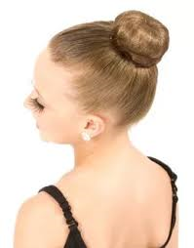
Dancers do NOT wear underwear on stage, tights only. No nail polish. Make sure your dancer has all accessories and shoes before performance days! Dancers without costume pieces do NOT go on stage!
If you need help with hair and makeup, PLEASE ask for it before the day of the show!!!

