D R A F T
EYEMED
Work Packages WORK PACKAGE 5 (WP5)
MENA (Middle East/Northern Africa) Pilots

WP1 Project Management and Coordination
WP2 Communication / Dissemination
WP3 Content
WP4 EU Pilots
WP5 MENA Pilots
WP6 Evaluation / Exploitation

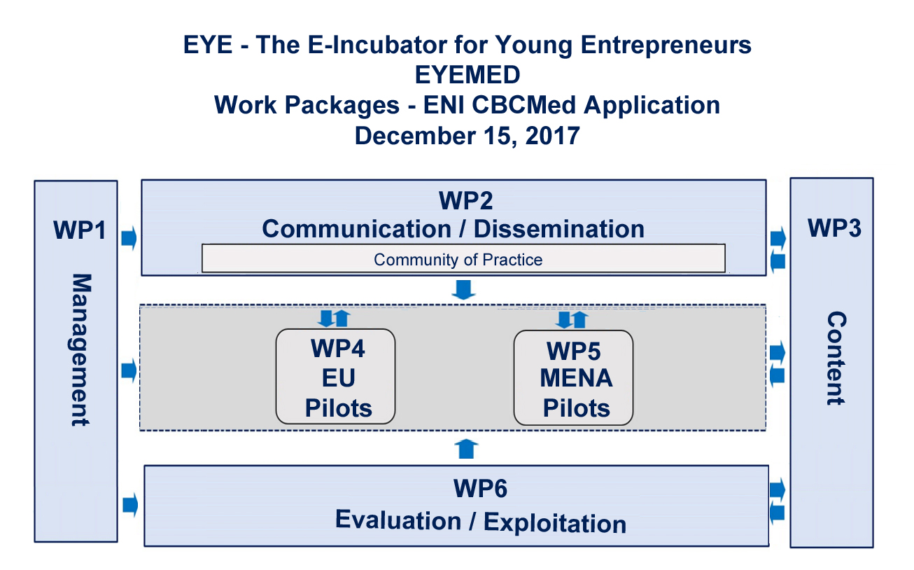
WP5 Partners:
WP Manager: PP4 Jordan University of Science & Technology
Participating partners: PP5 Yarmouk University

WP5 – MENA Pilots

The objective of work package 5 is to prepare for and implement the EYE model in Jordan as a model for other MENA countries (Middle East and Northern Africa) to emulate and replicate. This work package aims to define a common methodology for the measurement of results in order to ensure coherence and comparability both across the MENA pilots within the project and more widely with results from sister pilots taking place in the EU.
- Key Performance Indicators (KPIs) will be defined that take into account the objectives of the two MENA pilots from the point of view of various stakeholders.
- Baseline surveys will determine the educational and training needs of individuals in the MENA pilot areas in Jordan wanting to engage in entrepreneurial endeavors as a source of revenue in lieu of becoming wage-earnings to mitigate the negative effects of unemployment and/or underemployment. These will include environmental studies to include theoretical and empirical contributions to the understanding of the local economic and social consequences of unemployment and underemployment in our target groups (youth ages 24-32, NEETS, professionals leaving their homeland for employment opportunities abroad). Also included will be narratives on the difficulties and obstacles faced when attempting to create an SME or entrepreneurial venture, especially those related to laws or regulations, taxation, etc., dearth of technology/facilities/resources, language barriers, etc., and other impediments of bringing a project such as EYEMED to fruition.
- Benchmarks must be determined
Considering EYEMED as a comprehensive model requires an understanding of the types of activities partners are able to offer in terms of those related to the pre-E-Incubator phase of preparation (i.e. supporting the potential entrepreneur in developing a business idea, coaching and mentoring, workspace and facilities, etc.) and post-E-Incubator activities (i.e. accessing venture capital and other funding, growth and expansion of a start-up, etc. after completing the EYE coursework) available to beneficiaries of the programme.
An important goal of EYEMED is to create a Community of Practice for trainers, instructors and staff of public and private institutions dedicated to back-to-work schemes aimed at engaging targeted beneficiaries in entrepreneurship. By participating in train the trainer workshops, having access to supportive materials and becoming part of a professional network that allows them to exchange ideas and experiences with their peers, EYEMED partners are able to improve the quality of service and become effective facilitators of learning. Upon completion of the train the trainer workshops, they can then return to their country of origin to train others in their organization and increase the number of beneficiaries able to partake in the EYE model.
WP5 breaks down the EYE model through various stages:
- Baseline surveys and environmental studies;
- Assessment of adequate ICTs and broadband to accommodate an appropriate number of beneficiaries during the course of the project (target number: 20 per pilot);
- Identifying, recruiting and preparing beneficiaries for their participation in the project
- Training the trainers for use of the iPortal, instruction on motivating beneficiaries to complete the programming and retention;
- Pre-E-Incubator services, followed by engagement in the EYE coursework and ending with Post-E-Incubator activities.
As mentioned in other work packages, all partners will participate in communications and dissemination, evaluation and exploitation, and project management of their pilot at the local level. However, WP5 cannot be conceptualized until specifics from Partners PP4 and PP5 are received. A questionnaire will be sent within the week of Oct 30-Nov 3 to collect further information in order to further develop WP5.

