VP Advocacy Office Report, Laura Stewart
September 2020
This past month I have had the following meetings, plus sat on an interview panel for a new MCPS position, Director of the Sustainability and Compliance Division. I also represented MCPS in a County meeting, Racial Equity and MoCo Climate Action and Resiliency Plan, by their request.
Black and Brown Coalition, meeting every other week
The coalition is advocating for appropriate supports during the Covid emergency, especially for those that are in “digital deserts” and special populations.
SSP Subcommittee, meeting once a month and as needed.
We are meeting with councilmembers to discuss the upcoming hearing. Katya Marin is writing a response, asking that school planning is considered in the new policy, as well as new development.
Highlights:
Moratoria will only be in Clarksburg area. In Clarksburg, if there is a school that is nearby at 105% capacity, or less, then no moratorium will be implemented. Over 90% of county will have no moratoria or a review by the planning board.
Committee View: Moratoria has not worked and it is rarely implemented. There must be something to replace it so that schools are included in the overall planning.
Impact Taxes will be discounted in areas where growth is desired.
Committee View: In the new policy, they reduced student generation rates in new developments to more accurately reflect the ACTUAL population coming from the new development. This is in effect a discount from the last policy. To further discount means that the true (reduced) impact won’t be paid. There will be double discounts. .
Recordation Taxes will be progressive, making up for some of the revenue lost by Impact Tax discounts.
Utilization Payments will be paid in overcrowded areas.
Past Enterprise Zones would now be subject to impact taxes.
Committee: These generate more CIP revenue and will make up for the reduced Impact taxes. The county has not met forecasts in several years, which leads to MANY delays in CIP projects. T
Advocacy Committee, meeting 1 to 2 times a week
Finalizing the next draft to the Advocacy Priorities.
Charter Amendment Meetings (See analysis below)
Please see the analysis below from Rich Madaleno on why Montgomery County voters should defeat Question B and pass Question A. I suggest we back a Vote Against Question B coalition that includes MCEA and SEIU. If it passes, it takes power from our elected body to respond to a fiscal emergency. We could also back a “Yes on A” initiative which is backed by SEIU and possibly MCEA. This is the “Friedson” amendment and removes the overall property tax cap, but leaves the unanimous requirement to pass any property tax hikes.
Caveat: There is a state provision that MAY allow the county to pass a property tax that would be for schools only. This has not been tried in Montgomery County.
it’s important to grow the tax base but the current structure does not allow us to capture the benefits of an expanded tax base. The mantra has been to grow the tax base to pay for new or expanded services. Fact is, if every square foot of vacant commercial space was filled tomorrow, under the current charter, we could only collect the same amount of revenue as we did last year plus the rate of inflation (plus some new construction.)
A growing economy brings growing needs – increases in school population, public safety (EMS, fire, police), transit and roads, recreation, and parks. Our infrastructure needs are growing and our population is growing but revenues are only based on previous year’s revenues plus inflation.
The existing charter amendment is a relic of a different time period. It was passed in 1990, following a decade of high inflation and soaring property assessments. Today, we look back at a decade in which inflation ran below 2 percent and we look ahead to near-zero inflation. We know that the cost of maintaining local government.
Services grows faster than general inflation, and that we will soon face important new state school funding mandates that far exceed inflation. The charter amendment has increased our reliance on the income tax, which is far more volatile than the property tax and cannot be raised under state law.
In the past, tax rates have varied year to year to stay within the charter revenue limit. Tax rate today is lower than it was 20 years ago. We have the lowest and most variable property taxes among surrounding Maryland counties.
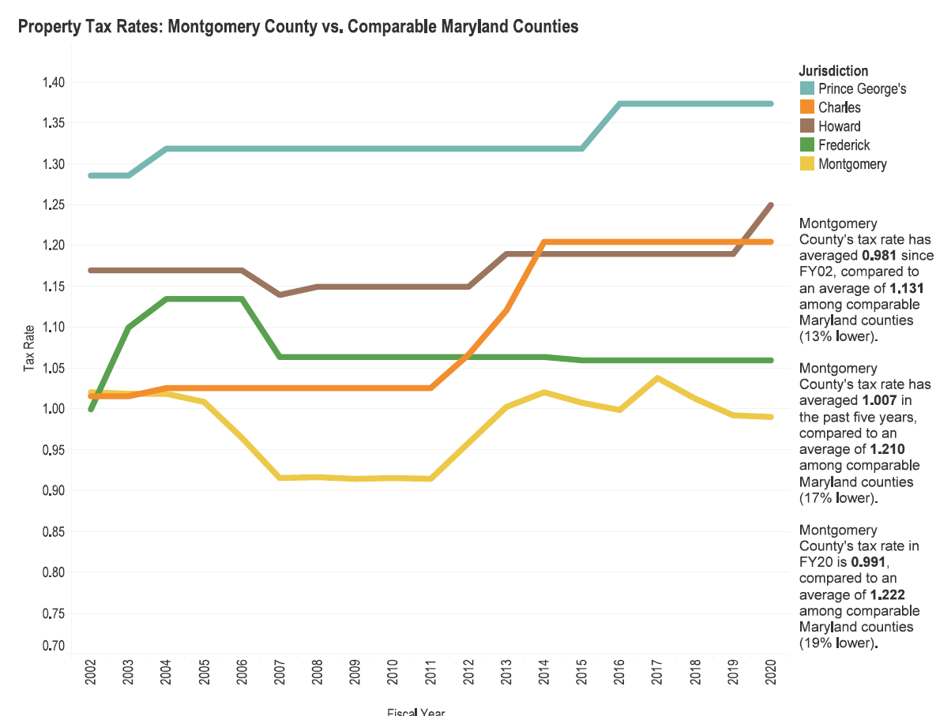

Comparison with the region – there are residential and commercial charts below because DC and VA allow different rates for different types of properties, but in Maryland, the commercial and residential property tax rate must be the same. Montgomery County has the lowest commercial tax rate in the region, and its residential tax rate is right in the middle of the pack.
DC - 85 cents residential vs. $1.85 commercial
If the new Ficker amendment passes which removes the possibility to ever raise total property tax revenue beyond inflation, it is likely that the Wall Street rating agencies that have given us the long running AAA (triple A) bond rating will downgrade Montgomery County, thus costing us more to borrow money to build schools, transportation, recreation facilities, libraries, etc. resulting in even less money for capital project and desired services.

