

**INSPIRATION**

The BEST project you will ever work on is YOU. #motivation

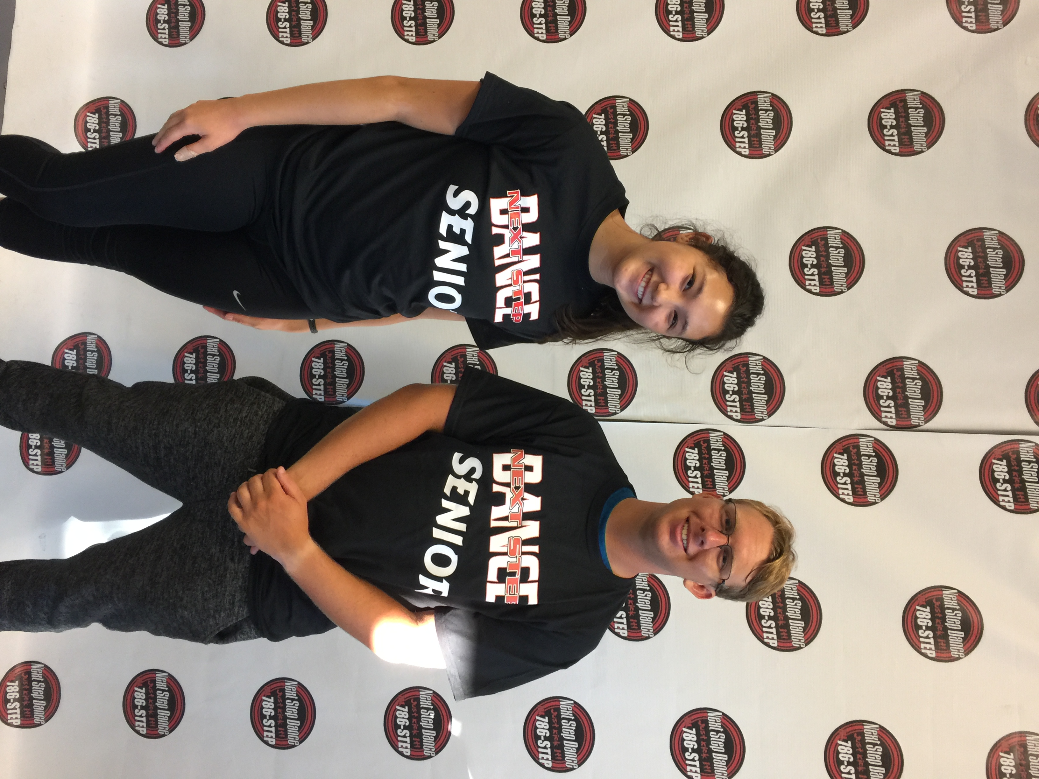

Welcome Back 2019 Seniors!

[**www.thenextstepnc.com**](http://www.thenextstepnc.com)

**7712 Sossamon Lane, NW Concord, NC 28027 (704) 786-7837 nsdcalendar@gmail.com**

***THANK YOU TO OUR 2018-19 COMMUNITY SPONSORS!***



**DUSTIN GRIFFIN**

**Farm Bureau**

**Platinum Sponsor**



**DELISA MACKLIN**

**Dmack LIFESTYLE**

**Platinum Sponsor**



**BRENDA ALEXANDER**

**Drama Kids**

**Gold Sponsor**

**SAVE THE DATE**

Labor Day- 9/3 (no classes)

Hip Hop Friday Night- 9/7

Butter Braid Fundraiser- all month

Make sure your dancer has the correct shoes for their class. You can purchase shoes, tights, leotards, booty shorts, shirts, and anything else you need from us!

Join us on **Facebook** and **Instagram** for what is happening inside the classroom at NSD.

**#class of the month**

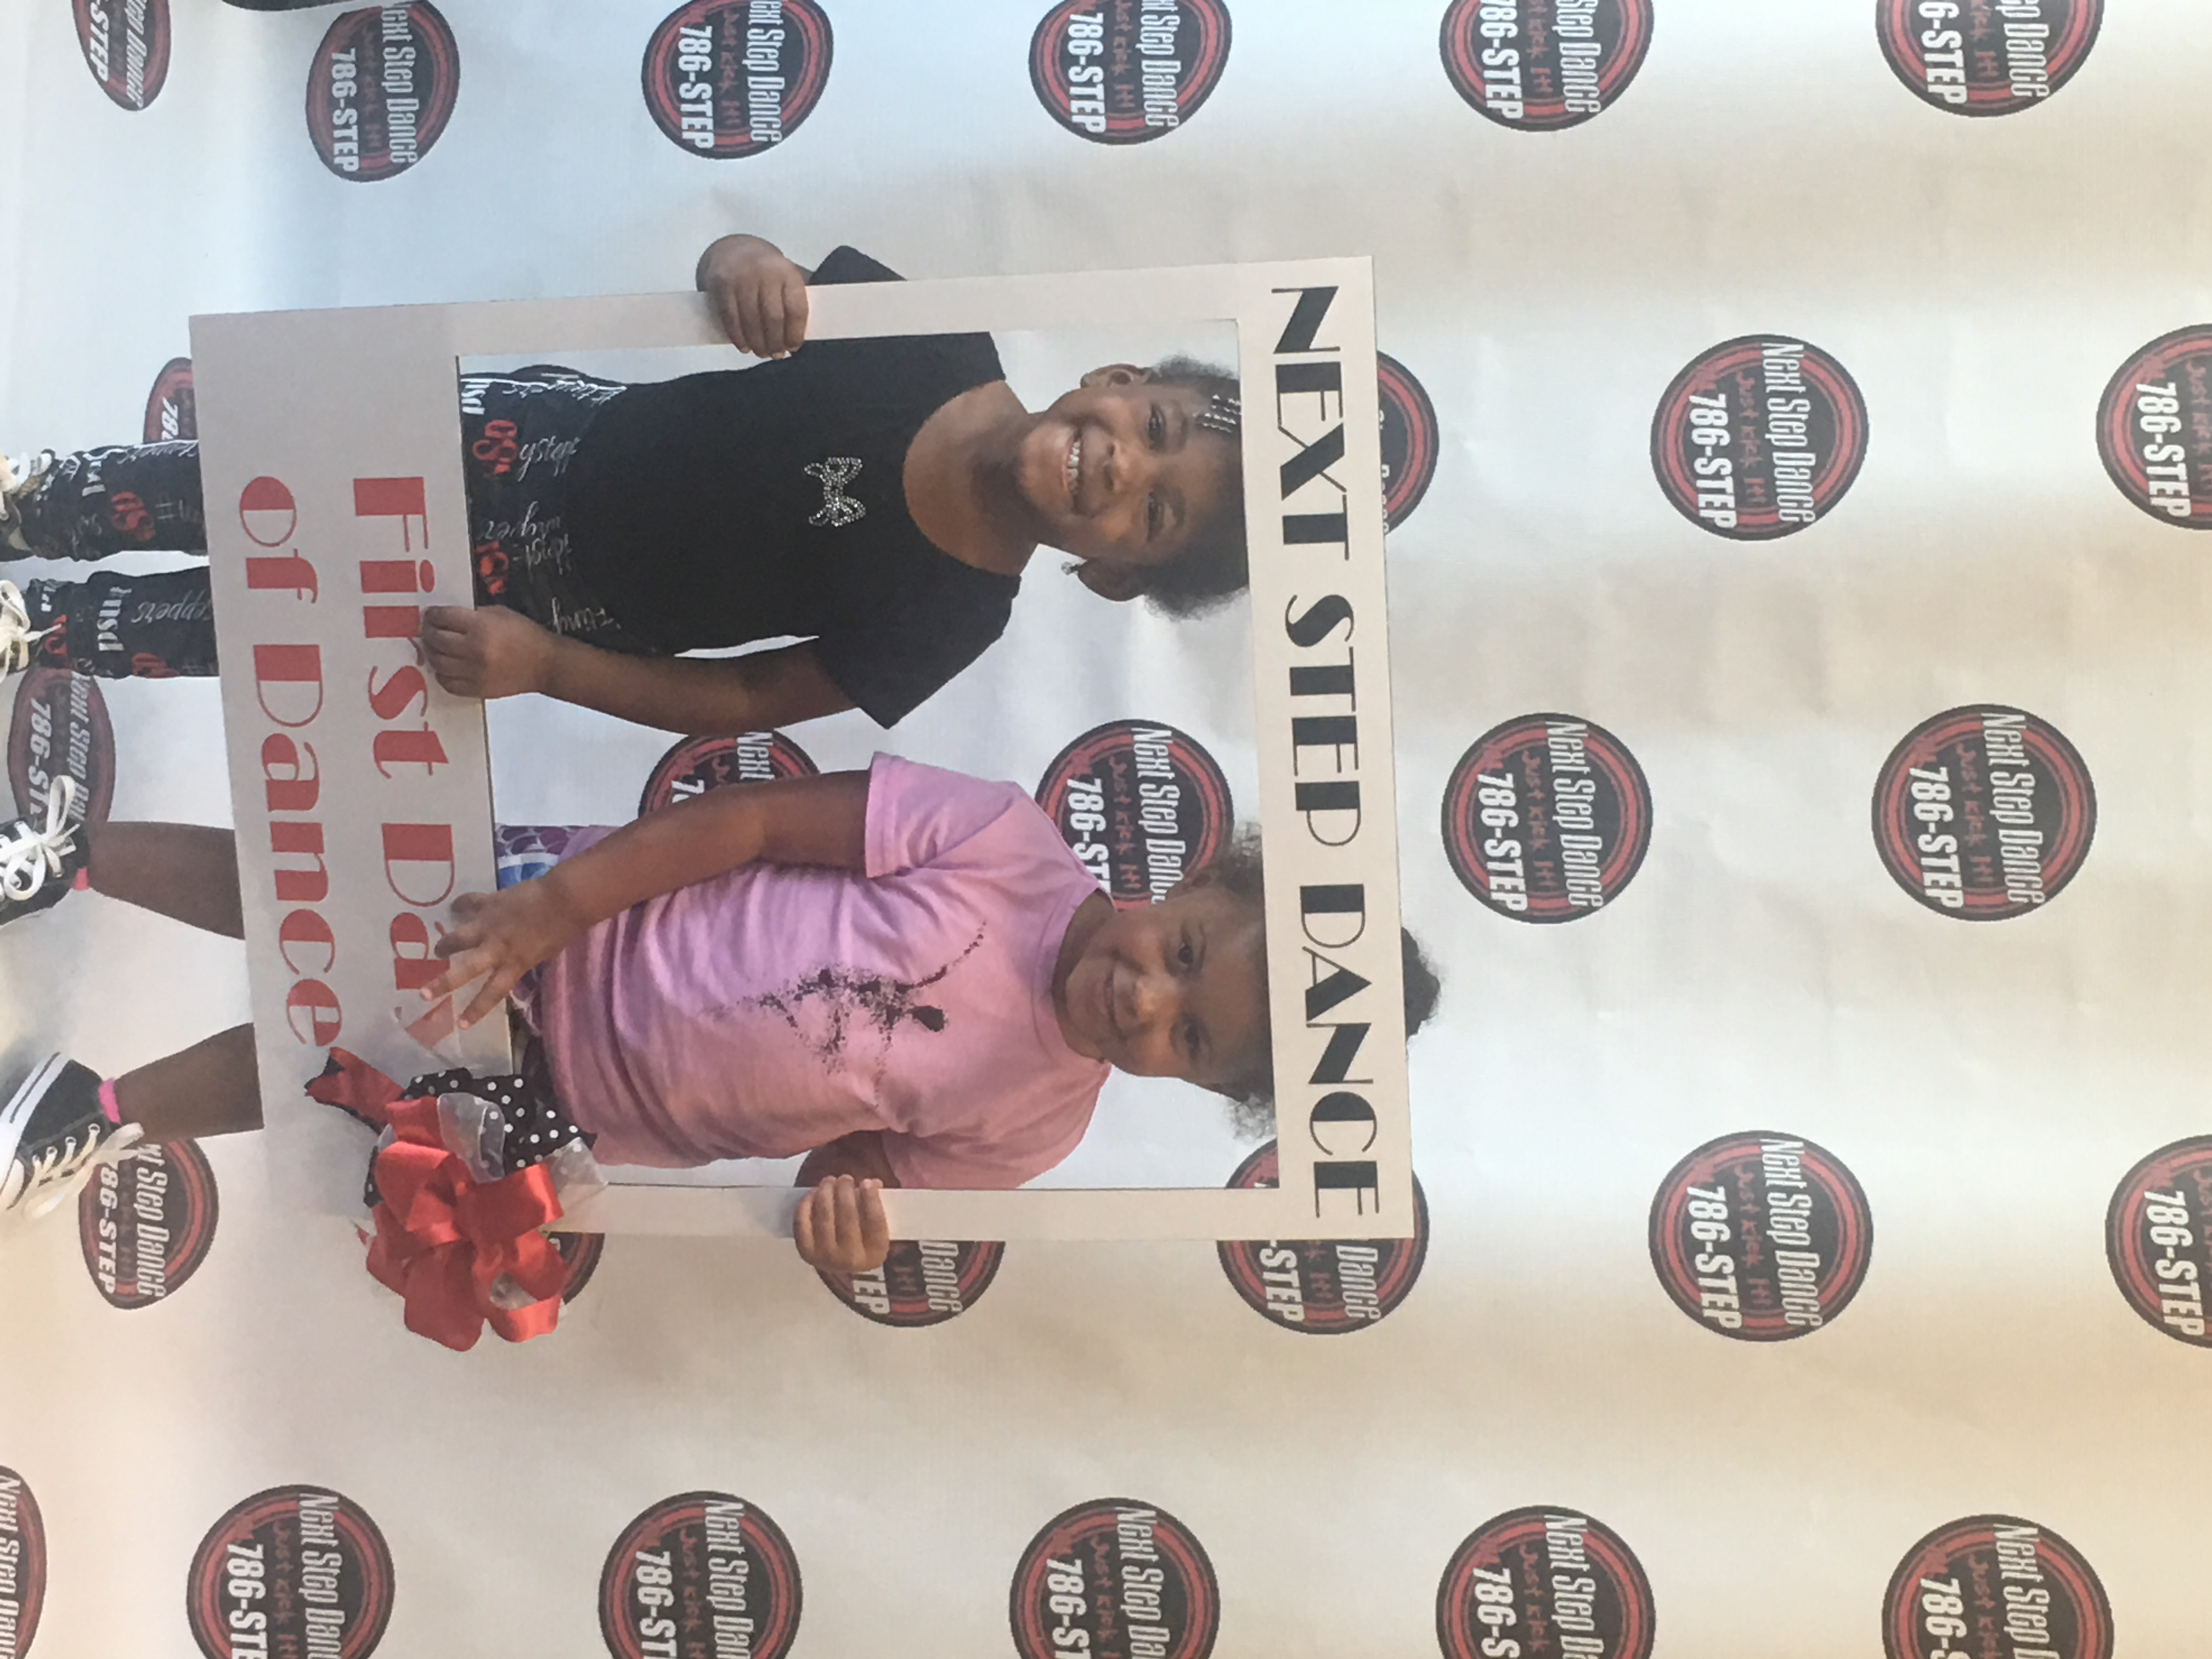

**Tiny Steppers Classes**

**Our sweetest classes in the studio! The 2-4 year old age group of students with energy to spare in Tap & Ballet, Hip Hop, or Ballet/Creative Movement. Register your tiny dancer now.**

**REFERRAL CARDS**

To participate, pick-up referral cards from your teacher or the front desk. Select a family from your friends, relatives, or co-workers that have an interest in their children developing a love for the arts. Movement gets them up off the couch and introduces them to new friends in a nurturing atmosphere of trained professionals that want to share their love of dance.

**Your child enjoys dancing at Next Step Dance,**

**So give someone else the gift of dance with us.**

Fill out the referral card with your child’s name and your friend’s name. Have the selected family call, email, or come by the studio to set up one week of unlimited classes for their future dancer. Directions are on the card for them to read. They can try different types of classes or different days of the week, their choice. We will direct them to the age appropriate opportunities.

When they register their child and pay their registration fee and first month of class tuition, you will receive a $25.00 credit to your account to be used for tuition for the following month. Your child will also receive a gift for bringing a new dancer to our NSD family.

Start today. Our referral cards are ready and waiting!

C:\Users\Stephanie\Pictures\Microsoft Clip Organizer\j0416014.wmf C:\Users\Stephanie\Pictures\Microsoft Clip Organizer\j0416014.wmf

Steppin’ into September 2018 with Next Step Dance

***HIP HOP FRIDAY NIGHT***

***STARTS SEPTEMBER 7thTH!***

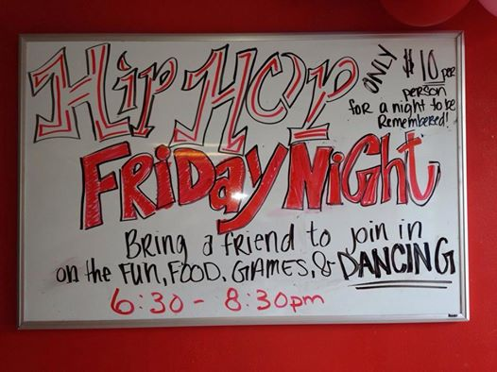

Join us for the first fun Hip Hop Friday Night of the year! Bring friends and have a blast. You don’t have to be a student at Next Step Dance to participate. $10.00 is the cost for 2 hours of dance, pizza, and prizes. Wear your best outfit to impress and win a prize.