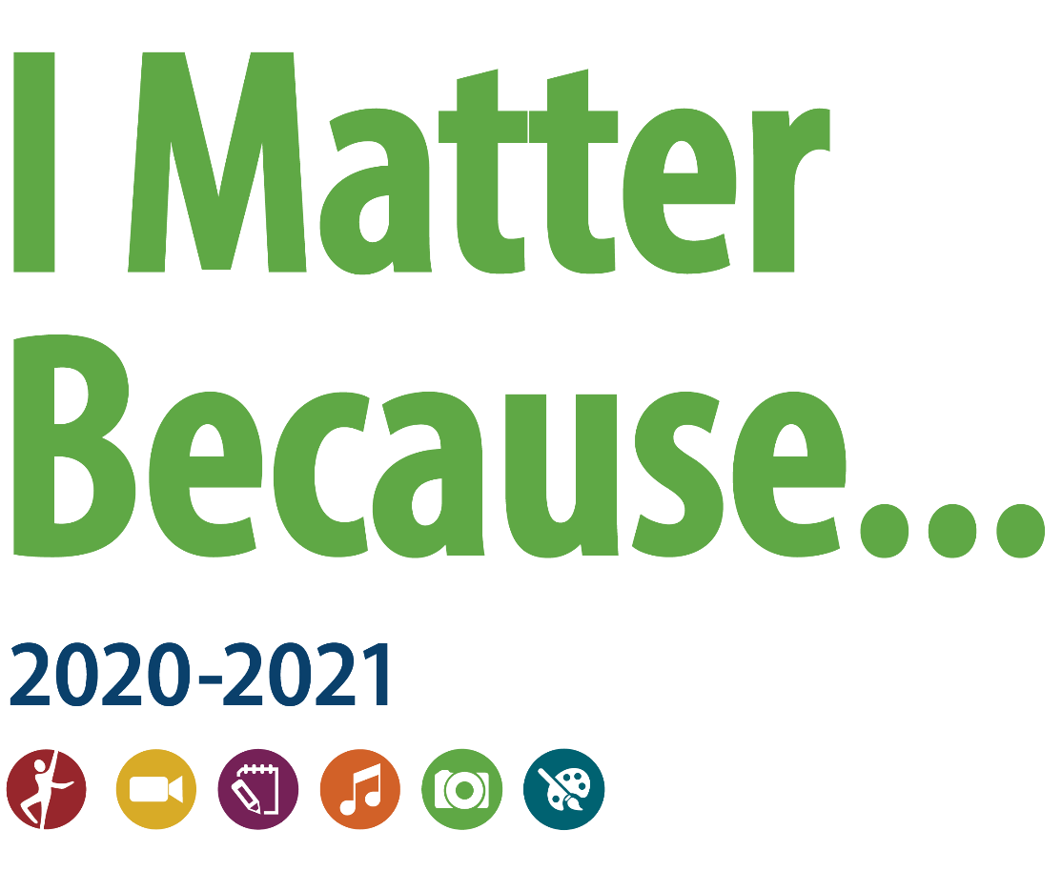
Important Deadlines:
Local PTA Deadline for Artwork Submission: _______________________ (set by each local)
Harford Council PTA Deadline for Artwork Submissions FROM Locals: 18 December 2020
Local PTAs must meet all Maryland PTA Standards of Affiliation before January 29, 2021 in order to participate in the Maryland PTA Reflections Program.

Harford County Council of PTA
Reflections Guidelines
2020-2021

Welcome to the Reflections Program for 2020-2021!
"The cultural arts are wisdom. They are mankind's commentary on the human condition—comedy and tragedy. They are insights into the anguish and ecstasy, the conflicts and triumphs, the failures and aspirations of humanity."
And with this statement, Mary Lou Anderson founded the National PTA's Reflections Program in 1969. That makes this year, 2021, the 52nd anniversary of the Reflections Program. This program engages students in expressions of the cultural arts based on a theme that is selected new each year.
If you are new to Reflections, or if you have questions about the program please do not hesitate to contact the HCCPTA Reflections chair. Contact info is provided in the email that contained this guidance package.
Reflections is an inexpensive program to run, it is student centric, and it gives us the opportunity to recognize additional dimensions of our youths’ talent that isn’t strictly academic or athletic. Every PTA in good standing is eligible to participate in Reflections. Join the 22+ PTAs in Harford County that already offer Reflections to their PTA community. Let’s see all our Harford PTAs reflect on “I Matter Because”.
A word about the COVID 19 pandemic: This year will test our capability to be flexible and patient. Maryland PTA, your Council PTA, and your local will all be striving to present opportunities to students. For Reflections, we may need to get innovative about how we handle art. We may need to run the program as completely electronically as possible. More guidance will follow as we get into the fall and we heed any new guidance from the State of Maryland. So, for students and chairs, plan to make your art available electronically for judging and promoting to the next level of competition. May we all stay healthy and safe as we move through these challenging times.
New Rule changes for 2020-2021—
Dance Choreography and Film Production entries must be submitted in AVI or MP4 format.
Music Composition entries must be submitted in MP3 or WAV format.
Photography and Visual Arts entries must be submitted in JPEG, JPG or PNG format.
Literature entries and scores as required for Music Composition entries must be submitted in PDF format.

Bottom Line Up Front for Locals:
- Locals in Harford County must follow the rules set forth by MDPTA as amended by this Harford County Reflections Guidelines document.
- Local PTAs are asked to visit https://www.pta.org/home/programs/reflections to register your local in the National Reflections Program.
- Harford County locals are asked to use the updated student entry form which is provided with this document. Please do not alter the structure of the student entry form since it is designed to facilitate blind judging at all levels of competition.
- VERY IMPORTANT: HCCPTA Reflections will continue to accept up to FOUR (4) entries in each arts area for each age division from each local. This means HCCPTA will accept from:
  - Elementary school PTAs, up to 24 entries from primary division plus up to 24 entries from intermediate division plus up to 24 entries from special artist division.
  - Middle school PTA/PTSAs, up to 24 entries from middle school division plus up to 24 entries from special artist division.
  - Middle/High school PTA/PTSAs, up to 24 entries from middle school division plus up to 24 entries from high school division plus up to 24 entries from special artist division.
  - High school PTSAs, up to 24 entries from high school division plus up to 24 entries from special artist division.
- Forms for the local participation summary and list of entries submitted to HCCPTA are required to accompany student entries forwarded to Harford Council. Please only list entries that are coming to HCCPTA to be judged—not all that were received at the local PTA level. This information allows the Council to account for entries submitted and makes certain that the correct entries were forwarded. Forms for the list of entries and the local participation summary are separate attachments included in the email transmitting this document.
- HCCPTA has again established the Council award structure so that in each arts area for each age division, HCCPTA will award (as the number of submitted entries permits):
  - Up to 1 Outstanding Interpretation (OI) with a $25 gift certificate;
  - Up to 2 Awards of Excellence (up to 3 if no OI is awarded) and a $10 gift certificate each;
  - Up to 5 Awards of Merit with a $5 gift certificate each.
- The Outstanding Interpretation and two Awards of Excellence (or three Awards of Excellence if no OI) will be the entries in each arts area for each age division that will go forward to Maryland PTA for competition at the state level.
- Harford County results will be announced by 15 February 2021.
Tips for success in the Reflections Program:
The following tips are provided to assist in assuring that Harford students are best prepared to submit winning Reflections entries. Please contact the HCCPTA if you have any questions:
- GENERAL: For each arts category the specifics of the process used to produce the work must be described on the student entry form. Make certain that music is credited where used. Only literature entries do not require any process information on the entry form but word count is required. Both the student and parent/guardian (unless student is 18 or older) must sign the entry form. The detailed instructions for each arts area list specific formatting and packaging requirements.
- LOCAL PTA CHAIRS: Local PTAs must complete the information in the top portion of the entry form. Protect all artwork submitted to HCCPTA but do not shrink-wrap.
- JUDGING AT HCCPTA: Please remind students that the theme is “I Matter Because”. While it is important to encourage students to submit the best work they can, interpreting the theme uniquely and creatively is the most important judging criterion.
Advice on Each Arts Area:
- Dance: Pay close attention to sound levels on the recording and the stability and focus of the camera. Students DO NOT present the artist’s statement to begin the recording.
- Film: Pay close attention to sound levels on the recording and the stability and focus of the camera. THE STUDENT MUST BE THE ONLY CAMERA OPERATOR. If a tripod is used, only the student submitting the entry may make adjustments to the camera (We do allow entries where an assistant holds the camera as still as possible and makes no adjustments -- acting as a tripod.). Many entries have been disqualified because it was obvious that a parent or assistant was adjusting the camera. Students DO NOT present the artist’s statement to begin the recording.
- Literature: Submit the original and two copies if hand-written. If the entry was produced on a computer, include three printed copies and an electronic copy of the work on CD/DVD/flash drive.
- Music: Pay close attention to sound levels on the recording. Notation is required for middle and high school entries. Entries may not include any imported MIDI or other source files or use algorithmic composition software (rhythm or beat boxes). The student must be the author of both the music and lyrics (if any) submitted. Students DO NOT present the artist’s statement to begin the recording.
- Photography: Take high-resolution pictures and enlarge to 8x10 inches where possible. Remember that the limit on size is 8x10 inches for the photo and 11x14 inches including matting. Collages will not be judged as photos but will be judged as visual arts. DO NOT AFFIX THE ENTRY FORM DIRECTLY TO THE PHOTO.
- Visual Art: This includes both 2D and 3D art. The size limit for 2D art is 24x30 inches including any mat but there is no thickness restriction. Protect the artwork but DO NOT shrink-wrap. DO NOT AFFIX THE ENTRY FORM DIRECTLY TO THE ART. 3D artwork must be able to be moved for display purposes. 3D art must include packaging materials and 3 photos of the entry (a combination of angles) for judging, ID and exhibition purposes. Entries that require assembling or repairing after transporting will be disqualified.
Local Reflections Chair’s Checklist
Step 1. Getting Started
- Enroll your PTA at https://www.pta.org/home/programs/reflections using the tab on the right hand side and notify HCCPTA that you have registered.
- Confirm that your local PTA is in good standing and eligible to participate.
- Make sure the Reflections program is included in your PTA’s program budget for the school year.
- Use the HCCPTA Guidelines for program deadlines and student materials.
- Recruit volunteers and engage school personnel and community members for additional support.
- Establish a timeline for your program according to deadlines set by HCCPTA, MDPTA, and National PTA.

Step 2. Promote Your Program
- Distribute program rules and student entry form.
- Promote submission deadline and instructions.

Step 3. Coordinate the Review of Student Submissions
- Collect and organize submissions by category and division. Qualify entries according to category rules.
- Recruit judges to review student works.
- Facilitate judging and support judges as needed.
- Assign awards.
- Prepare eligible works to go on to HCCPTA competition, check student entry forms for completeness and legibility.
- Prepare list of entries going to HCCPTA and local PTA participation summary to accompany the art going forward to HCCPTA.

Step 4. Celebrate Your Student Participants
- Announce awardees to the whole school community.
- Host a Reflections Celebration Event to showcase student work and distribute certificates/awards.

Step 5. Wrap Up and Report Program Success
- Return non-advancing submissions to students.
- Recognize volunteers and evaluate your program to consider future improvements.
- Announce all students awarded at County, State and/or National level to the school community.
OFFICIAL RULES FOR PARTICIPATION
- ELIGIBILITY. Students must participate through a local PTA/PTSA affiliated with the school the student attends. A student may create entries in or out of school.
- ARTS CATEGORIES. There are six arts categories—dance choreography, film production, literature, music composition, photography and visual arts. Students may enter the National PTA Reflections Program in one or more arts categories. See each arts category rules for additional entry requirements.
- GRADE DIVISIONS. Students may enter in the appropriate division for their grade (Primary: Preschool-Grade 2; Intermediate: Grades 3-5; Middle School: Grades 6-8; High School: Grades 9-12; Special Artist: All grades welcome). See Special Artist Division Rules for entry requirements.
- HOW TO ENTER. Entrants must submit their artwork and student entry form to their local PTA/PTSA program according to local and state PTA procedures. Entrants must follow requirements and instructions specific to each arts category and division. Contact local PTA programs for deadlines and additional information.
- ENTRY REQUIREMENTS. (All participants must also follow arts category and if applicable, Special Artist Division rules)
- Only new pieces of artwork inspired by the current year’s theme may be submitted.
- Each entry must be the original work of one student only. An adult may not alter the creative integrity of a student’s work. Because the program is designed to encourage and recognize each student’s individual creativity, help from an adult or collaboration with other students is not allowed except in the Special Artist Division. Other individuals may appear in or perform a student’s work, but the work itself must be the creative product of one student only. Only one student may be recognized as the award recipient for each entry. See the specific arts category rules and special artist division rules for details.
- Each entry must contain a title and include an artist statement. The artist statement communicates what inspired the work, how it relates to the theme, and the content of the work. The statement must include at least 10 words and not exceed 100 words.
- Use of copyrighted material is prohibited, except for background music in dance choreography and film production entries. If used in dance choreography and film production entries, credit for background music must be cited on the entry form. Plagiarized entries will be disqualified. Use of PowerPoint templates is prohibited.
- FINALIST SELECTION AND NOTIFICATION. Entries are reviewed at local, regional, state and national levels. Each PTA determines its own reviewers for the program. Entries will be reviewed primarily on how well the student uses their artistic vision to portray the theme, their originality and creativity. The National PTA Reflections® program makes no restrictions on content or subject matter in artwork. At all PTA levels, the decision of the judges is final and cannot be challenged by parents or students. Each PTA in its sole discretion will select finalists for exhibition and provide awards/prizes. Awards are announced per local and state procedures.
- OWNERSHIP AND LICENSE. Ownership in any submission shall remain the property of the entrant, but entry into this program constitutes entrant’s irrevocable permission and consent that PTA may display, copy, reproduce, enhance, print, sublicense, publish, distribute and create derivative works for PTA purposes. PTA is not responsible for lost or damaged entries. Submission of entry into the PTA Reflections program constitutes acceptance of all rules and conditions.
- PARTICIPATING ENTITIES. This program is administered by the National Parent Teacher Association (PTA) and PTA affiliates. Parent groups not affiliated with National PTA are not eligible to sponsor this program.
Summary of Arts Area Rules
Choose one or more categories below to submit original work that interprets the 2020-2021 PTA Reflections theme: I Matter Because

Dance Choreography: Solo and ensemble works of all dance styles are accepted. Entrant must be the choreographer and may also be the performer, or one of the performers. If background music is used, cite it on the entry form. Video file must not exceed 5 minutes in length or 1,000 MB (1,000 megabyte) in file size and be in MP4 or AVI format.
Film Production: Accepted short film styles include: animation, narrative, documentary, experimental or media presentation. Use of PowerPoint is prohibited. Entrant must be the screenwriter, cinematographer, editor and producer. If background music is used, cite it on the entry form. Video file must not exceed 5 minutes in length or 1,000 MB (1,000 megabyte) in file size and be in MP4 or AVI format.
Literature: Accepted forms of fiction and nonfiction include: prose, poetry, reflective essay, screen play and play script, narrative, and short story. Entrants may write in their primary language as long as an interpretive English translation is also attached. Use of copyrighted material is prohibited. Writing must not exceed 2,000 words and may be handwritten or typed. Accepted formats: single-sided print on 8½x11 inch paper or PDF file.
Music Composition: All music styles and combinations of instrumentation are accepted. Entrant must be the composer and may also be the performer, or one of the performers. Use of copyrighted material is prohibited. Audio recording must not exceed 5 minutes in length or 1,000 MB (1,000 megabyte) in file size and be in MP3 or WAV format. Notation (score/tablature) single-sided print on 8½x11 inch paper or in PDF format is required for middle and high school divisions.
Photography: Photo must be a single print/digital image. Collages and collections of photos are not accepted. Entrant must be the photographer and may use a variety of digital editing techniques including but not limited to, multiple exposure, negative sandwich and photogram. Use of copyrighted material is prohibited. Print image dimensions must be no smaller than 3x5 inches and no larger than 8x10 inches. Accepted print formats: Mounted on mat or poster board no larger than 11x14 inches. Framed prints are not accepted. Digital image dimensions must be at least 640x960 (pixels) and 300 dpi (resolution), and be in JPEG, JPG, or PNG format.
Visual Arts: Works of both fine and design arts are accepted, including but not limited to: architectural drawing and models, ceramics, collage, computer generated images and graphics, crafts, drawing, fashion clothes and jewelry, fiber work, mixed media, painting, printmaking and sculpture. Use of copyrighted material is prohibited. 2D artworks must be mounted on sturdy material and no larger than 24x30 inches with matting. Framed entries are not accepted. Include one digital image of artwork with your submission. 3D artwork submissions must contain 3 digital images of artwork at different angles. Image(s) are used for artwork identification, judging and exhibition purposes. Accepted file formats for images: JPEG, JPG, and PNG.
Special Artist Division Rules
The Special Artist division of the National PTA Reflections Program is optional at state and local levels. Maryland PTA makes the Special Artist division available to Maryland local PTAs.
Student Eligibility:
The National PTA Special Artist division is an option for students with disabilities who receive services under IDEA or Section 504 to have the opportunity and accommodations they may need in order to participate fully in the National PTA Reflections Program. The Special Artist division offers modified rules and guidelines to ensure that every student has the chance to be part of the National PTA Reflections program.
Who qualifies as a disabled individual under the law?
The ADA defines an individual with a disability as a person who:
(1) Has a physical or mental impairment that substantially limits one or more of the major life activities of that person;
(2) Has a record of such an impairment; or
(3) Is regarded as having such an impairment.
Student Entry Process:
Students who identify as having a disability have two ways to enter the National PTA Reflections Program:
- Option 1. Enter in traditional grade divisions: Qualifying students follow all arts category rules, and may not receive assistance other than that which is allowed for all children, but do receive accommodation to submit Reflections entries in the grade division most closely aligned to their functional abilities. They are recognized and awarded prizes as part of the general student population without regard to special needs or challenges.
- Grade Divisions: Regardless of age, students with special needs may enter the National PTA Reflections Program in the grade division most closely aligned to their functional abilities. The divisions are as follows:
Primary: preschool – grade 2 Middle School: grades 6 – 8
Intermediate: grades 3 – 5 High School: grades 9 – 12
- Option 2. Enter in Special Artist division: Qualifying students entering this non-grade-based division create their own artwork, but may receive non-artistic accommodation and assistance from an adult.
- Parent or Guardian Signature: The student and family will complete a student entry form. A parent or guardian signature is required for all students entering the program in the Special Artist division, regardless of the student’s age.
- Judging Procedure and Awards: At the national level, Special Artist entries will be judged by expert judges in each arts category. The top Special Artist entry from each of the six arts categories will then be reviewed. One Special Artist from across all arts categories will be selected to receive an Outstanding Interpretation Award and will be recognized at National PTA’s Annual Convention. Up to five additional Special Artists may be selected to receive national Awards of Excellence.
Special Artist Accommodations and Guidelines:
Special Artists should follow the general rules and guidelines outlined in the Arts Category Student Rules specific to their submissions, modified only by accommodations for individuals with disabilities. The accommodation, in general, should be both specific and limited to the student’s disability.
- Allowable Accommodations: Given the diverse range of physical and mental disabilities that exist, it would be impossible to outline specific accommodations for each and every disability, but the following provides a non-exhaustive list of allowable accommodations:
- The Special Artist Division will not be divided by age or traditional school grade level
- Use of adaptive technology is allowed
- All submissions must be solely created by the Special Artist. However, a parent/guardian, teacher, or other adult may assist the Special Artist with typing, holding a camera, etc.
- Accommodations that are Not Allowed: Individuals providing assistance to Special Artists may not, in any way, involve themselves in the actual artistic process by:
- Selecting a title for artwork
- Writing, editing, or interpreting a student’s artist statement, story, poetry, or script
- Choreographing a dance, composing music, or writing lyrics
- Drawing, painting, or personally creating a visual arts submission; choosing a camera angle, etc.
Guidance for Filling Out the Student Entry Form
Council and State are filled in for you.
Local PTA chair must fill out information at the top of the form. We recommend that local chairs fill out as much of this portion of the form as possible before duplicating for distribution to students. Good standing information will have to be completed later for the entries that come forward to Council.
Make sure student and parent/guardian information is legible and complete. Please ensure that this information is accurate since winners are notified using this data.
Both student and parent/guardian must sign student entry form unless student is 18 or older. Entries submitted in the Special Artist category must always be signed by a parent/guardian.
Note that the form has been redesigned to allow information for judges to be at the bottom of the form. This new design facilitates blind judging.
Make sure grade division and arts category are checked appropriately. Only one grade division and only one arts category should be checked.
STUDENT MUST INCLUDE TITLE AND ARTIST’S STATEMENT ON THE ENTRY FORM.
We strongly recommend that the student not use the theme as the title.
Depending on the arts category, the lines for artwork details must include:
Dance – credit music (with title, composer, performer, and lyricist)
Film – camera used, editing software, credit music (with title, composer, performer, and lyricist), list of those appearing in film
Literature – word count of composition
Music – list of those performing the piece, list of instruments used, music composition software (if any)
Photography – camera used, kind of process to prepare photo, location and date of shot, dimensions of picture (up to 8x10 inches), dimensions with matting (up to 11x14 inches)
Visual Arts – describe medium used, dimensions of artwork, dimensions with matting (2D only; up to 24x30 inches)
Encourage the student to be creative in the artist’s statement and be persuasive about why the work relates to the theme.

Other Reflections Opportunities
National PTA Reflections sponsors a student-focused Theme Search Contest annually to determine a theme for two years later. The winner for the 2020-2021 school year will be selected in January 2021 and will receive $100 from National PTA and recognition at the 2021 Annual PTA Convention.

Maryland PTAs deadline for 2020-2021 theme search contest submissions is November 6, 2020 (NO EXCEPTIONS!!!). For theme search student entry form and a list of past themes, see Appendix 10.

Mary Lou Anderson Reflections Arts Enhancement Grants: The National PTA Mary Lou Anderson Grant Program provides matching-dollar funding to local PTAs to support in-school and after-school arts enhancement programs in local communities. PTAs serving at-risk student populations are particularly encouraged to apply. Applications will be available at PTA.org/Reflections in January 2021.
For more information, visit: PTA.org/Reflections
Maryland PTA Standards of Affiliation
Local Chairs - check with the State Office to make sure your PTA unit meets all requirements before sending entries to the council or state for judging. Units not meeting the Standards of Affiliation by January 29, 2021 will have any submitted Reflections entries disqualified at Maryland PTA.
- Adhere to the purposes and basic policies of the National PTA and Maryland PTA;
- Remit the national and state dues to the Maryland PTA office by dates designated;
- Have bylaws approved every three (3) years according to the procedures of Maryland PTA;
- Have a minimum of twenty-five members;
- Shall submit the names and contact information including phone number, address and e-mail address of all elected officers to the Maryland PTA office within two (2) weeks of their election;
- Remit bonding and liability insurance premiums by the date designated;
- Have an EIN (Employer Identification Number) from the Internal Revenue Service (IRS) on file with the Maryland PTA;
- Maintain its status as a corporation, have as required by MD Non-Profit law, at a minimum a president, secretary, and treasurer;
- File the appropriate tax forms, by the required dates, with the IRS and submits a copy to the Maryland PTA office within thirty (30) days of filing;
- Each local PTA shall submit a copy of its annual financial review to the Maryland PTA within 120 days following the local fiscal year end of June 30th.
- Files all appropriate state forms with the appropriate state authorities by the required date and submit a copy to the Maryland PTA office within thirty (30) days of filing;

