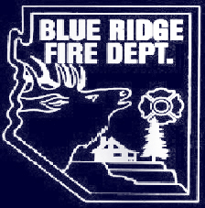
BLUE RIDGE
FIRE DISTRICT
COCONINO
COUNTY,
ARIZONA

NOTICE OF POSSIBLE QUORUM OF THE GOVERNING BOARD OF THE BLUE RIDGE FIRE DISTRICT

NOTICE IS HEREBY GIVEN that a quorum of the Governing Board of the Blue Ridge Fire District may be present at the following event, but they will not conduct any business of the Blue Ridge Fire District and will not be making any decisions:

BRFD AUXILIARY
ANNUAL APPRECIATION DINNER
Saturday, August 2, at 5:00 p.m. at the
Blue Ridge Fire Station
5023 Enchanted Lane, Happy Jack, Arizona

Dated this 30th day of July, 2014.
Respectfully submitted,
original signed by Alma Seward

Alma Seward, Clerk of the Board

