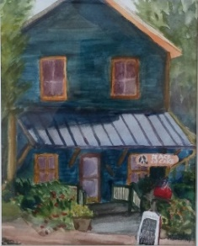
Kent Island Federation of Art Presents:
Artists Paint Stevensville
2024 Event Calendar

Wednesday, May 29, 2024
7:30 – 9:00 am Early Registration* –Get paper/canvas stamped, pick up information packet, and start painting! Light refreshments included.
4:00 - 6:00 pm Welcoming Registration Meet & Greet for the Artists* held at the Kent Island Federation of Arts, 405 Main St. Stevensville MD. If artists have not done so, they can check in, get their paper and canvas stamped, and pick up their information packet. Artists may choose to do a nocturnal painting.
Thursday, May 30, 2024
7:30 – 10 am – Additional registration for artists. Artists paint all day on Kent Island and
surrounding area as designated on the Map. Nocturnal painting planned at Kent Narrows.
KIFA open to the public and artists 1-4pm

Friday, May 31, 2024
Artists paint all day. Artists bring their paintings for judging to Kent Island Kent Island Federation of Arts by 4:00 pm. Judge TBA. Each artist will be allowed a 3 X 6 standard to hang additional pieces from the week for the Wet Paint Sale. Judging 4:30 pm, Wet Paint Sale and Viewing of artwork 5:00 to 7:00 pm
Saturday, June 1, 2024
Quick Draw Competition – Artists Paint Historic Stevensville
9:00-11:00 am - Quick draw artists register at KIFA.
11:00 - 1:00 pm – Artists paint against the clock in the Historic District
1:00 – 3:00 pm Youth Artists Quick Draw (Register at KIFA by 1:00)
2 groups: under 12 & 12 – 18yrs.
1:30 – Judging of the Quick draw pieces will be held. Judge:
2:00 – 3:30 pm - Off the easel sale
3:30 – Youth Quick Draw judged. Judges:
4:00 – Artists return to KIFA with their Plein Air pieces from the 4 days to be hung.
5:00 – 7:00 pm – Reception for the artists and viewing of the artwork from the Competition

*Artists will be given maps in their packets at registration designating prime areas to paint as well as name tags and handouts for viewers. All artists must have their canvases and paper stamped at KIFA 405 Main Street, Stevensville.

Email or call Maureen Wheatley at reeniart@gmail.com / 410-739-0850 for other arrangements or questions..

