BELBROUGHTON AND FAIRFIELD PARISH COUNCIL
(BROMSGROVE DISTRICT)
Ruth Mullett 167 Bromsgrove Road
Clerk Hunnington
belbroughtonpc@live.co.uk B62 0JU
07967 501943

To Members of Belbroughton Parish Council

Notice is hereby given that the next meeting of the Finance Committee will be held on Monday 16th October 2023, 7.30pm at Belbroughton Recreation Centre.

BUSINESS OF THE AGENDA

- APOLOGIES
Council to receive apologies and to approve the reason for absence.

- DECLARATIONS OF INTEREST
To declare any Disclosable Pecuniary Interests (DPI) in items on the agenda and their nature (a DPI relates to anything on the member’s entry in the Member’s Register of Interests).

To declare any Other Disclosable Interests (ODI) in items on the agenda and their nature.

Councillors who have declared a DPI or ODI must leave the room for the relevant item unless granted a dispensation on specific grounds to stay/speak; the request for a dispensation must be put in writing to the Clerk in advance of the meeting.

- DISPENSATIONS
To consider any request for dispensation from a member who may have a DPI or ODI to allow them to stay/speak/vote in the meeting during consideration of the item.

- MINUTES OF THE PREVIOUS MEETING
To agree the minutes of the meeting held on16th August 2023 (Attached).

- BANK RECONCILIATIONS
To note the Bank Reconciliation, Balance Sheet and Profit and Loss for the council’s operational account and to appoint a councillor to conduct the next month’s reconciliations (Attached)

6. ACCOUNTS FOR PAYMENT
- To consider payments due in the current month (Attached)
- To confirm receipt of £35,000.00 half yearly precept from BDC

7. MAINTENACE WORK
- To receive update on Parish Maintenance Contractor
- Any other urgent maintenance works.

8. INTERNAL AUDITOR
To discuss and RESOLVE to instruct John Benner as Internal Auditor for 2023/23.

9. Date of next meeting – Monday 20th November 2023, 7.30pm at Belbroughton Recreation Centre.

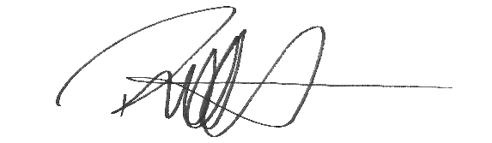

Signed ……………………………………………
Ruth Mullett, Clerk to the Council
9th October 2023

