RSAI 2021 Position Paper:
COVID-19 Learning Loss

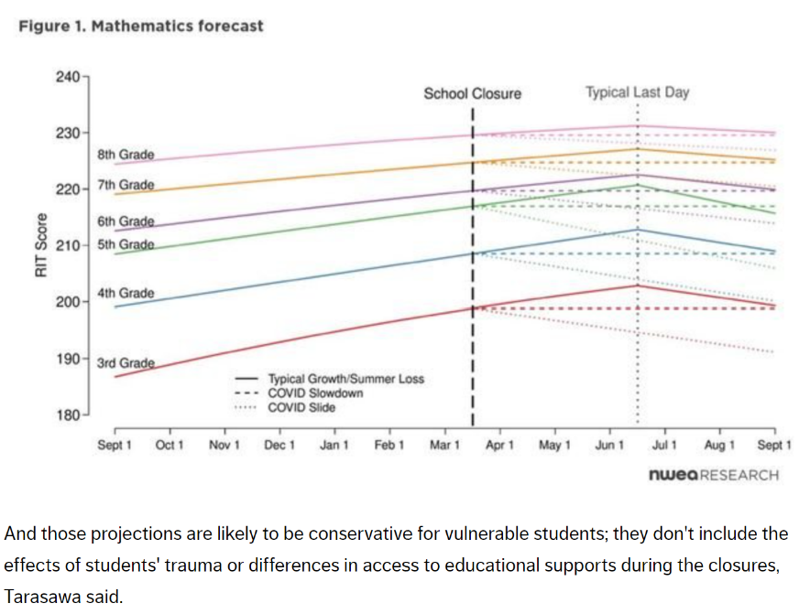
History: Before the COVID-19 pandemic interrupted the learning of Iowa’s students last March, Iowa policymakers considered the impact of instructional time on student learning, including the summer slide, which is the term for lost learning over the long summer break. The Iowa DE convened an Instructional Time Task Force, as directed by the 2012 Education Reform Legislation. The Task Force’s Final Report, October 2012, focused on the goal of increased student achievement. Ideas of counting hours instead of days, school start date, calendars and more time were emerging. In many cases, there was a focus on the impact of instructional time on student demographic groups. Lack of funding for implementation of additional time was mentioned throughout the report. In 2012, Education Next showed the estimated effect of adding 10 days of learning for 3rd graders, which exceeds the impact of repeating a grade, having a better teacher or reducing class size.

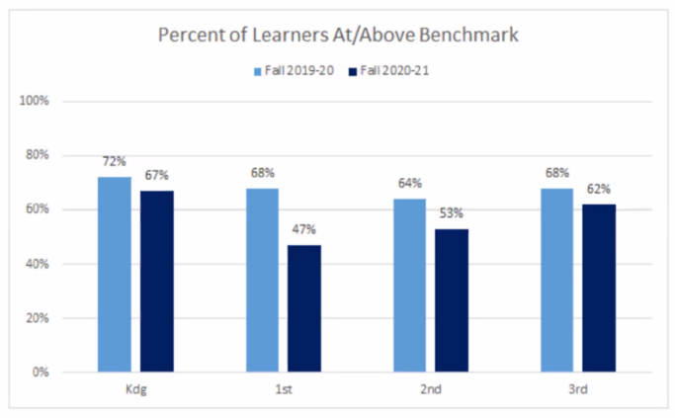
So what does the COVID closure last Spring mean for students? Education Week’s Inside Research Report, Academically Speaking, the 'COVID Slide' Could Be a Lot Worse Than You Think, April 9, 2020, stated, “Prior research on summer learning loss has found students can lose somewhere from two weeks to two months of academic growth over the summer. But NWEA's projections suggest learning loss related to these (COVID) closures would be anything but typical: If students return to school campuses in the fall without continuity of instruction during the closures, they could have retained only about 70 percent of their reading progress, compared to a normal year.” And math looks worse: “Depending on the grade, students were projected to lose anywhere from half to all of their academic growth from the last year, compared to normal student growth.”

Current Reality: Is this kind of learning loss likely in Iowa? The Iowa State Board of Education held an early literacy workshop at their Nov. 18 meeting, during which they discussed the results of early literacy FAST testing for the kindergarten-3rd grade classes of 2020-21. All grades showed learning loss compared to the prior Fall testing results, with 1st and 2nd grade classes showing significant loss.

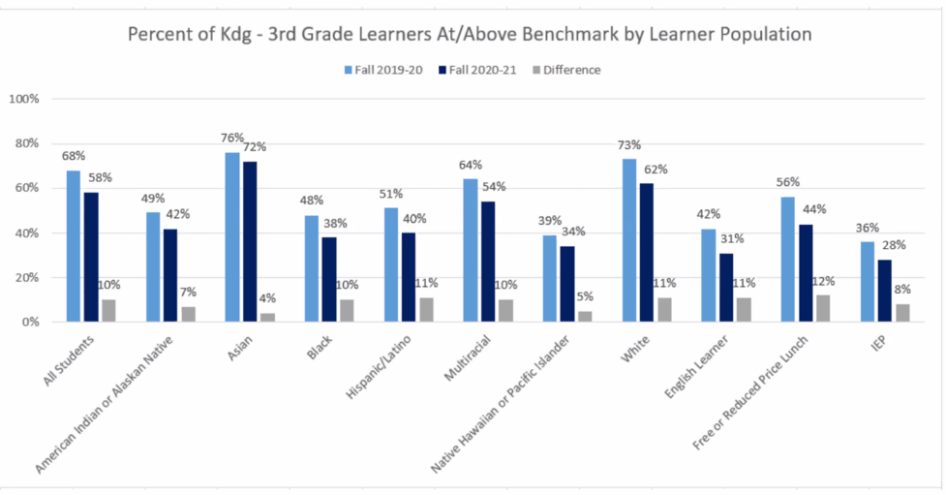
COVID Slide Impacts all Demographic Groups: The longitudinal data trend for all four grade levels shows greater learning loss than previously experienced due to a summer slide alone, following the 3- to 4-month closure of schools in Spring or 2020. The State Board members discussed this chart, which shows the learning loss by learner population:

Note the most significant loss, 12%, for Free and Reduced Price Lunch eligible students, which is a measure of low-income, although all learner population groups lost ground.

How long will this last? Although experience varies by district and community, there are many students in Iowa without full-time access to school. Balancing the needs of students and staff safety with the need for academic success is very challenging. School leaders want to have all students back in school full time, but that may not be an option for the remainder of the school year until a vaccine is widely distributed and COVID-19 is history. In the meantime, Iowa school leaders, educators, parents and communities are working double duty to keep students on track. Additionally, social-emotional and behavioral supports are increasingly necessary as students, their families, and staff face the mental health challenges of this pandemic.

Solutions: Possible solutions to recover lost learning (the Legislature is strongly encouraged to provide great flexibility to local school boards to choose the investments most likely to close the gap for their students):
- Adequate base funding so districts can pay a competitive wage and benefit packages to school employees, fill vacant positions, hire enough substitutes to fill in for other staff due to illness or quarantine, provide appropriate practices for cleaning and socially distancing, and make sure there are sufficient bus drivers, food service workers and paraprofessionals to fully staff school every day.
- Provide additional learning time: funding for more school days, possibly summer school, especially for targeted students for whom the learning loss is significant and has not recovered during the 2020-21 school year. The Instructional Time Task Force estimated the cost of a day for all students statewide at $15 million in FY 2013.
- Teachers and other staff need professional development in building skills to connect with students virtually, assessing student progress and providing appropriate individualized and small group instructional supports for all students.
- Schools will continue to experience elevated costs of equipment, technology, and cleaning needs, as well as additional staffing to meet safety protocols, as long as COVID-19 is a threat.
- Early preventive efforts, focused on preschool through 3rd grade should be at the top of the list.
See related RSAI Position Papers on Adequate School Funding; Opportunity Equity for Low-Income Students; Preschool; Assessing Social-Emotional and Behavioral Health for Staff and Students; and Educator/Staff Shortages for additional COVID-19 impact. These can all be found on the RSAI Legislative Web Page: http://www.rsaia.org/2021-legislative-session.html

