REGULAR MEETING
APRIL 21, 2022
The Regular Meeting of the Town Board of the Town of Hampton, County of Washington and the State of New York was held at the Town Hall, 2629 State Route 22A, Hampton, New York, also via Zoom and live streaming on the You Tube Channel for “Town of Hampton New York” on the 21st day of April 2022.

Due to the Corona Virus, occupancy inside the Town Hall is limited at this time. Supervisor O’Brien did provide a link to join the meeting via Zoom.

PRESENT: David K. O’Brien------------Supervisor
Donald Sady-----------------Councilman
Tamme Taran----------------Councilwoman
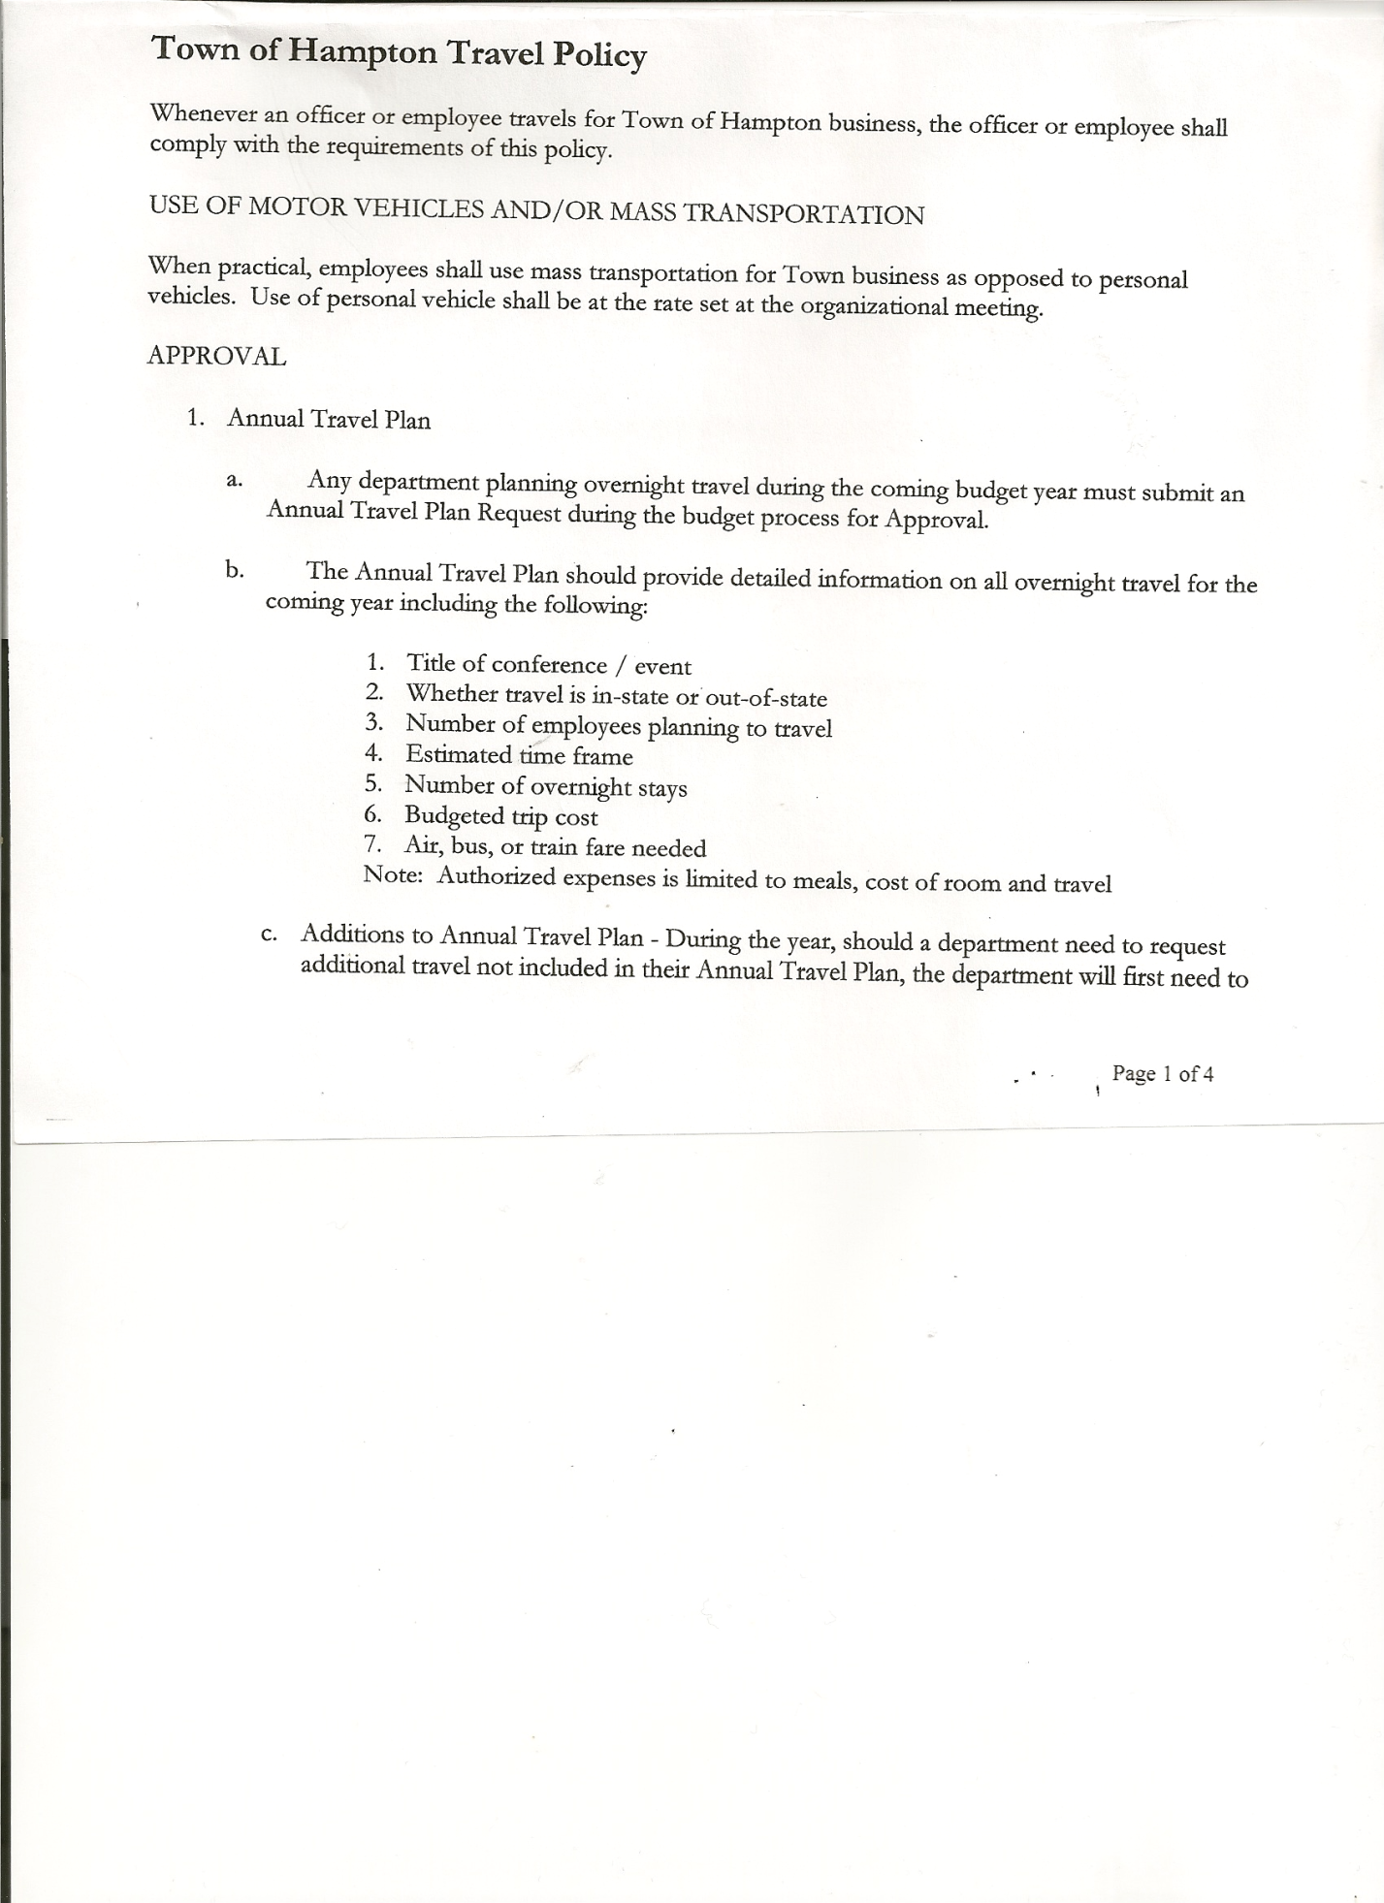
Michael Pietryka------------Councilman
Travis Dean------------------Councilman - absent
Rebecca Jones---------------Town Clerk
Camilla Shaw----------------Tax Collector/Deputy Town Clerk – via zoom
Tyler McClure---------------Highway Superintendent

Planning Board Member (s):… Bonnie Hawley, Chair; Matthew Pratt and Richard Cole
Others present at the Town Hall: Karen Spaulding & Heather Gale, Artie Pratt and Leonard Reed

The Regular Meeting was called to order by Supervisor O’Brien at 7:30pm, followed by the Pledge of Allegiance. Location of Fire Exits were given. Quorum of board members present.

Supervisor O’Brien asked that Karen Spaulding and Heather Gale, in memory of Jeremy Spaulding, join him in reading the “Workers’ Memorial Day” Proclamation. Copy of Proclamation is attached.

RESOLUTION NO. 29-2022
APPROVAL OF THE MINUTES
On a motion of Councilwoman Taran, seconded by Councilman Sady, the following resolution was ADOPTED: AYES 4 O’Brien, Sady, Taran, Pietryka
NAYS 0
ABSENT 1 Dean
RESOLVED, that the Regular Town Board Meeting Minutes for March 17, 2022 are approved.

Larry Carman, Dog Control Officer submitted his report dated 4/18/22 which was read by Supervisor O’Brien, copy of report is attached. Larry also submitted his DCO report dated 3/18/22, copy of that report is also attached.

Camilla Shaw, Tax Collector….. Submitted her March/April 2022 Report to the Board for review. Also Submitted Bank Statement to the Board for review and signatures.

Bonnie Hawley, Chair gave Planning Board Report……copy of the minutes of their meeting held April 21, 2022 are attached. Next meeting is planned for May 11th, 2022 at the Town Hall.

TOWN BOARD MEETING
APRIL 21, 2022 PAGE 2

Tyler McClure, Highway Superintendent submitted his report, copy of which, is attached.
Following a discussion on the contract price for mowing the roadsides for the County in the Town, the following Resolution was introduced.
RESOLUTION NO. 30-2022
COUNTY ROADSIDE MOWING CONTRACT
On a motion of Councilman Sady, seconded by Councilwoman Taran, the following resolution was ADOPTED: AYES 4 O’Brien, Sady, Taran, Pietryka
NAYS 0
ABSENT 1 Dean
RESOLVED that, Tyler McClure, Highway Superintendent, be authorized to sign the Washington County Mowing Contract for 2022.

Following Tyler’s request to attend Highway School in June, the following Resolution was introduced.
RESOLUTION NO. 31-2022
HIGHWAY SUPERINTENDENT SCHOOL
On a motion of Councilwoman Taran, seconded by Councilman Sady, the following resolution was ADOPTED: AYES 4 O’Brien, Sady, Taran, Pietryka
NAYS 0
ABSENT 1 Dean
RESOLVED that, Tyler McClure, Highway Superintendent is authorized to attend the 202c cxd2 Highway School at Ithaca College from June 6th to June 8th, 2022.

SUPERVISOR’S REPORT/ COUNTY UPDATES/ COMMUNICATIONS

RESOLUTION NO. 32-2022
APPROVAL OF SUPERVISOR’S MONTHLY REPORT
On a motion of Councilman Pietryka, seconded by Councilman Sady, the following resolution was ADOPTED: AYES 4 O’Brien, Sady, Taran, Pietryka
NAYS 0
ABSENT 1 Dean
RESOLVED that, the Supervisor’s Monthly report be accepted as submitted for MARCH
02/28/22 03/31/22
ACCOUNT BALANCE RECEIPTS DISBURSEMENTS BALANCE
General Fund $ 62,484.37 $ 751.25 $ 6,574.23 $ 56,661.39
Highway Fund $419,362.38 $ 10.33 $ 51,654.66 $ 367,718.05
Equipment Reserve $ 79,927.34 $ 35,002.27 $ 0.00 $ 114,929.61
Fire #1 $ 44,163.00 $ 0.00 $ 0.00 $ 44,163.00
Fire #2 $ 10,404.00 $ 0.00 $ 0.00 $ 10,404.00
Cemetery $ 1,756.19 $ 1.44 $ 0.00 $ 1,757.63
Totals $618,097.28 $ 35,765.29 $ 58,228.89 $ 595,633.68
All Board Members present signed Supervisor’s Report.

Supervisor O’Brien informed the Board that County paving is up 23%. He also said that the County would be receiving $273 million over a 30 year period for a transmission line that is to run from Canada to New York City.

TOWN BOARD MEETING
APRIL 21, 2022 PAGE 3

OLD BUSINESS
UPDATED Stimulus Funds Proposed Usage (copy is attached). Following a discussion regarding the funds, the following resolutions were introduced.
RESOLUTION NO. 33-2022
APPROVAL OF DIESEL TANK REPLACEMENT
On a motion of Councilman Sady, seconded by Councilwoman Taran, the following resolution was ADOPTED:
By Roll Call: Supervisor O’Brien AYE
Councilman Sady AYE
Councilwoman Taran AYE
Councilman Pietryka AYE
Councilman Dean ABSENT
RESOLVED that monies from the Stimulus Fund, approximately $11,000.00 be approved to replace the Diesel Fuel Tank for the Highway Department.
RESOLUTION NO. 34-2022
APPROVAL TO MOVE THE BALANCE OF STIMULUS FUNDS
On a motion of Councilman Sady, seconded by Councilman Pietryka, the following resolution was ADOPTED:
By Roll Call: Supervisor O’Brien AYE
Councilman Sady AYE
Councilwoman Taran AYE
Councilman Pietryka AYE
Councilman Dean ABSENT
RESOLVED that, the balance of the Stimulus Funds, approximately $25,000.00 be added to the Paving Budget for 2022.

NEW BUSINESS
New York State Retirement. Following a discussion regarding a letter received from NYS Retirement system, the following resolutions were introduced. The Standard Workday and Reporting Resolution needed to be amended and Tyler’s information needed to be added.
RESOLUTION NO. 35-2022
RETIREMENT CALENDAR FOR HIGHWAY SUPERINTENDENT
On a motion of Councilwoman Taran, seconded by Councilman Sady, the following resolution was ADOPTED: AYES 4 O’Brien, Sady, Taran, Pietryka
NAYS 0
ABSENT 1 Dean
RESOLVED, to accept Highway Superintendent, Tyler McClure’s three (3) months Record of
Activities for Retirement purposes.
RESOLUTION NO. 36-2022
STANDARD WORKDAY and REPORTING RESOLUTION
On a motion of Councilman Sady, seconded by Councilwoman Taran, the following resolution was ADOPTED
By Roll Call: Supervisor O’Brien AYE
Councilman Sady AYE
Councilwoman Taran AYE
Councilman Pietryka AYE
Councilman Dean ABSENT
RESOLVED that, the Standard Workday and Reporting Resolution for Elected and Appointed Officials (RS 2417-A) be approved as amended. (Copy is attached).

TOWN BOARD MEETING
APRIL 21, 2022 PAGE 4

PUBLIC COMMENTS/COUNCIL COMMENTS
Fire Department contacts and Planning Board members need to be updated on the Web site.
Planning Board Chair, Bonnie Hawley would also like to make sure the current Site Plan Law is available on the Town’s website.

RESOLUTION NO. 37 -2022
AUDIT OF CLAIMS
On a motion of Councilwoman Taran, seconded by Councilman Sady the following resolution was ADOPTED:
By Roll Call: Supervisor O’Brien AYE
Councilman Sady AYE
Councilwoman Taran AYE
Councilman Pietryka AYE
Councilman Dean ABSENT
RESOLVED that the bills have been reviewed by the Town Board and are authorized for payment in the following amounts.
General Fund No. 44 through No. 58 $ 4,064.27
Highway Fund No. 35 through No. 47 $ 19,610.11
Total both funds $ 23,674.38

The Town Clerk’s report for March 2022 was submitted to the Board. The Town Clerk had Board Members review and sign bank reconciliation statements for the Town Clerk Account and Special Clerk Account dated March 31, 2022.

RESOLUTION NO. 38-2022
MEETING ADJOURNED
On a motion of Councilman Sady , seconded by Councilman Pietryka, the following resolution was ADOPTED: AYES 4 O’Brien, Sady, Taran, Pietryka
NAYS 0
ABSENT 1 Dean
RESOLVED that the meeting adjourned at 8:13pm.

Respectfully submitted,

Rebecca S. Jones, RMC
Town Clerk

