JSB Capital Management, LLC
Pro-active Wealth Management

January 6, 2021

To conclude that the year 2020 was extraordinary and unpredictable would actually be an understatement. No one needs to be reminded of the challenges and damage that was wrought, but this note will attempt to put it in some brief perspective before moving on to what we expect to see, at least in the financial world, this year.

In a historically brief period of time (less than one year) we effectively watched a full stock market cycle and a full economic cycle happen in a more condensed period of time than anything we have ever seen in the past. If you would have predicted the scenario that played out and said we’d have a bear market that started on Feb. 19 and ended on March 23, and that we’d be back at new all-time highs by early September, nobody would have believed it. As one pundit put it, “The vaccine has pulled forward the economic recovery after the virus crushed it.”

It is important to note that when the stock market (as measured by the S&P 500 Index) peaked on Sept. 2, at that point the Big Five Stocks: Apple, Amazon, Microsoft, Facebook and Google were up 65%. The other 495 were only up 3%!

Because the Big Five represented 25% of the index, it lifted the overall index. But the other 495 stocks were barely up—36% of S&P 500 constituents were still in bear-market territory, meaning down at least 20% from their 52-week highs. That is reflective of what was going on in the economy, where there were a small subset of winners and a tremendous amount of pain for most everyone else. Three of the biggest technology giants (Apple, Amazon and Microsoft) accounted for over half of the S&P 500 Index return in 2020.

This explains for the average investor, if you weren’t lucky enough to guess which tech stocks would outperform everything else, why you might look at the headlines screaming “all-time new highs in the stock market” and wonder what happened to me?

By the summer, the recession was largely over for the rich. The work-from-home crowd kept their jobs and experienced a major savings boost as they spent less on dining out, travel and entertainment. Remarkably, U.S. household savings increased by more than $1 trillion this year, thanks to government stimulus checks and the wealthy not having much to spend their money on. Economists predict that some of that savings will be spent in 2021, potentially creating a major tail wind for the overall economy and probably the stock market as well.

What to expect in 2021
Historically the stock market has risen for at least three years after a bear market. What will likely be a major contributing factor to the continuation of this historical trend this year will be Federal Reserve Bank Chair Jerome H. Powell’s pledge to keep interest rates low for a long time. This is an excellent indicator that stocks and corporate investment will remain strong for the foreseeable future. Mr. Powell pledged in March to “do whatever it takes” to stabilize financial markets. He immediately cut interest rates to zero in mid-March and pumped more liquidity into markets than the Fed did in the entire 2007-08 financial crisis.

“Fed Chair Powell has been quite explicit that interest rates will stay close to zero for another three years," said Greg Valliere, chief U.S. policy strategist for AGF Investments. "That dwarfs everything else in importance.”

Congress also has acted aggressively, approving $3.5 trillion in emergency relief and stimulus measures in 2020, the largest action in the face of a recession in U.S. history and one of the biggest aid packages in the world during the latest economic crisis.

There’s “north of $1 trillion of accumulated saving,” Richard Clarida, vice chair of the Federal Reserve Bank, said at a Brookings Institution event in November. “This is the only downturn in my professional career in which disposable income actually went up in a deep recession.”

On the other hand, employment for low-wage workers remains about 20 percent below pre-pandemic levels, a trend that has not improved in recent months. This fact has led to the expression “a K-shaped Recovery” since the fortunes of those at the top of the food chain have measurably improved while the mid- to lower-income people are experiencing business closures, lower income and small unemployment checks. This divergence gives rise to the “K” shaped recovery pattern.

“The recovery has been incredibly lopsided. High-income workers have been back to full employment for six months, but the recovery has stalled for low-income workers and we’re still missing millions of jobs," said John Friedman, a Brown University economist and co-director of Opportunity Insights. “If anything, things have gotten worse over the last few months for low-income workers.”

Potential Major Trends in 2021

One trend that should begin to be noticeable as the year progresses is the pick-up in buying interest in some of the lagging stocks. While tech has soared, the stocks of companies in industries such as consumer discretionary, travel and leisure, banks and the overall energy complex have languished at or near their 52-week lows reached last March. The valuations for the Big Five in particular have skyrocketed to nose-bleed heights and we should begin to see some rotation (selling high priced tech stocks and buying “bargain” stocks) to what are typically referred to as “value stocks” that have high dividend payouts and low price-to-earnings (P/E) ratios.

The graph below shows the consolidation and short-term sideways movement in the technology sector over the last few months:

Technology (XLK) – Running Low On Leadership
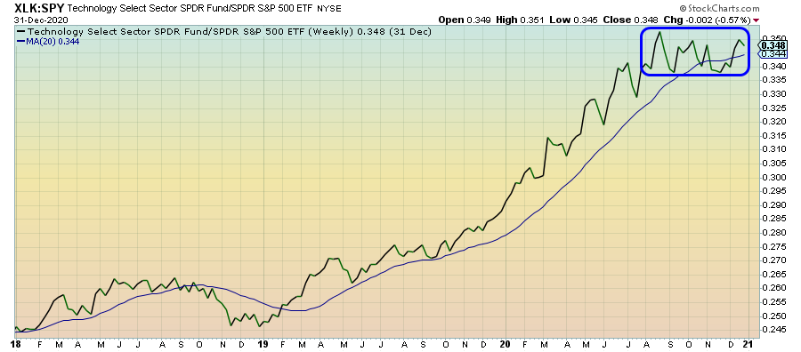
Conversely, up until recently the “cyclical” or economy driven sectors such as banks and other financial industry stocks have appeared to “find a bottom” and have begun to rise in anticipation of their leadership role in 2021:
Financials (XLF) – The Only Leading Cyclical Sector
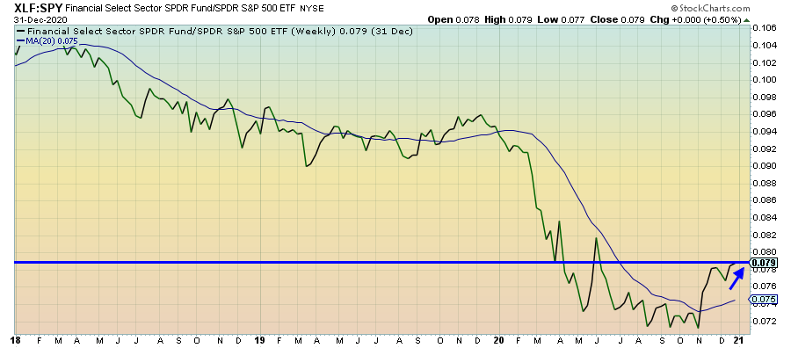
Another investable trend in 2021 is the emergence and proliferation of a relatively new wireless communication technology known as “Fifth Generation” or “5G.” In 2020 our portfolios enjoyed the addition of several key players in the 5G roll out: Qualcomm (cell phone chips), Ciena (fiber optic connectivity) and Apple (various hardware, including the ubiquitous iPhone). They will play leading roles in the various infrastructure buildouts of the emerging high-speed technology. Others will be added as their prices become attractive.

If our forecast is correct and the economy begins to expand over the first two quarters as the lockdown from the viral crisis subsides, there is the possibility of a brief correction in stock prices as interest rates begin to rise and the potential of inflation to increase plays out. This would lead to a fairly significant fall in U.S. Treasury prices (as rates rise), a rise in the dollar and the corresponding rise in financial services stocks depending on the rapidity of steepening in the longer-term interest rate structure.

Unfortunately, the U.S. Treasury has increased total debt by $4 trillion over the last 12 months (about $12,800 per citizen) and as debt matures it will have to be replaced with more costly (higher interest rate) debt. If the U.S. 10-year debt were to increase rapidly from its current level of around 0.95% to the pre-virus level around 2.5% that could precipitate a fall in stock prices of up to 20% in a short period of time. For some perspective, every increase of 0.50 percent in the cost of government debt is equivalent to the entire annual budget for the U.S. Navy.

One last note: energy prices are likely to rise to pre-pandemic levels (around $70 per barrel of crude oil) and the energy sector will likely outperform the index as a result. We have some investments in that area already and they have done very well over the last month or so as oil cracked $50/barrel today. As always, we will vigilantly monitor the portfolios while searching for excellent investment opportunities.

