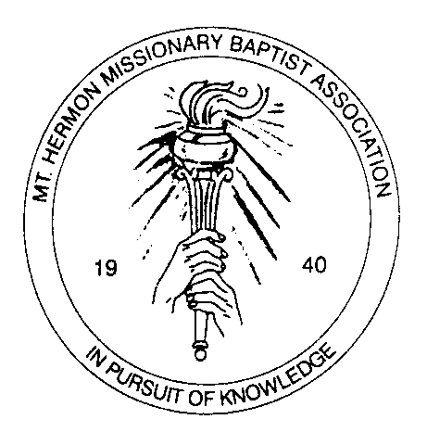
Mount Hermon Missionary Baptist Association
Congress of Christian Education
Church Registration Form
Date _____________________________________

Name of Church_______________________________________________________________
Street Address________________________________________________________________
City, State, Zip Code___________________________________________________________
Name of Pastor________________________________________________________________
Telephone Number: Church ____________________Pastor____________________________
Mailing Address, if different from above:____________________________________________
____________________________________________________________________________
Date of Organization______________________________Incorporated? __________________
Current Membership Size _____________________ Active Membership Size ______________
Contributions toward the Convention Budget:
Church Registration $100.00
Total $______
Signature of person submitting form _______________________________________________
Date form submitted ___________________________________________________________

Rev. Stanley Smith, Moderator
Mount Hermon Missionary Baptist Association
Mailing address:
P. O. Box 42206
Atlanta, GA 30311

