How do I… log in?

You can log in on a desktop by visiting https://www.dayforcehcm.com/mydayforce/login.aspx
Company: mytompsc
User Name: last name + 6-digit employee ID number
Password: TOMP[last4SSN] – you will then be prompted to create your own

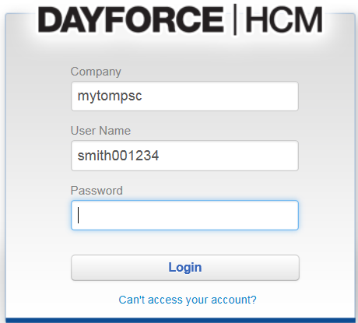
A mobile application is available as well, which is called Dayforce|HCM.
You will use the same log in information as above.
