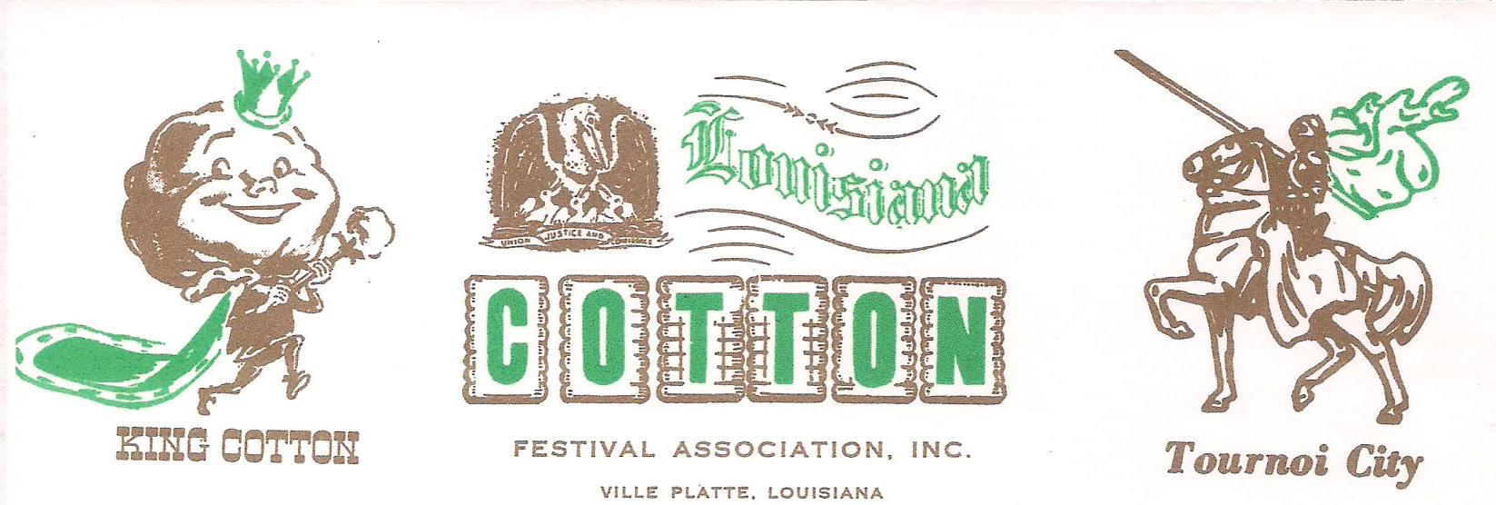

Greetings from the Louisiana Cotton Festival!

On behalf of Louisiana Cotton Festival, we are hereby soliciting CONTESTANTS for the 63rd Annual Louisiana Cotton Queen’s Coronation to be held on Saturday, October 15, 2016 in Ville Platte, La.

All Cotton Contestants must report to the Cotton House - 1111 West Main St. Arrive on Saturday, October 15, 2016, morning between 10:00 to 10:30 am. Arrive in your interview suit with hair and makeup done. We start interviews at 11:00 sharp. You will remain with us until after the “Grand Parade of Cotton” on Sunday.

All girls are to bring their own single bed sheets, pillows, blankets, or sleeping bags, towels, washcloths etc. The girls may also bring an air mattress w/ pump if she desires. We will have an old fashion girl’s slumber party!

Necessary clothing consists of 2 dresses or suits (one for Saturday & one for Sunday Mass) & a formal, which is to be worn to the Cotton Coronation on Saturday afternoon & in the parade on Sunday afternoon. Also bring your festival t-shirt and a pair of jeans.

Enclosed is an entry form, personal data sheet, and rules & regulations forms for the 2016 Cotton Queen’s Coronation to be returned to us as soon as possible with the $110.00 entry fee (non-refundable), and a head/shoulder photograph (for the local paper), either black/white or colored. Make checks or money orders payable to LA Cotton Festival. All entry forms and fee must be received by Thursday, October 1, 2016.

Addition information may be obtained by calling Kelli Ritter Buller 337-831-3340 or email me at kellibuller@hotmail.com you may go to our website at www.Louisianacottonfestival.com for information on cotton.

Sincerely,
Kelli Ritter Buller
Pageant Director / Secretary

Mail entry forms, photo, and the entry fee by Thursday, October 1, 2016
1293 Lee Street Ville Platte, La 70586

Page 1

