+ FIRST CONGREGATIONAL CHURCH
An Open and affirming congregation of the
United Church of Christ, Saugus, Massachusetts
Service of Worship & Baptism 10:00 a.m.
11th Sunday after Pentecost, August 5, 2018
*Indicates for those who are able to, please stand.
Bold print indicates congregational response.
NCH = New Century Hymnal (black cover)
HOP = Spiral bound cover

Greeters & Ushers are John Gilmore & Carol Gilmore.
Scripture Reader is Richard Warbin
Deacon of the Month is John Gilmore.

PRELUDE Rebecca Harrold
WELCOME & ANNOUNCEMENTS Rev. Martha Leahy
LIGHTING THE PEACE CANDLE “Surely the Presence” HOP 74
Surely the presence of the Lord is in this place;
I can feel his mighty power and his grace.
I can hear the brush of angel’s wings,
I see glory on each face;
surely the presence of the Lord is in this place.

CALL TO WORSHIP, (“God, we’re here!”):
L: Who is welcome at God’s table?
P: All who come seeking God are welcome.
L: What do we gather to share?
P: The Bread of Life and the Cup of Blessing.
L: Will this food satisfy us?
P: For our whole lives.
L: Will we hunger or thirst ever again?
All: Not if we truly take God into our hearts and minds.

*OPENING HYMN:
“Come, Gather in This Special Place” NCH 335

*PRAYER OF CONFESSION, (“God, we’re sorry): God, we confess that we often feast on things that do not fill us with the energy we need to do your work. This creates space between you and us and between each other as the Body of Christ. Forgive us. Give us the self-awareness to know when we are too full of ourselves and not full enough on your Word. Amen.

CHORAL RESPONSE: “Thy Word” HOP 92

Thy word is a lamp unto my feet and a light unto my path. (2x)

*ASSURANCE OF PARDON, (“God forgives us”), in unison: Loving God, through the gift of Jesus, we have been given an example of one who was truly nourished and sustained by you. In Christ, we are forgiven, made whole, and restored to the one body. For this indescribable gift, we are eternally grateful. Amen.

*GLORY TO GOD “Holy, Holy, Holy” NCH #277
Holy, holy, holy, God the Almighty! Early in the morning we praise your majesty./ Holy, holy, holy! Merciful and mighty/ God in three persons/ blessed Trinity!

SCRIPTURE: John 6:25-35 (SP755, LP1562)
SP=Small print Bible; LP=Large Print Bible

MESSAGE: “Filling and Fulfilling” Rev. Martha Leahy

PRAYER INTRO: “Sanctuary” HOP 135

Lord, prepare me to be a sanctuary/pure and holy,

tried and true./With thanksgiving, I’ll be a living

sanctuary for you.

PASTORAL PRAYER & LORD’S PRAYER
Our Father, who art in heaven, hallowed be thy name.
Thy kingdom come, thy will be done, on earth as it is in heaven. Give us this day our daily bread; and forgive us our trespasses, as we forgive those who trespass against us; and lead us not into temptation, but deliver us from evil. For thine is the kingdom, the power and the glory forever. Amen.

PRAYER RESPONSE: “Take My Life & Let it Be” HOP 129 Take my life and let it be/Consecrated Lord, to thee./ Take my hands and let them move at the impulse of thy love/ At the impulse of thy love.

OFFERTORY INVITATION, (“God, we give back”), in unison:
Jesus said, “I am the bread of life. Whoever comes to me will never be hungry, and whoever believes in me will never be thirsty.” Let us offer our gifts and our hearts in the service of God’s holy work. May God bless our generosity with both. Amen.

OFFERTORY: “You Have Come Down to the Lakeshore” NCH173
*DOXOLOGY: NCH #778 lyrics; NCH 780 tune
Praise God from whom all blessings flow;
Praise God all creatures here below;
Praise God for all that love has done.
Creator, Christ and Spirit, One. Amen.

*PRAYER OF DEDICATION FOR OUR GIFTS & PLEDGES, (“God bless our gifts”), in unison: O God, we ask your blessing upon the gifts we bring to your altar today. Inspire us to share these gifts freely in the spirit of Jesus who gave us everything, even his own precious life. Amen.

*COMMUNION HYMN: “I Come with Joy” NCH 349, v1-2-3

SACRAMENT OF HOLY COMMUNION (see insert)
Intinction song: “Here, O My Lord, I See You Face to Face” NCH 336

*CLOSING HYMN:
“Let Us Talents and Tongues Employ” NCH347

*COMMISSION AND BLESSING (“God, we will try”), in unison:
God of Bread and Cup, we will try to fill ourselves at your Open Table of Love, as generously as Jesus filled his followers’ hearts and minds. And then we will try to go out into the world and fill others with his Word. Amen.

BENEDICTION (“God, please bless us”), in unison:
L: Who is welcome at God’s table?
P: All who come seeking God are welcome.
L: What do we gather to share?
P: The Bread of Life and the Cup of Blessing.
L: Will this food satisfy us?
P: For our whole lives.
L: Will we hunger or thirst ever again?
All: Not if we truly take God into our hearts and minds.

*CHORAL BENEDICTION:
“Sent Forth by God’s Blessing” NCH76

POSTLUDE Rebecca Harrold

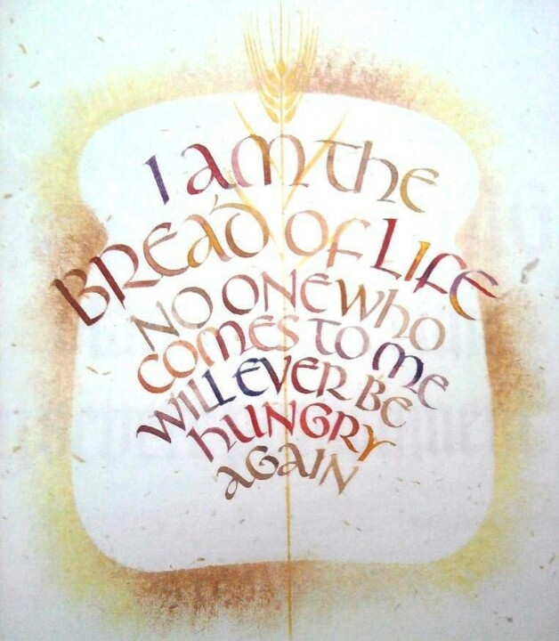

Jokohok.com
“Filling and Fulfilling”
Service of Worship & Communion
11th Sunday after Pentecost
August 5, 2018
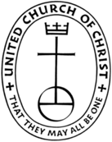
First Congregational Church, United Church of Christ
300 Central Street, Saugus, MA 01906
Rev. Martha Leahy, Pastor
Office 781-233-3028 Cell phone 617-763-7354
Carolyn Davis, Secretary
Rebecca Harrold, Music Director
E-mail address: uccsaugus@verizon.net
Website: http://1stchurchsaugus.org
Facebook: https:www.facebook.com/uccsaugus
Healing Circle: https://facebook.com/healingcirclesaugus

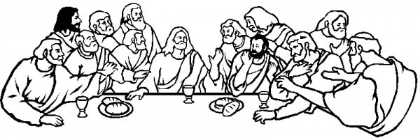

THE SACRAMENT OF HOLY COMMUNION

THE INVITATION All are welcome at Christ’s table.

THE COVENANT OF THE FIRST CONGREGATIONAL CHURCH in SAUGUS UCC in simplified language (unison):
We gather together at church to learn about God through the stories of the Bible, knowing that these stories are not the end, but the beginning, because we believe that “God is still speaking.”
We believe our purpose is to worship God; to tell the story of Jesus; to study Christian history so we know where we have been and where we are going; to comfort the poor and the outcast; to work for peace; and to honor diversity as God’s own creation.
We depend upon the Holy Spirit to teach us and guide us so that we can transform the world into God’s Kingdom here on Earth, and we look forward to the day when we will meet our loving God in Heaven. Amen.

THE COMMUNION PRAYER

THE CONSECRATION OF THE ELEMENTS

THE SHARING OF THE LORD’S SUPPER
Intinction song: “Here, O My Lord, I See You Face to Face” NCH 336

Please come forward in prayerful silence to receive the Bread of Life and the Cup of Blessing. Then return to your seat and sit in silent prayer until all have been served.

THE PRAYER OF THANKSGIVING (unison): We thank you, O God of Abundance, for granting us these simple gifts of bread and cup, which are, for us, the meal of your covenant community. As we are fed here today - in body, mind and spirit - may we go out into the world and invite others to this table. Amen.

Jesus the Bread of Life
Gospel of John 6:25-35
²⁵ When they found him on the other side of the lake, they asked him, “Rabbi, when did you get here?”
²⁶ Jesus answered, “Very truly I tell you, you are looking for me, not because you saw the signs I performed but because you ate the loaves and had your fill. ²⁷ Do not work for food that spoils, but for food that endures to eternal life, which the Son of Man will give you. For on him God has placed the seal of approval.”
²⁸ Then they asked him, “What must we do to do the works God requires?”
²⁹ Jesus answered, “The work of God is this: to believe in the one God has sent.”
³⁰ So they asked him, “What sign then will you give that we may see it and believe you? What will you do? ³¹ Our ancestors ate the manna in the wilderness; as it is written: ‘God gave them bread from heaven to eat.’”
³² Jesus said to them, “Very truly I tell you, it is not Moses who has given you the bread from heaven, but it is God who gives you the true bread from heaven. ³³ For the bread of God is the bread that comes down from heaven and gives life to the world.”
³⁴ “Sir,” they said, “always give us this bread.”
³⁵ Then Jesus declared, “I am the bread of life. Whoever comes to me will never go hungry, and whoever believes in me will never be thirsty.”

